Convulsions and Seizures Workbook

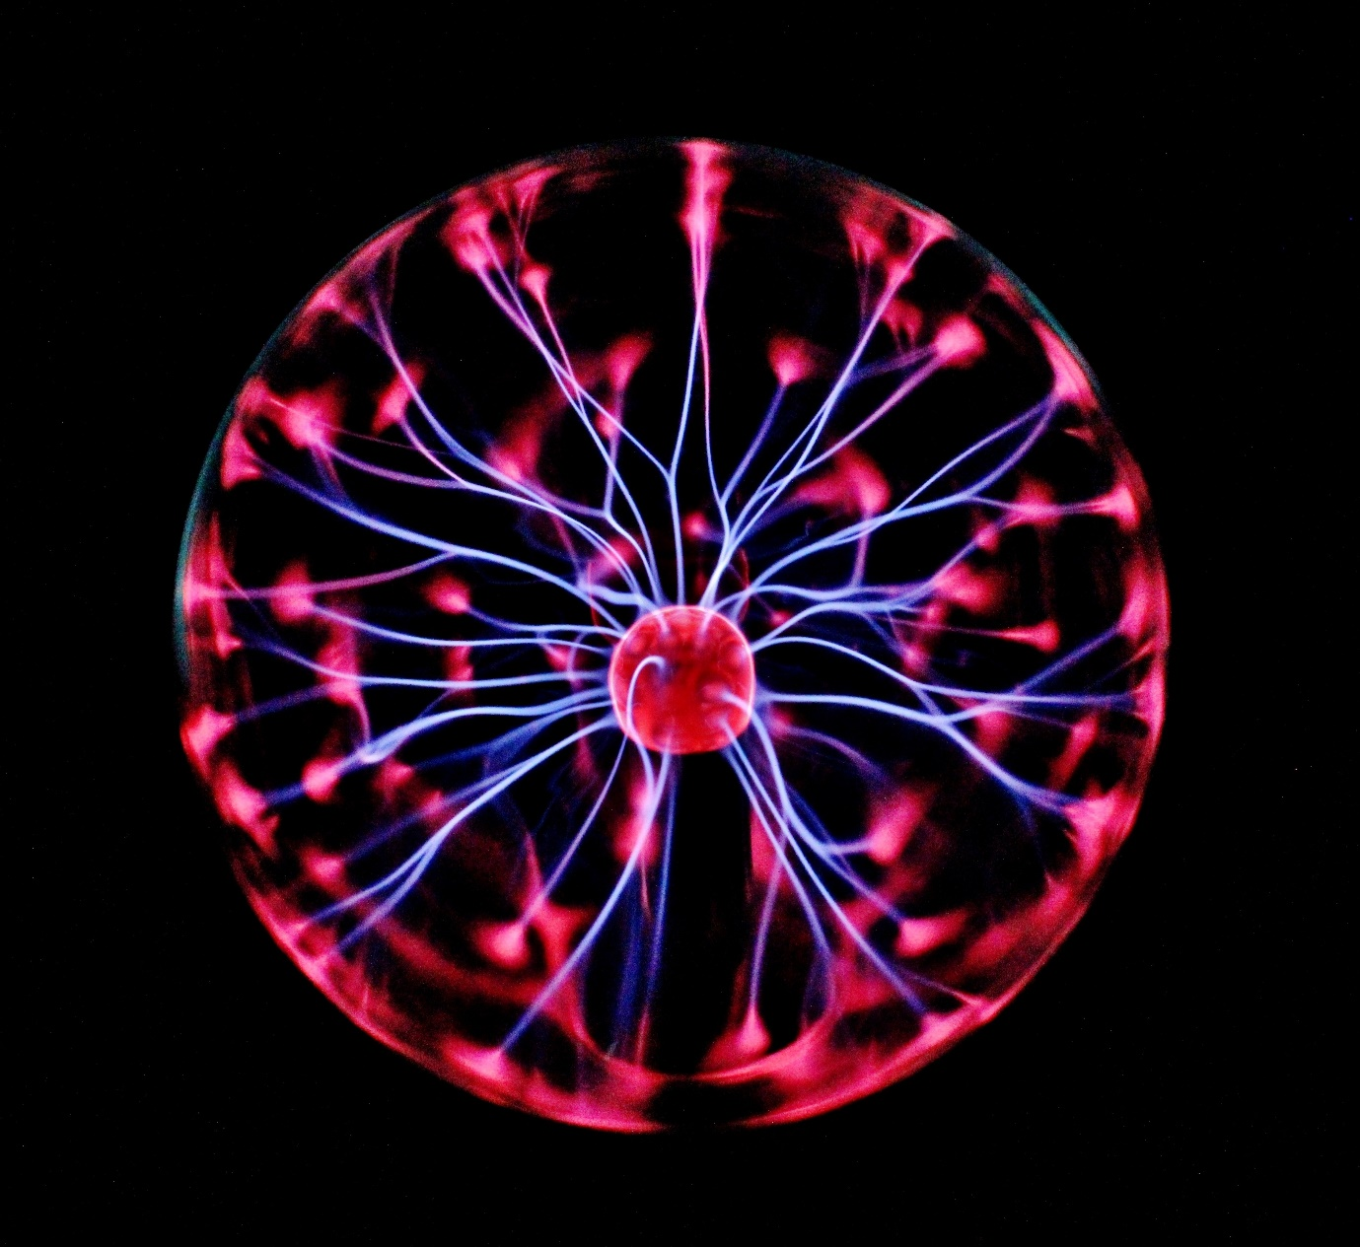

Name:

Grade:

Employer:
Introduction
Welcome to the Ambulance CPD Workbook. When filling out this workbook, to get the most out of your CPD, try and use multiple reputable/peer reviewed sources to fill in your answers. Try to provide references for your answers or links to where you gathered your information. If you need to add more space for your work, you can print out more copies or add information to the notes section.

Question 1: Describe what is a Convulsion and what is a Seizure:
………………………………………………………………………………………………………………………….
………………………………………………………………………………………………………………………….
………………………………………………………………………………………………………………………….
………………………………………………………………………………………………………………………….
………………………………………………………………………………………………………………………….
………………………………………………………………………………………………………………………….
………………………………………………………………………………………………………………………….
………………………………………………………………………………………………………………………….
………………………………………………………………………………………………………………………….
………………………………………………………………………………………………………………………….

Question 2: Discuss the physiological and presentational differences between a Focal and Generalised Seizure:
………………………………………………………………………………………………………………………….
………………………………………………………………………………………………………………………….
………………………………………………………………………………………………………………………….
………………………………………………………………………………………………………………………….
………………………………………………………………………………………………………………………….
………………………………………………………………………………………………………………………….
………………………………………………………………………………………………………………………….
………………………………………………………………………………………………………………………….
………………………………………………………………………………………………………………………….
………………………………………………………………………………………………………………………….

Question 3: List 5 different types of convulsion and their presentations:
………………………………………………………………………………………………………………………….
………………………………………………………………………………………………………………………….
………………………………………………………………………………………………………………………….
………………………………………………………………………………………………………………………….
………………………………………………………………………………………………………………………….
………………………………………………………………………………………………………………………….
………………………………………………………………………………………………………………………….
………………………………………………………………………………………………………………………….
………………………………………………………………………………………………………………………….
………………………………………………………………………………………………………………………….

Question 4: How is a psychological seizure different from a non-psychological seizure and how will your treatment and management differ?
………………………………………………………………………………………………………………………….
………………………………………………………………………………………………………………………….
………………………………………………………………………………………………………………………….
………………………………………………………………………………………………………………………….
………………………………………………………………………………………………………………………….
………………………………………………………………………………………………………………………….
………………………………………………………………………………………………………………………….
………………………………………………………………………………………………………………………….
………………………………………………………………………………………………………………………….
………………………………………………………………………………………………………………………….

Question 5: What drug managements are available for patients with Epilepsy and how do they work pharmacologically?
………………………………………………………………………………………………………………………….
………………………………………………………………………………………………………………………….
………………………………………………………………………………………………………………………….
………………………………………………………………………………………………………………………….
………………………………………………………………………………………………………………………….
………………………………………………………………………………………………………………………….
………………………………………………………………………………………………………………………….
………………………………………………………………………………………………………………………….
………………………………………………………………………………………………………………………….
………………………………………………………………………………………………………………………….

Question 6: Explain what is Status Epilepticus and what dangers this condition presents:
………………………………………………………………………………………………………………………….
………………………………………………………………………………………………………………………….
………………………………………………………………………………………………………………………….
………………………………………………………………………………………………………………………….
………………………………………………………………………………………………………………………….
………………………………………………………………………………………………………………………….
………………………………………………………………………………………………………………………….
………………………………………………………………………………………………………………………….
………………………………………………………………………………………………………………………….
………………………………………………………………………………………………………………………….

Question 7: What is the flow of pre-hospital drug management for a patient in Status Epilepticus?
………………………………………………………………………………………………………………………….
………………………………………………………………………………………………………………………….
………………………………………………………………………………………………………………………….
………………………………………………………………………………………………………………………….
………………………………………………………………………………………………………………………….
………………………………………………………………………………………………………………………….
………………………………………………………………………………………………………………………….
………………………………………………………………………………………………………………………….
………………………………………………………………………………………………………………………….
………………………………………………………………………………………………………………………….

Question 8: In what relation is GABA associated with the treatment of Seizures?
………………………………………………………………………………………………………………………….
………………………………………………………………………………………………………………………….
………………………………………………………………………………………………………………………….
………………………………………………………………………………………………………………………….
………………………………………………………………………………………………………………………….
………………………………………………………………………………………………………………………….
………………………………………………………………………………………………………………………….
………………………………………………………………………………………………………………………….
………………………………………………………………………………………………………………………….
………………………………………………………………………………………………………………………….
Question 9: What effect can a prolonged Status Epilepticus state have on GABA and treatment of the Convulsion?
………………………………………………………………………………………………………………………….
………………………………………………………………………………………………………………………….
………………………………………………………………………………………………………………………….
………………………………………………………………………………………………………………………….
………………………………………………………………………………………………………………………….
………………………………………………………………………………………………………………………….
………………………………………………………………………………………………………………………….
………………………………………………………………………………………………………………………….
………………………………………………………………………………………………………………………….
………………………………………………………………………………………………………………………….

Question 10: Discuss Pre-eclampsia, Eclampsia, and their treatment:
………………………………………………………………………………………………………………………….
………………………………………………………………………………………………………………………….
………………………………………………………………………………………………………………………….
………………………………………………………………………………………………………………………….
………………………………………………………………………………………………………………………….
………………………………………………………………………………………………………………………….
………………………………………………………………………………………………………………………….
………………………………………………………………………………………………………………………….
………………………………………………………………………………………………………………………….
………………………………………………………………………………………………………………………….

Question 11: What other physiological events can cause convulsions?
………………………………………………………………………………………………………………………….
………………………………………………………………………………………………………………………….
………………………………………………………………………………………………………………………….
………………………………………………………………………………………………………………………….
………………………………………………………………………………………………………………………….
………………………………………………………………………………………………………………………….
………………………………………………………………………………………………………………………….
………………………………………………………………………………………………………………………….
………………………………………………………………………………………………………………………….
………………………………………………………………………………………………………………………….

Question 12: In relation to Convulsions and Seizures, discuss Sodium Ion Channels, Calcium Ion Channels, and Glutamate Receptors role in the Brain:
………………………………………………………………………………………………………………………….
………………………………………………………………………………………………………………………….
………………………………………………………………………………………………………………………….
………………………………………………………………………………………………………………………….
………………………………………………………………………………………………………………………….
………………………………………………………………………………………………………………………….
………………………………………………………………………………………………………………………….
………………………………………………………………………………………………………………………….
………………………………………………………………………………………………………………………….
………………………………………………………………………………………………………………………….

Notes:
………………………………………………………………………………………………………………………….
………………………………………………………………………………………………………………………….
………………………………………………………………………………………………………………………….
………………………………………………………………………………………………………………………….
………………………………………………………………………………………………………………………….
………………………………………………………………………………………………………………………….
………………………………………………………………………………………………………………………….
………………………………………………………………………………………………………………………….
………………………………………………………………………………………………………………………….
………………………………………………………………………………………………………………………….
………………………………………………………………………………………………………………………….
………………………………………………………………………………………………………………………….
………………………………………………………………………………………………………………………….
………………………………………………………………………………………………………………………….
………………………………………………………………………………………………………………………….
………………………………………………………………………………………………………………………….
………………………………………………………………………………………………………………………….
………………………………………………………………………………………………………………………….
………………………………………………………………………………………………………………………….
………………………………………………………………………………………………………………………….
………………………………………………………………………………………………………………………….
………………………………………………………………………………………………………………………….
………………………………………………………………………………………………………………………….
………………………………………………………………………………………………………………………….

