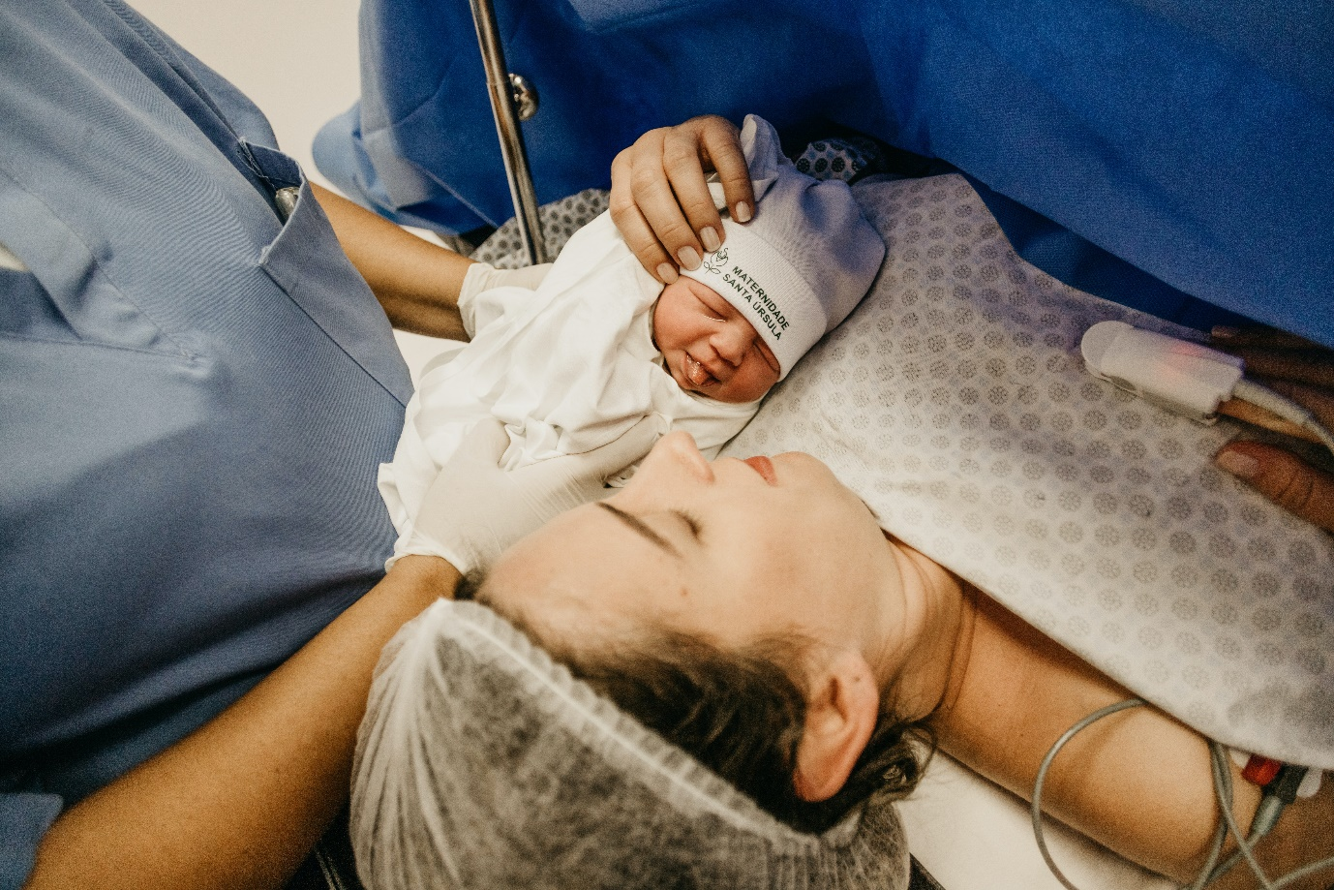
Emergency Birth in the Community

Name:

Grade:

Employer:

Introduction
Welcome to the Ambulance CPD Workbook. When filling out this workbook, to get the most out of your CPD, try and use multiple reputable/peer reviewed sources to fill in your answers. Try to provide references for your answers or links to where you gathered your information. If you need to add more space for your work, you can print out more copies or add information to the notes section.

Question 1: Explain the terms Gravidity, Parity, Multigravida, Multipara, Antenatal, Postnatal, and Gestation:
………………………………………………………………………………………………………………………….
………………………………………………………………………………………………………………………….
………………………………………………………………………………………………………………………….
………………………………………………………………………………………………………………………….
………………………………………………………………………………………………………………………….
………………………………………………………………………………………………………………………….
………………………………………………………………………………………………………………………….
………………………………………………………………………………………………………………………….
………………………………………………………………………………………………………………………….
………………………………………………………………………………………………………………………….

Question 2: Discuss the 1st, 2nd, and 3rd trimesters and what developmental Fetal stages are in each:
………………………………………………………………………………………………………………………….
………………………………………………………………………………………………………………………….
………………………………………………………………………………………………………………………….
………………………………………………………………………………………………………………………….
………………………………………………………………………………………………………………………….
………………………………………………………………………………………………………………………….
………………………………………………………………………………………………………………………….
………………………………………………………………………………………………………………………….
………………………………………………………………………………………………………………………….
………………………………………………………………………………………………………………………….

Question 3: What physiological changes occur to a patient during pregnancy:
………………………………………………………………………………………………………………………….
………………………………………………………………………………………………………………………….
………………………………………………………………………………………………………………………….
………………………………………………………………………………………………………………………….
………………………………………………………………………………………………………………………….
………………………………………………………………………………………………………………………….
………………………………………………………………………………………………………………………….
………………………………………………………………………………………………………………………….
………………………………………………………………………………………………………………………….
………………………………………………………………………………………………………………………….

Question 4: Discuss Rhesus Blood Type, and Anaemia. What impact they can have during pregnancy:
………………………………………………………………………………………………………………………….
………………………………………………………………………………………………………………………….
………………………………………………………………………………………………………………………….
………………………………………………………………………………………………………………………….
………………………………………………………………………………………………………………………….
………………………………………………………………………………………………………………………….
………………………………………………………………………………………………………………………….
………………………………………………………………………………………………………………………….
………………………………………………………………………………………………………………………….
………………………………………………………………………………………………………………………….

Question 5: Prior to 24 weeks, list what pregnancy emergencies and complications can develop:
………………………………………………………………………………………………………………………….
………………………………………………………………………………………………………………………….
………………………………………………………………………………………………………………………….
………………………………………………………………………………………………………………………….
………………………………………………………………………………………………………………………….
………………………………………………………………………………………………………………………….
………………………………………………………………………………………………………………………….
………………………………………………………………………………………………………………………….
………………………………………………………………………………………………………………………….
………………………………………………………………………………………………………………………….

Question 6: Discuss Ectopic Pregnancy, what is it, signs and symptoms, and treatment in a pre-hospital, and hospital setting:
………………………………………………………………………………………………………………………….
………………………………………………………………………………………………………………………….
………………………………………………………………………………………………………………………….
………………………………………………………………………………………………………………………….
………………………………………………………………………………………………………………………….
………………………………………………………………………………………………………………………….
………………………………………………………………………………………………………………………….
………………………………………………………………………………………………………………………….
………………………………………………………………………………………………………………………….
………………………………………………………………………………………………………………………….

Question 7: List what obstetric emergencies and complications can happen, late pregnancy and during labour:
………………………………………………………………………………………………………………………….
………………………………………………………………………………………………………………………….
………………………………………………………………………………………………………………………….
………………………………………………………………………………………………………………………….
………………………………………………………………………………………………………………………….
………………………………………………………………………………………………………………………….
………………………………………………………………………………………………………………………….
………………………………………………………………………………………………………………………….
………………………………………………………………………………………………………………………….
………………………………………………………………………………………………………………………….

Question 8: What are some of the treatments available in the pre-hospital setting for a patient with a Post-Partum Haemorrhage?
………………………………………………………………………………………………………………………….
………………………………………………………………………………………………………………………….
………………………………………………………………………………………………………………………….
………………………………………………………………………………………………………………………….
………………………………………………………………………………………………………………………….
………………………………………………………………………………………………………………………….
………………………………………………………………………………………………………………………….
………………………………………………………………………………………………………………………….
………………………………………………………………………………………………………………………….
………………………………………………………………………………………………………………………….

Question 9: Discuss shoulder dystocia and what can be done in a pre-hospital environment:
………………………………………………………………………………………………………………………….
………………………………………………………………………………………………………………………….
………………………………………………………………………………………………………………………….
………………………………………………………………………………………………………………………….
………………………………………………………………………………………………………………………….
………………………………………………………………………………………………………………………….
………………………………………………………………………………………………………………………….
………………………………………………………………………………………………………………………….
………………………………………………………………………………………………………………………….
………………………………………………………………………………………………………………………….

Question 10: Discuss what Placenta Praevia is and its types, and what Placenta Abrupiton is:
………………………………………………………………………………………………………………………….
………………………………………………………………………………………………………………………….
………………………………………………………………………………………………………………………….
………………………………………………………………………………………………………………………….
………………………………………………………………………………………………………………………….
………………………………………………………………………………………………………………………….
………………………………………………………………………………………………………………………….
………………………………………………………………………………………………………………………….
………………………………………………………………………………………………………………………….
………………………………………………………………………………………………………………………….
Question 11: What drugs can be considered in an Obstetric Emergency and what are their indications: ………………………………………………………………………………………………………………………….
………………………………………………………………………………………………………………………….
………………………………………………………………………………………………………………………….
………………………………………………………………………………………………………………………….
………………………………………………………………………………………………………………………….
………………………………………………………………………………………………………………………….
………………………………………………………………………………………………………………………….
………………………………………………………………………………………………………………………….
………………………………………………………………………………………………………………………….
………………………………………………………………………………………………………………………….

Question 12: Discuss what APGAR means and what it can help identify when assessing a Newborn:
………………………………………………………………………………………………………………………….
………………………………………………………………………………………………………………………….
………………………………………………………………………………………………………………………….
………………………………………………………………………………………………………………………….
………………………………………………………………………………………………………………………….
………………………………………………………………………………………………………………………….
………………………………………………………………………………………………………………………….
………………………………………………………………………………………………………………………….
………………………………………………………………………………………………………………………….
………………………………………………………………………………………………………………………….

Question 13: What signs, symptoms, and past medical/obstetric history may indicate a Newborn may be distressed or in Respiratory/Cardiac Arrest on delivery:
………………………………………………………………………………………………………………………….
………………………………………………………………………………………………………………………….
………………………………………………………………………………………………………………………….
………………………………………………………………………………………………………………………….
………………………………………………………………………………………………………………………….
………………………………………………………………………………………………………………………….
………………………………………………………………………………………………………………………….
………………………………………………………………………………………………………………………….
………………………………………………………………………………………………………………………….
………………………………………………………………………………………………………………………….

Question 14: What stepwise actions/treatments will you undertake on delivery of a Newborn in Respiratory/Cardiac Arrest:
………………………………………………………………………………………………………………………….
………………………………………………………………………………………………………………………….
………………………………………………………………………………………………………………………….
………………………………………………………………………………………………………………………….
………………………………………………………………………………………………………………………….
………………………………………………………………………………………………………………………….
………………………………………………………………………………………………………………………….
………………………………………………………………………………………………………………………….
………………………………………………………………………………………………………………………….
………………………………………………………………………………………………………………………….

Notes:
………………………………………………………………………………………………………………………….
………………………………………………………………………………………………………………………….
………………………………………………………………………………………………………………………….
………………………………………………………………………………………………………………………….
………………………………………………………………………………………………………………………….
………………………………………………………………………………………………………………………….
………………………………………………………………………………………………………………………….
………………………………………………………………………………………………………………………….
………………………………………………………………………………………………………………………….
………………………………………………………………………………………………………………………….
………………………………………………………………………………………………………………………….
………………………………………………………………………………………………………………………….
………………………………………………………………………………………………………………………….
………………………………………………………………………………………………………………………….
………………………………………………………………………………………………………………………….
………………………………………………………………………………………………………………………….
………………………………………………………………………………………………………………………….
………………………………………………………………………………………………………………………….
………………………………………………………………………………………………………………………….
………………………………………………………………………………………………………………………….
………………………………………………………………………………………………………………………….
………………………………………………………………………………………………………………………….
………………………………………………………………………………………………………………………….
………………………………………………………………………………………………………………………….

