Airway Management Workbook

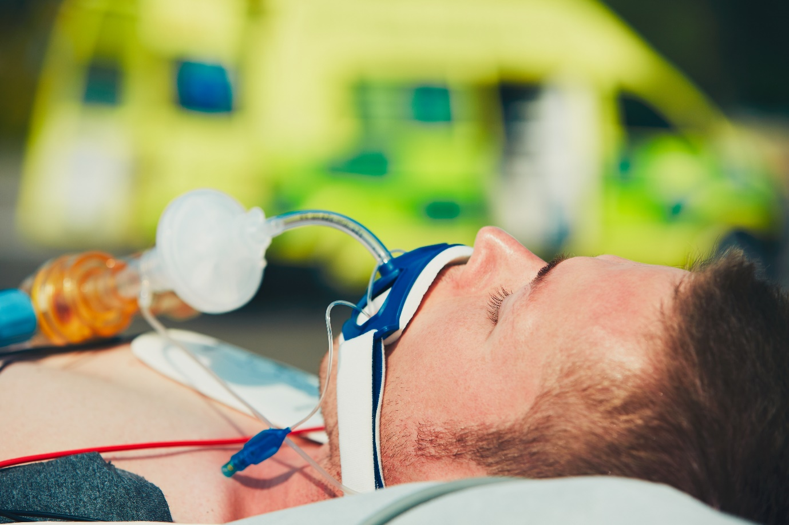

Name:

Grade:

Employer:

Introduction
Welcome to the Ambulance CPD Workbook. When filling out this workbook, to get the most out of your CPD, try and use multiple reputable/peer reviewed sources to fill in your answers. Try to provide references for your answers or links to where you gathered your information. If you need to add more space for your work, you can print out more copies or add information to the notes section.

Question 1: Discuss what manual airway manoeuvres are available and how you would implement them:
………………………………………………………………………………………………………………………….
………………………………………………………………………………………………………………………….
………………………………………………………………………………………………………………………….
………………………………………………………………………………………………………………………….
………………………………………………………………………………………………………………………….
………………………………………………………………………………………………………………………….
………………………………………………………………………………………………………………………….
………………………………………………………………………………………………………………………….
………………………………………………………………………………………………………………………….
………………………………………………………………………………………………………………………….

Question 2: List what is your stepwise Airway Management approach:
………………………………………………………………………………………………………………………….
………………………………………………………………………………………………………………………….
………………………………………………………………………………………………………………………….
………………………………………………………………………………………………………………………….
………………………………………………………………………………………………………………………….
………………………………………………………………………………………………………………………….
………………………………………………………………………………………………………………………….
………………………………………………………………………………………………………………………….
………………………………………………………………………………………………………………………….
………………………………………………………………………………………………………………………….

Question 3: What are the benefits of an Oro-pharyngeal airway and what are its limitations:
………………………………………………………………………………………………………………………….
………………………………………………………………………………………………………………………….
………………………………………………………………………………………………………………………….
………………………………………………………………………………………………………………………….
………………………………………………………………………………………………………………………….
………………………………………………………………………………………………………………………….
………………………………………………………………………………………………………………………….
………………………………………………………………………………………………………………………….
………………………………………………………………………………………………………………………….
………………………………………………………………………………………………………………………….

Question 4: What are the benefits of a Naso-pharyngeal airway and what are its limitations:
………………………………………………………………………………………………………………………….
………………………………………………………………………………………………………………………….
………………………………………………………………………………………………………………………….
………………………………………………………………………………………………………………………….
………………………………………………………………………………………………………………………….
………………………………………………………………………………………………………………………….
………………………………………………………………………………………………………………………….
………………………………………………………………………………………………………………………….
………………………………………………………………………………………………………………………….
………………………………………………………………………………………………………………………….

Question 5: What are the benefits of an Supraglottic airway and what are its limitations:
………………………………………………………………………………………………………………………….
………………………………………………………………………………………………………………………….
………………………………………………………………………………………………………………………….
………………………………………………………………………………………………………………………….
………………………………………………………………………………………………………………………….
………………………………………………………………………………………………………………………….
………………………………………………………………………………………………………………………….
………………………………………………………………………………………………………………………….
………………………………………………………………………………………………………………………….
………………………………………………………………………………………………………………………….

Question 6: What are indications of a successful/effective airway management using any of the above:
………………………………………………………………………………………………………………………….
………………………………………………………………………………………………………………………….
………………………………………………………………………………………………………………………….
………………………………………………………………………………………………………………………….
………………………………………………………………………………………………………………………….
………………………………………………………………………………………………………………………….
………………………………………………………………………………………………………………………….
………………………………………………………………………………………………………………………….
………………………………………………………………………………………………………………………….
………………………………………………………………………………………………………………………….

Question 7: What are the benefits of an Endo-Tracheal Tube Intubation and what are its limitations:
………………………………………………………………………………………………………………………….
………………………………………………………………………………………………………………………….
………………………………………………………………………………………………………………………….
………………………………………………………………………………………………………………………….
………………………………………………………………………………………………………………………….
………………………………………………………………………………………………………………………….
………………………………………………………………………………………………………………………….
………………………………………………………………………………………………………………………….
………………………………………………………………………………………………………………………….
………………………………………………………………………………………………………………………….

Question 8: What confirmations are required when assessing the success or failure of Intubation:
………………………………………………………………………………………………………………………….
………………………………………………………………………………………………………………………….
………………………………………………………………………………………………………………………….
………………………………………………………………………………………………………………………….
………………………………………………………………………………………………………………………….
………………………………………………………………………………………………………………………….
………………………………………………………………………………………………………………………….
………………………………………………………………………………………………………………………….
………………………………………………………………………………………………………………………….
………………………………………………………………………………………………………………………….

Question 9: Discuss your process of Intubation; what is your approach, airway position, hand position, what landmarks are you looking for?
………………………………………………………………………………………………………………………….
………………………………………………………………………………………………………………………….
………………………………………………………………………………………………………………………….
………………………………………………………………………………………………………………………….
………………………………………………………………………………………………………………………….
………………………………………………………………………………………………………………………….
………………………………………………………………………………………………………………………….
………………………………………………………………………………………………………………………….
………………………………………………………………………………………………………………………….
………………………………………………………………………………………………………………………….

Question 10: Discuss what is the LEMON score and Mallampati score in relation to Intubation:
………………………………………………………………………………………………………………………….
………………………………………………………………………………………………………………………….
………………………………………………………………………………………………………………………….
………………………………………………………………………………………………………………………….
………………………………………………………………………………………………………………………….
………………………………………………………………………………………………………………………….
………………………………………………………………………………………………………………………….
………………………………………………………………………………………………………………………….
………………………………………………………………………………………………………………………….
………………………………………………………………………………………………………………………….

Question 11: Discuss medical and trauma scenarios where you might consider early Intubation:
………………………………………………………………………………………………………………………….
………………………………………………………………………………………………………………………….
………………………………………………………………………………………………………………………….
………………………………………………………………………………………………………………………….
………………………………………………………………………………………………………………………….
………………………………………………………………………………………………………………………….
………………………………………………………………………………………………………………………….
………………………………………………………………………………………………………………………….
………………………………………………………………………………………………………………………….
………………………………………………………………………………………………………………………….

Question 12: Discuss the BURP and Sellick manoeuvres, what are they used for and how do you do them: ………………………………………………………………………………………………………………………….
………………………………………………………………………………………………………………………….
………………………………………………………………………………………………………………………….
………………………………………………………………………………………………………………………….
………………………………………………………………………………………………………………………….
………………………………………………………………………………………………………………………….
………………………………………………………………………………………………………………………….
………………………………………………………………………………………………………………………….
………………………………………………………………………………………………………………………….
………………………………………………………………………………………………………………………….

Question 13: Discuss Needle Cricothyroidotomy, what are its indications, landmarks, and processes for the manoeuvre:
………………………………………………………………………………………………………………………….
………………………………………………………………………………………………………………………….
………………………………………………………………………………………………………………………….
………………………………………………………………………………………………………………………….
………………………………………………………………………………………………………………………….
………………………………………………………………………………………………………………………….
………………………………………………………………………………………………………………………….
………………………………………………………………………………………………………………………….
………………………………………………………………………………………………………………………….
………………………………………………………………………………………………………………………….

Question 14: Discuss the importance of a good Airway Management Log and what are its benefits:
………………………………………………………………………………………………………………………….
………………………………………………………………………………………………………………………….
………………………………………………………………………………………………………………………….
………………………………………………………………………………………………………………………….
………………………………………………………………………………………………………………………….
………………………………………………………………………………………………………………………….
………………………………………………………………………………………………………………………….
………………………………………………………………………………………………………………………….
………………………………………………………………………………………………………………………….
………………………………………………………………………………………………………………………….

Notes:
………………………………………………………………………………………………………………………….
………………………………………………………………………………………………………………………….
………………………………………………………………………………………………………………………….
………………………………………………………………………………………………………………………….
………………………………………………………………………………………………………………………….
………………………………………………………………………………………………………………………….
………………………………………………………………………………………………………………………….
………………………………………………………………………………………………………………………….
………………………………………………………………………………………………………………………….
………………………………………………………………………………………………………………………….
………………………………………………………………………………………………………………………….
………………………………………………………………………………………………………………………….
………………………………………………………………………………………………………………………….
………………………………………………………………………………………………………………………….
………………………………………………………………………………………………………………………….
………………………………………………………………………………………………………………………….
………………………………………………………………………………………………………………………….
………………………………………………………………………………………………………………………….
………………………………………………………………………………………………………………………….
………………………………………………………………………………………………………………………….
………………………………………………………………………………………………………………………….
………………………………………………………………………………………………………………………….
………………………………………………………………………………………………………………………….
………………………………………………………………………………………………………………………….

