Drowning Workbook

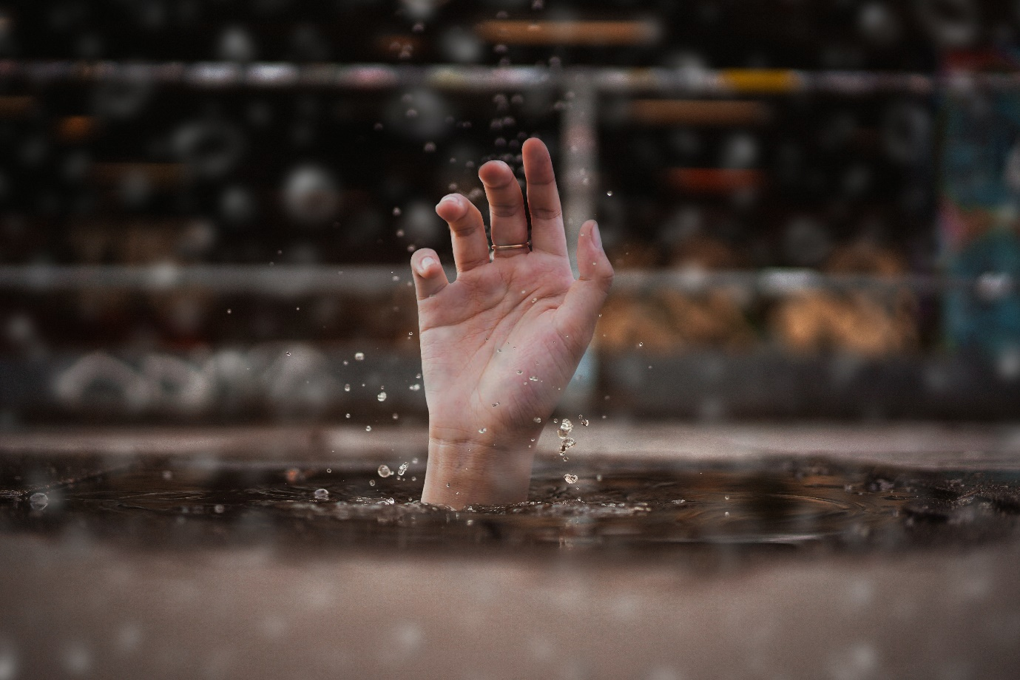

Name:

Grade:

Employer:

Introduction
Welcome to the Ambulance CPD Workbook. When filling out this workbook, to get the most out of your CPD, try and use multiple reputable/peer reviewed sources to fill in your answers. Try to provide references for your answers or links to where you gathered your information. If you need to add more space for your work, you can print out more copies or add information to the notes section.

Question 1: Discuss what is the prevalence of drowning within your Country of work:
………………………………………………………………………………………………………………………….
………………………………………………………………………………………………………………………….
………………………………………………………………………………………………………………………….
………………………………………………………………………………………………………………………….
………………………………………………………………………………………………………………………….
………………………………………………………………………………………………………………………….
………………………………………………………………………………………………………………………….
………………………………………………………………………………………………………………………….
………………………………………………………………………………………………………………………….
………………………………………………………………………………………………………………………….

Question 2: Discuss what time limitations are in place when conducting rescue operations for a submerged casualty:
………………………………………………………………………………………………………………………….
………………………………………………………………………………………………………………………….
………………………………………………………………………………………………………………………….
………………………………………………………………………………………………………………………….
………………………………………………………………………………………………………………………….
………………………………………………………………………………………………………………………….
………………………………………………………………………………………………………………………….
………………………………………………………………………………………………………………………….
………………………………………………………………………………………………………………………….
………………………………………………………………………………………………………………………….

Question 3: How can an icy cold body of water affect the outcome of a drowning patient:
………………………………………………………………………………………………………………………….
………………………………………………………………………………………………………………………….
………………………………………………………………………………………………………………………….
………………………………………………………………………………………………………………………….
………………………………………………………………………………………………………………………….
………………………………………………………………………………………………………………………….
………………………………………………………………………………………………………………………….
………………………………………………………………………………………………………………………….
………………………………………………………………………………………………………………………….
………………………………………………………………………………………………………………………….

Question 4: What are the differences between Submersion and Immersion in the context of drowning:
………………………………………………………………………………………………………………………….
………………………………………………………………………………………………………………………….
………………………………………………………………………………………………………………………….
………………………………………………………………………………………………………………………….
………………………………………………………………………………………………………………………….
………………………………………………………………………………………………………………………….
………………………………………………………………………………………………………………………….
………………………………………………………………………………………………………………………….
………………………………………………………………………………………………………………………….
………………………………………………………………………………………………………………………….

Question 5: What are the differences between near-drowning and drowning:
………………………………………………………………………………………………………………………….
………………………………………………………………………………………………………………………….
………………………………………………………………………………………………………………………….
………………………………………………………………………………………………………………………….
………………………………………………………………………………………………………………………….
………………………………………………………………………………………………………………………….
………………………………………………………………………………………………………………………….
………………………………………………………………………………………………………………………….
………………………………………………………………………………………………………………………….
………………………………………………………………………………………………………………………….

Question 6: What physiological complications would a submersion patient likely present with:
………………………………………………………………………………………………………………………….
………………………………………………………………………………………………………………………….
………………………………………………………………………………………………………………………….
………………………………………………………………………………………………………………………….
………………………………………………………………………………………………………………………….
………………………………………………………………………………………………………………………….
………………………………………………………………………………………………………………………….
………………………………………………………………………………………………………………………….
………………………………………………………………………………………………………………………….
………………………………………………………………………………………………………………………….

Question 7: What physiological complications would an immersion patient likely present with:
………………………………………………………………………………………………………………………….
………………………………………………………………………………………………………………………….
………………………………………………………………………………………………………………………….
………………………………………………………………………………………………………………………….
………………………………………………………………………………………………………………………….
………………………………………………………………………………………………………………………….
………………………………………………………………………………………………………………………….
………………………………………………………………………………………………………………………….
………………………………………………………………………………………………………………………….
………………………………………………………………………………………………………………………….

Question 8: What considerations are required when dealing with a drowning patient in regards to Airway and Breathing:
………………………………………………………………………………………………………………………….
………………………………………………………………………………………………………………………….
………………………………………………………………………………………………………………………….
………………………………………………………………………………………………………………………….
………………………………………………………………………………………………………………………….
………………………………………………………………………………………………………………………….
………………………………………………………………………………………………………………………….
………………………………………………………………………………………………………………………….
………………………………………………………………………………………………………………………….
………………………………………………………………………………………………………………………….

Question 9: What safety requirements must you consider in regards to an actively drowning patient?
………………………………………………………………………………………………………………………….
………………………………………………………………………………………………………………………….
………………………………………………………………………………………………………………………….
………………………………………………………………………………………………………………………….
………………………………………………………………………………………………………………………….
………………………………………………………………………………………………………………………….
………………………………………………………………………………………………………………………….
………………………………………………………………………………………………………………………….
………………………………………………………………………………………………………………………….
………………………………………………………………………………………………………………………….

Question 10: What other agencies/professionals can you consider calling for assistance with an actively drowning patient:
………………………………………………………………………………………………………………………….
………………………………………………………………………………………………………………………….
………………………………………………………………………………………………………………………….
………………………………………………………………………………………………………………………….
………………………………………………………………………………………………………………………….
………………………………………………………………………………………………………………………….
………………………………………………………………………………………………………………………….
………………………………………………………………………………………………………………………….
………………………………………………………………………………………………………………………….
………………………………………………………………………………………………………………………….

Question 11: What would your plan of treatment be for a near-drowning patient who is still conscious and breathing:
………………………………………………………………………………………………………………………….
………………………………………………………………………………………………………………………….
………………………………………………………………………………………………………………………….
………………………………………………………………………………………………………………………….
………………………………………………………………………………………………………………………….
………………………………………………………………………………………………………………………….
………………………………………………………………………………………………………………………….
………………………………………………………………………………………………………………………….
………………………………………………………………………………………………………………………….
………………………………………………………………………………………………………………………….

Question 12: What would your plan of treatment be for a drowning patient who is unconscious in cardiac arrest: ………………………………………………………………………………………………………………………….
………………………………………………………………………………………………………………………….
………………………………………………………………………………………………………………………….
………………………………………………………………………………………………………………………….
………………………………………………………………………………………………………………………….
………………………………………………………………………………………………………………………….
………………………………………………………………………………………………………………………….
………………………………………………………………………………………………………………………….
………………………………………………………………………………………………………………………….
………………………………………………………………………………………………………………………….

Question 13: Are there physiological differences to drowning in fresh water compared to salt water, discuss:
………………………………………………………………………………………………………………………….
………………………………………………………………………………………………………………………….
………………………………………………………………………………………………………………………….
………………………………………………………………………………………………………………………….
………………………………………………………………………………………………………………………….
………………………………………………………………………………………………………………………….
………………………………………………………………………………………………………………………….
………………………………………………………………………………………………………………………….
………………………………………………………………………………………………………………………….
………………………………………………………………………………………………………………………….

Question 14: In the context of drowning or near-drowning in a river, what are your considerations for traumatic injuries:
………………………………………………………………………………………………………………………….
………………………………………………………………………………………………………………………….
………………………………………………………………………………………………………………………….
………………………………………………………………………………………………………………………….
………………………………………………………………………………………………………………………….
………………………………………………………………………………………………………………………….
………………………………………………………………………………………………………………………….
………………………………………………………………………………………………………………………….
………………………………………………………………………………………………………………………….
………………………………………………………………………………………………………………………….

Notes:
………………………………………………………………………………………………………………………….
………………………………………………………………………………………………………………………….
………………………………………………………………………………………………………………………….
………………………………………………………………………………………………………………………….
………………………………………………………………………………………………………………………….
………………………………………………………………………………………………………………………….
………………………………………………………………………………………………………………………….
………………………………………………………………………………………………………………………….
………………………………………………………………………………………………………………………….
………………………………………………………………………………………………………………………….
………………………………………………………………………………………………………………………….
………………………………………………………………………………………………………………………….
………………………………………………………………………………………………………………………….
………………………………………………………………………………………………………………………….
………………………………………………………………………………………………………………………….
………………………………………………………………………………………………………………………….
………………………………………………………………………………………………………………………….
………………………………………………………………………………………………………………………….
………………………………………………………………………………………………………………………….
………………………………………………………………………………………………………………………….
………………………………………………………………………………………………………………………….
………………………………………………………………………………………………………………………….
………………………………………………………………………………………………………………………….
………………………………………………………………………………………………………………………….

