ECG Theory Workbook

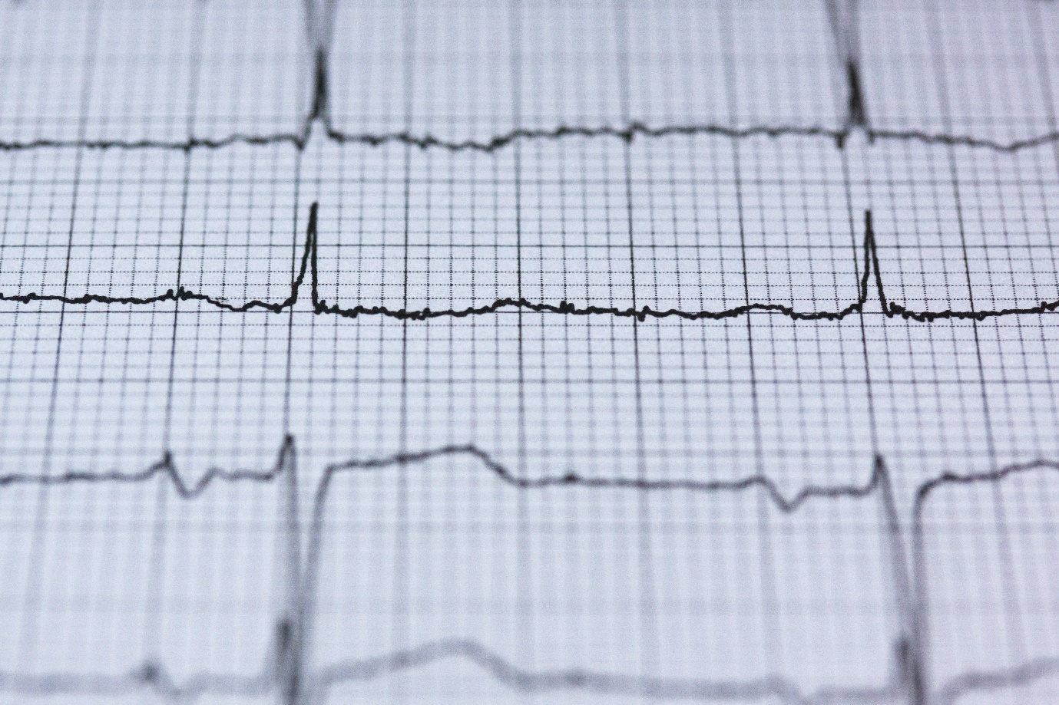

Name:

Grade:

Employer:

Introduction
Welcome to the Ambulance CPD Workbook. When filling out this workbook, to get the most out of your CPD, try and use multiple reputable/peer reviewed sources to fill in your answers. Try to provide references for your answers or links to where you gathered your information. If you need to add more space for your work, you can print out more copies or add information to the notes section.

Question 1: Discuss the electrical pathway of a healthy heart starting at the SA node:
………………………………………………………………………………………………………………………….
………………………………………………………………………………………………………………………….
………………………………………………………………………………………………………………………….
………………………………………………………………………………………………………………………….
………………………………………………………………………………………………………………………….
………………………………………………………………………………………………………………………….
………………………………………………………………………………………………………………………….
………………………………………………………………………………………………………………………….
………………………………………………………………………………………………………………………….
………………………………………………………………………………………………………………………….

Question 2: Discuss the physiological events in the heart during the P, QRS, and T segments on an ECG:
………………………………………………………………………………………………………………………….
………………………………………………………………………………………………………………………….
………………………………………………………………………………………………………………………….
………………………………………………………………………………………………………………………….
………………………………………………………………………………………………………………………….
………………………………………………………………………………………………………………………….
………………………………………………………………………………………………………………………….
………………………………………………………………………………………………………………………….
………………………………………………………………………………………………………………………….
………………………………………………………………………………………………………………………….

Question 3: How can you identify Cardiac Axis Deviation on an ECG, and the differences between Normal, Left, Right, and Extreme:
………………………………………………………………………………………………………………………….
………………………………………………………………………………………………………………………….
………………………………………………………………………………………………………………………….
………………………………………………………………………………………………………………………….
………………………………………………………………………………………………………………………….
………………………………………………………………………………………………………………………….
………………………………………………………………………………………………………………………….
………………………………………………………………………………………………………………………….
………………………………………………………………………………………………………………………….
………………………………………………………………………………………………………………………….

Question 4: What pathophysiological health complications could be associated with Left, Right, and Extreme Axis Deviation:
………………………………………………………………………………………………………………………….
………………………………………………………………………………………………………………………….
………………………………………………………………………………………………………………………….
………………………………………………………………………………………………………………………….
………………………………………………………………………………………………………………………….
………………………………………………………………………………………………………………………….
………………………………………………………………………………………………………………………….
………………………………………………………………………………………………………………………….
………………………………………………………………………………………………………………………….
………………………………………………………………………………………………………………………….

Question 5: Detail the areas of the heart in relation to a 12 lead ECG; Leads (II,III, aVF), (V1, V2), (V3, V4), (V5, V6):
………………………………………………………………………………………………………………………….
………………………………………………………………………………………………………………………….
………………………………………………………………………………………………………………………….
………………………………………………………………………………………………………………………….
………………………………………………………………………………………………………………………….
………………………………………………………………………………………………………………………….
………………………………………………………………………………………………………………………….
………………………………………………………………………………………………………………………….
………………………………………………………………………………………………………………………….
………………………………………………………………………………………………………………………….

Question 6: Discuss the pathophysiology involved in Atrial Fibrillation:
………………………………………………………………………………………………………………………….
………………………………………………………………………………………………………………………….
………………………………………………………………………………………………………………………….
………………………………………………………………………………………………………………………….
………………………………………………………………………………………………………………………….
………………………………………………………………………………………………………………………….
………………………………………………………………………………………………………………………….
………………………………………………………………………………………………………………………….
………………………………………………………………………………………………………………………….
………………………………………………………………………………………………………………………….

Question 7: Discuss the physiological differences between Left/Right Bundle Branch Block, and the differences on an ECG:
………………………………………………………………………………………………………………………….
………………………………………………………………………………………………………………………….
………………………………………………………………………………………………………………………….
………………………………………………………………………………………………………………………….
………………………………………………………………………………………………………………………….
………………………………………………………………………………………………………………………….
………………………………………………………………………………………………………………………….
………………………………………………………………………………………………………………………….
………………………………………………………………………………………………………………………….
………………………………………………………………………………………………………………………….

Question 8: Discuss what is a Heart Block, and what are the different Types:
………………………………………………………………………………………………………………………….
………………………………………………………………………………………………………………………….
………………………………………………………………………………………………………………………….
………………………………………………………………………………………………………………………….
………………………………………………………………………………………………………………………….
………………………………………………………………………………………………………………………….
………………………………………………………………………………………………………………………….
………………………………………………………………………………………………………………………….
………………………………………………………………………………………………………………………….
………………………………………………………………………………………………………………………….
Question 9: Discuss the development and evolution of a Myocardial Infarction on an ECG:
………………………………………………………………………………………………………………………….
………………………………………………………………………………………………………………………….
………………………………………………………………………………………………………………………….
………………………………………………………………………………………………………………………….
………………………………………………………………………………………………………………………….
………………………………………………………………………………………………………………………….
………………………………………………………………………………………………………………………….
………………………………………………………………………………………………………………………….
………………………………………………………………………………………………………………………….
………………………………………………………………………………………………………………………….

Question 10: Why does an ECG show elevation during a Myocardial Infarction and depression/T-Wave inversion during Ischaemia:
………………………………………………………………………………………………………………………….
………………………………………………………………………………………………………………………….
………………………………………………………………………………………………………………………….
………………………………………………………………………………………………………………………….
………………………………………………………………………………………………………………………….
………………………………………………………………………………………………………………………….
………………………………………………………………………………………………………………………….
………………………………………………………………………………………………………………………….
………………………………………………………………………………………………………………………….
………………………………………………………………………………………………………………………….

Question 11: Discuss what is Wolff-Parkinson-White Syndrome and how might it present on an ECG:
………………………………………………………………………………………………………………………….
………………………………………………………………………………………………………………………….
………………………………………………………………………………………………………………………….
………………………………………………………………………………………………………………………….
………………………………………………………………………………………………………………………….
………………………………………………………………………………………………………………………….
………………………………………………………………………………………………………………………….
………………………………………………………………………………………………………………………….
………………………………………………………………………………………………………………………….
………………………………………………………………………………………………………………………….

Question 12: What can a flat or peaked T-Wave signify and what are the physiological reasons for this:
………………………………………………………………………………………………………………………….
………………………………………………………………………………………………………………………….
………………………………………………………………………………………………………………………….
………………………………………………………………………………………………………………………….
………………………………………………………………………………………………………………………….
………………………………………………………………………………………………………………………….
………………………………………………………………………………………………………………………….
………………………………………………………………………………………………………………………….
………………………………………………………………………………………………………………………….
………………………………………………………………………………………………………………………….

Question 13: What can a J-Wave signify and what are the physiological reasons for this:
………………………………………………………………………………………………………………………….
………………………………………………………………………………………………………………………….
………………………………………………………………………………………………………………………….
………………………………………………………………………………………………………………………….
………………………………………………………………………………………………………………………….
………………………………………………………………………………………………………………………….
………………………………………………………………………………………………………………………….
………………………………………………………………………………………………………………………….
………………………………………………………………………………………………………………………….
………………………………………………………………………………………………………………………….

Question 14: Discuss what the ECG pattern S1Q3T3 refers to and what are the physiological reasons for this:
………………………………………………………………………………………………………………………….
………………………………………………………………………………………………………………………….
………………………………………………………………………………………………………………………….
………………………………………………………………………………………………………………………….
………………………………………………………………………………………………………………………….
………………………………………………………………………………………………………………………….
………………………………………………………………………………………………………………………….
………………………………………………………………………………………………………………………….
………………………………………………………………………………………………………………………….
………………………………………………………………………………………………………………………….

Question 15: Discuss Brugada Syndrome, how might it present on an ECG, and what outcomes can it mean for a patient:
………………………………………………………………………………………………………………………….
………………………………………………………………………………………………………………………….
………………………………………………………………………………………………………………………….
………………………………………………………………………………………………………………………….
………………………………………………………………………………………………………………………….
………………………………………………………………………………………………………………………….
………………………………………………………………………………………………………………………….
………………………………………………………………………………………………………………………….
………………………………………………………………………………………………………………………….
………………………………………………………………………………………………………………………….

Notes:
………………………………………………………………………………………………………………………….
………………………………………………………………………………………………………………………….
………………………………………………………………………………………………………………………….
………………………………………………………………………………………………………………………….
………………………………………………………………………………………………………………………….
………………………………………………………………………………………………………………………….
………………………………………………………………………………………………………………………….
………………………………………………………………………………………………………………………….
………………………………………………………………………………………………………………………….
………………………………………………………………………………………………………………………….
………………………………………………………………………………………………………………………….
………………………………………………………………………………………………………………………….
………………………………………………………………………………………………………………………….
………………………………………………………………………………………………………………………….
………………………………………………………………………………………………………………………….
………………………………………………………………………………………………………………………….
………………………………………………………………………………………………………………………….
………………………………………………………………………………………………………………………….
………………………………………………………………………………………………………………………….
………………………………………………………………………………………………………………………….
………………………………………………………………………………………………………………………….
………………………………………………………………………………………………………………………….
………………………………………………………………………………………………………………………….
………………………………………………………………………………………………………………………….

