Sepsis Workbook

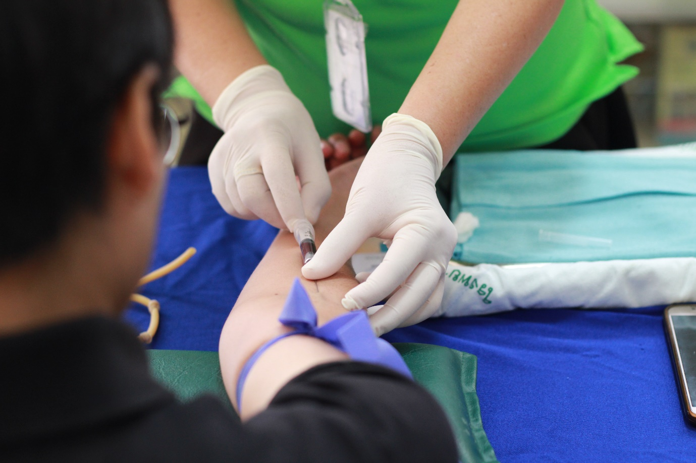

Name:

Grade:

Employer:

Introduction
Welcome to the Ambulance CPD Workbook. When filling out this workbook, to get the most out of your CPD, try and use multiple reputable/peer reviewed sources to fill in your answers. Try to provide references for your answers or links to where you gathered your information. If you need to add more space for your work, you can print out more copies or add information to the notes section.

Question 1: Define what is sepsis:
………………………………………………………………………………………………………………………….
………………………………………………………………………………………………………………………….
………………………………………………………………………………………………………………………….
………………………………………………………………………………………………………………………….
………………………………………………………………………………………………………………………….
………………………………………………………………………………………………………………………….
………………………………………………………………………………………………………………………….
………………………………………………………………………………………………………………………….
………………………………………………………………………………………………………………………….
………………………………………………………………………………………………………………………….

Question 2: Discuss the pathophysiology of sepsis:
………………………………………………………………………………………………………………………….
………………………………………………………………………………………………………………………….
………………………………………………………………………………………………………………………….
………………………………………………………………………………………………………………………….
………………………………………………………………………………………………………………………….
………………………………………………………………………………………………………………………….
………………………………………………………………………………………………………………………….
………………………………………………………………………………………………………………………….
………………………………………………………………………………………………………………………….
………………………………………………………………………………………………………………………….

Question 3: Discuss Systemic Inflammatory Response Syndrome:
………………………………………………………………………………………………………………………….
………………………………………………………………………………………………………………………….
………………………………………………………………………………………………………………………….
………………………………………………………………………………………………………………………….
………………………………………………………………………………………………………………………….
………………………………………………………………………………………………………………………….
………………………………………………………………………………………………………………………….
………………………………………………………………………………………………………………………….
………………………………………………………………………………………………………………………….
………………………………………………………………………………………………………………………….

Question 4: Discuss what describes ‘Severe Sepsis’:
………………………………………………………………………………………………………………………….
………………………………………………………………………………………………………………………….
………………………………………………………………………………………………………………………….
………………………………………………………………………………………………………………………….
………………………………………………………………………………………………………………………….
………………………………………………………………………………………………………………………….
………………………………………………………………………………………………………………………….
………………………………………………………………………………………………………………………….
………………………………………………………………………………………………………………………….
………………………………………………………………………………………………………………………….

Question 5: Discuss what is multi organ dysfunction syndrome and its relation to sepsis:
………………………………………………………………………………………………………………………….
………………………………………………………………………………………………………………………….
………………………………………………………………………………………………………………………….
………………………………………………………………………………………………………………………….
………………………………………………………………………………………………………………………….
………………………………………………………………………………………………………………………….
………………………………………………………………………………………………………………………….
………………………………………………………………………………………………………………………….
………………………………………………………………………………………………………………………….
………………………………………………………………………………………………………………………….

Question 6: Discuss what is Septic Shock:
………………………………………………………………………………………………………………………….
………………………………………………………………………………………………………………………….
………………………………………………………………………………………………………………………….
………………………………………………………………………………………………………………………….
………………………………………………………………………………………………………………………….
………………………………………………………………………………………………………………………….
………………………………………………………………………………………………………………………….
………………………………………………………………………………………………………………………….
………………………………………………………………………………………………………………………….
………………………………………………………………………………………………………………………….
Question 7: Discuss what groups of patients are at greater risk of developing sepsis:
………………………………………………………………………………………………………………………….
………………………………………………………………………………………………………………………….
………………………………………………………………………………………………………………………….
………………………………………………………………………………………………………………………….
………………………………………………………………………………………………………………………….
………………………………………………………………………………………………………………………….
………………………………………………………………………………………………………………………….
………………………………………………………………………………………………………………………….
………………………………………………………………………………………………………………………….
………………………………………………………………………………………………………………………….

Question 8: Discuss 3 types of infections that can lead to sepsis:
………………………………………………………………………………………………………………………….
………………………………………………………………………………………………………………………….
………………………………………………………………………………………………………………………….
………………………………………………………………………………………………………………………….
………………………………………………………………………………………………………………………….
………………………………………………………………………………………………………………………….
………………………………………………………………………………………………………………………….
………………………………………………………………………………………………………………………….
………………………………………………………………………………………………………………………….
………………………………………………………………………………………………………………………….

Question 9: Discuss what is Neutropenic Sepsis:
………………………………………………………………………………………………………………………….
………………………………………………………………………………………………………………………….
………………………………………………………………………………………………………………………….
………………………………………………………………………………………………………………………….
………………………………………………………………………………………………………………………….
………………………………………………………………………………………………………………………….
………………………………………………………………………………………………………………………….
………………………………………………………………………………………………………………………….
………………………………………………………………………………………………………………………….
………………………………………………………………………………………………………………………….

Question 10: List what signs and symptoms may be present in a septic patient:
………………………………………………………………………………………………………………………….
………………………………………………………………………………………………………………………….
………………………………………………………………………………………………………………………….
………………………………………………………………………………………………………………………….
………………………………………………………………………………………………………………………….
………………………………………………………………………………………………………………………….
………………………………………………………………………………………………………………………….
………………………………………………………………………………………………………………………….
………………………………………………………………………………………………………………………….
………………………………………………………………………………………………………………………….

Question 11: What is the prevalence of sepsis and mortality in the UK:
………………………………………………………………………………………………………………………….
………………………………………………………………………………………………………………………….
………………………………………………………………………………………………………………………….
………………………………………………………………………………………………………………………….
………………………………………………………………………………………………………………………….
………………………………………………………………………………………………………………………….
………………………………………………………………………………………………………………………….
………………………………………………………………………………………………………………………….
………………………………………………………………………………………………………………………….
………………………………………………………………………………………………………………………….

Question 12: Discuss what treatments would you consider administering to a poorly septic patient:
………………………………………………………………………………………………………………………….
………………………………………………………………………………………………………………………….
………………………………………………………………………………………………………………………….
………………………………………………………………………………………………………………………….
………………………………………………………………………………………………………………………….
………………………………………………………………………………………………………………………….
………………………………………………………………………………………………………………………….
………………………………………………………………………………………………………………………….
………………………………………………………………………………………………………………………….
………………………………………………………………………………………………………………………….

Question 13: Discuss what assessment tools you may use to assess sepsis:
………………………………………………………………………………………………………………………….
………………………………………………………………………………………………………………………….
………………………………………………………………………………………………………………………….
………………………………………………………………………………………………………………………….
………………………………………………………………………………………………………………………….
………………………………………………………………………………………………………………………….
………………………………………………………………………………………………………………………….
………………………………………………………………………………………………………………………….
………………………………………………………………………………………………………………………….
………………………………………………………………………………………………………………………….

Question 14: What further treatment might be considered in a hospital setting for sepsis:
………………………………………………………………………………………………………………………….
………………………………………………………………………………………………………………………….
………………………………………………………………………………………………………………………….
………………………………………………………………………………………………………………………….
………………………………………………………………………………………………………………………….
………………………………………………………………………………………………………………………….
………………………………………………………………………………………………………………………….
………………………………………………………………………………………………………………………….
………………………………………………………………………………………………………………………….
………………………………………………………………………………………………………………………….

Notes:
………………………………………………………………………………………………………………………….
………………………………………………………………………………………………………………………….
………………………………………………………………………………………………………………………….
………………………………………………………………………………………………………………………….
………………………………………………………………………………………………………………………….
………………………………………………………………………………………………………………………….
………………………………………………………………………………………………………………………….
………………………………………………………………………………………………………………………….
………………………………………………………………………………………………………………………….
………………………………………………………………………………………………………………………….
………………………………………………………………………………………………………………………….
………………………………………………………………………………………………………………………….
………………………………………………………………………………………………………………………….
………………………………………………………………………………………………………………………….
………………………………………………………………………………………………………………………….
………………………………………………………………………………………………………………………….
………………………………………………………………………………………………………………………….
………………………………………………………………………………………………………………………….
………………………………………………………………………………………………………………………….
………………………………………………………………………………………………………………………….
………………………………………………………………………………………………………………………….
………………………………………………………………………………………………………………………….
………………………………………………………………………………………………………………………….
………………………………………………………………………………………………………………………….

