Stroke/TIA Workbook

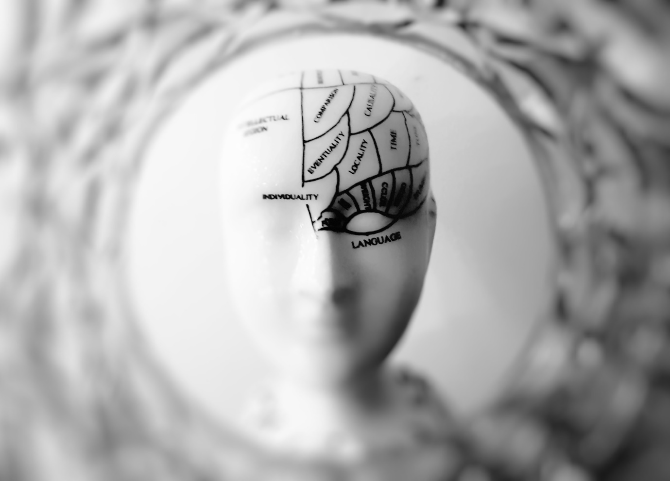

Name:

Grade:

Employer:

Introduction
Welcome to the Ambulance CPD Workbook. When filling out this workbook, to get the most out of your CPD, try and use multiple reputable/peer reviewed sources to fill in your answers. Try to provide references for your answers or links to where you gathered your information. If you need to add more space for your work, you can print out more copies or add information to the notes section.

Question 1: Discuss what signs and symptoms, alongside FAST, may be present in a CVA:
………………………………………………………………………………………………………………………….
………………………………………………………………………………………………………………………….
………………………………………………………………………………………………………………………….
………………………………………………………………………………………………………………………….
………………………………………………………………………………………………………………………….
………………………………………………………………………………………………………………………….
………………………………………………………………………………………………………………………….
………………………………………………………………………………………………………………………….
………………………………………………………………………………………………………………………….
………………………………………………………………………………………………………………………….

Question 2: Discuss what presenting differences there may be depending on the location of a CVA:
………………………………………………………………………………………………………………………….
………………………………………………………………………………………………………………………….
………………………………………………………………………………………………………………………….
………………………………………………………………………………………………………………………….
………………………………………………………………………………………………………………………….
………………………………………………………………………………………………………………………….
………………………………………………………………………………………………………………………….
………………………………………………………………………………………………………………………….
………………………………………………………………………………………………………………………….
………………………………………………………………………………………………………………………….

Question 3: Discuss the two main causes/types of CVA:
………………………………………………………………………………………………………………………….
………………………………………………………………………………………………………………………….
………………………………………………………………………………………………………………………….
………………………………………………………………………………………………………………………….
………………………………………………………………………………………………………………………….
………………………………………………………………………………………………………………………….
………………………………………………………………………………………………………………………….
………………………………………………………………………………………………………………………….
………………………………………………………………………………………………………………………….
………………………………………………………………………………………………………………………….

Question 4: Explain why a blood glucose analysis is important in an assessment of a CVA patient:
………………………………………………………………………………………………………………………….
………………………………………………………………………………………………………………………….
………………………………………………………………………………………………………………………….
………………………………………………………………………………………………………………………….
………………………………………………………………………………………………………………………….
………………………………………………………………………………………………………………………….
………………………………………………………………………………………………………………………….
………………………………………………………………………………………………………………………….
………………………………………………………………………………………………………………………….
………………………………………………………………………………………………………………………….

Question 5: What are the differences between a TIA and a Stroke:
………………………………………………………………………………………………………………………….
………………………………………………………………………………………………………………………….
………………………………………………………………………………………………………………………….
………………………………………………………………………………………………………………………….
………………………………………………………………………………………………………………………….
………………………………………………………………………………………………………………………….
………………………………………………………………………………………………………………………….
………………………………………………………………………………………………………………………….
………………………………………………………………………………………………………………………….
………………………………………………………………………………………………………………………….

Question 6: Alongside FAST, discuss what other assessment/scoring tools are available and how they work:
………………………………………………………………………………………………………………………….
………………………………………………………………………………………………………………………….
………………………………………………………………………………………………………………………….
………………………………………………………………………………………………………………………….
………………………………………………………………………………………………………………………….
………………………………………………………………………………………………………………………….
………………………………………………………………………………………………………………………….
………………………………………………………………………………………………………………………….
………………………………………………………………………………………………………………………….
………………………………………………………………………………………………………………………….

Question 7: Discuss what protocols are followed in your area when admitting a CVA patient:
………………………………………………………………………………………………………………………….
………………………………………………………………………………………………………………………….
………………………………………………………………………………………………………………………….
………………………………………………………………………………………………………………………….
………………………………………………………………………………………………………………………….
………………………………………………………………………………………………………………………….
………………………………………………………………………………………………………………………….
………………………………………………………………………………………………………………………….
………………………………………………………………………………………………………………………….
………………………………………………………………………………………………………………………….

Question 8: What non-specific symptoms and considerations may be present in a child suffering a CVA:
………………………………………………………………………………………………………………………….
………………………………………………………………………………………………………………………….
………………………………………………………………………………………………………………………….
………………………………………………………………………………………………………………………….
………………………………………………………………………………………………………………………….
………………………………………………………………………………………………………………………….
………………………………………………………………………………………………………………………….
………………………………………………………………………………………………………………………….
………………………………………………………………………………………………………………………….
………………………………………………………………………………………………………………………….

Question 9: Discuss what treatments may be conducted in hospital for a ischaemic CVA?
………………………………………………………………………………………………………………………….
………………………………………………………………………………………………………………………….
………………………………………………………………………………………………………………………….
………………………………………………………………………………………………………………………….
………………………………………………………………………………………………………………………….
………………………………………………………………………………………………………………………….
………………………………………………………………………………………………………………………….
………………………………………………………………………………………………………………………….
………………………………………………………………………………………………………………………….
………………………………………………………………………………………………………………………….

Question 10: Discuss what treatments may be conducted in hospital for a haemorrhagic CVA:
………………………………………………………………………………………………………………………….
………………………………………………………………………………………………………………………….
………………………………………………………………………………………………………………………….
………………………………………………………………………………………………………………………….
………………………………………………………………………………………………………………………….
………………………………………………………………………………………………………………………….
………………………………………………………………………………………………………………………….
………………………………………………………………………………………………………………………….
………………………………………………………………………………………………………………………….
………………………………………………………………………………………………………………………….

Question 11: How might symptoms vary between Ischaemic and Haemorrhagic CVA:
………………………………………………………………………………………………………………………….
………………………………………………………………………………………………………………………….
………………………………………………………………………………………………………………………….
………………………………………………………………………………………………………………………….
………………………………………………………………………………………………………………………….
………………………………………………………………………………………………………………………….
………………………………………………………………………………………………………………………….
………………………………………………………………………………………………………………………….
………………………………………………………………………………………………………………………….
………………………………………………………………………………………………………………………….

Question 12: List what are considered preluding factors to CVA: ………………………………………………………………………………………………………………………….
………………………………………………………………………………………………………………………….
………………………………………………………………………………………………………………………….
………………………………………………………………………………………………………………………….
………………………………………………………………………………………………………………………….
………………………………………………………………………………………………………………………….
………………………………………………………………………………………………………………………….
………………………………………………………………………………………………………………………….
………………………………………………………………………………………………………………………….
………………………………………………………………………………………………………………………….

Question 13: List what are the 12 cranial nerves, how you assess them, and their importance:
………………………………………………………………………………………………………………………….
………………………………………………………………………………………………………………………….
………………………………………………………………………………………………………………………….
………………………………………………………………………………………………………………………….
………………………………………………………………………………………………………………………….
………………………………………………………………………………………………………………………….
………………………………………………………………………………………………………………………….
………………………………………………………………………………………………………………………….
………………………………………………………………………………………………………………………….
………………………………………………………………………………………………………………………….
………………………………………………………………………………………………………………………….
………………………………………………………………………………………………………………………….
………………………………………………………………………………………………………………………….
………………………………………………………………………………………………………………………….
………………………………………………………………………………………………………………………….
………………………………………………………………………………………………………………………….
………………………………………………………………………………………………………………………….
………………………………………………………………………………………………………………………….
………………………………………………………………………………………………………………………….
………………………………………………………………………………………………………………………….
………………………………………………………………………………………………………………………….
………………………………………………………………………………………………………………………….
………………………………………………………………………………………………………………………….
………………………………………………………………………………………………………………………….

Notes:
………………………………………………………………………………………………………………………….
………………………………………………………………………………………………………………………….
………………………………………………………………………………………………………………………….
………………………………………………………………………………………………………………………….
………………………………………………………………………………………………………………………….
………………………………………………………………………………………………………………………….
………………………………………………………………………………………………………………………….
………………………………………………………………………………………………………………………….
………………………………………………………………………………………………………………………….
………………………………………………………………………………………………………………………….
………………………………………………………………………………………………………………………….
………………………………………………………………………………………………………………………….
………………………………………………………………………………………………………………………….
………………………………………………………………………………………………………………………….
………………………………………………………………………………………………………………………….
………………………………………………………………………………………………………………………….
………………………………………………………………………………………………………………………….
………………………………………………………………………………………………………………………….
………………………………………………………………………………………………………………………….
………………………………………………………………………………………………………………………….
………………………………………………………………………………………………………………………….
………………………………………………………………………………………………………………………….
………………………………………………………………………………………………………………………….
………………………………………………………………………………………………………………………….

