ECG Analysis Workbook

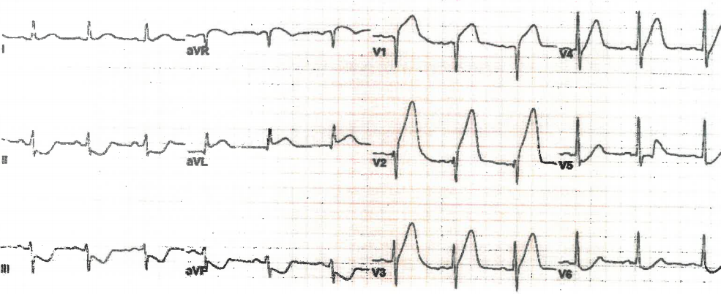

Name:

Grade:

Employer:

Introduction
Welcome to the Ambulance CPD Workbook. When filling out this workbook, to get the most out of your CPD, try and use multiple reputable/peer reviewed sources to fill in your answers. Try to provide references for your answers or links to where you gathered your information. If you need to add more space for your work, you can print out more copies or add information to the notes section.

Question 1: List what important features do you assess when evaluating an ECG:
………………………………………………………………………………………………………………………….
………………………………………………………………………………………………………………………….
………………………………………………………………………………………………………………………….
………………………………………………………………………………………………………………………….
………………………………………………………………………………………………………………………….
………………………………………………………………………………………………………………………….
………………………………………………………………………………………………………………………….
………………………………………………………………………………………………………………………….
………………………………………………………………………………………………………………………….
………………………………………………………………………………………………………………………….
………………………………………………………………………………………………………………………….
………………………………………………………………………………………………………………………….
………………………………………………………………………………………………………………………….
………………………………………………………………………………………………………………………….
………………………………………………………………………………………………………………………….
………………………………………………………………………………………………………………………….
………………………………………………………………………………………………………………………….
………………………………………………………………………………………………………………………….
Below there will be a series of ECG’s presented. Analyse the following ECG’s and note your evaluations, assessment, and findings:
Question 2:
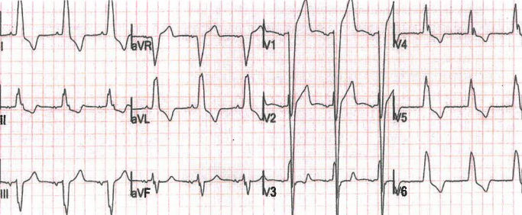
………………………………………………………………………………………………………………………….
………………………………………………………………………………………………………………………….
………………………………………………………………………………………………………………………….
………………………………………………………………………………………………………………………….
………………………………………………………………………………………………………………………….
………………………………………………………………………………………………………………………….
………………………………………………………………………………………………………………………….
………………………………………………………………………………………………………………………….
………………………………………………………………………………………………………………………….
………………………………………………………………………………………………………………………….Question 3:
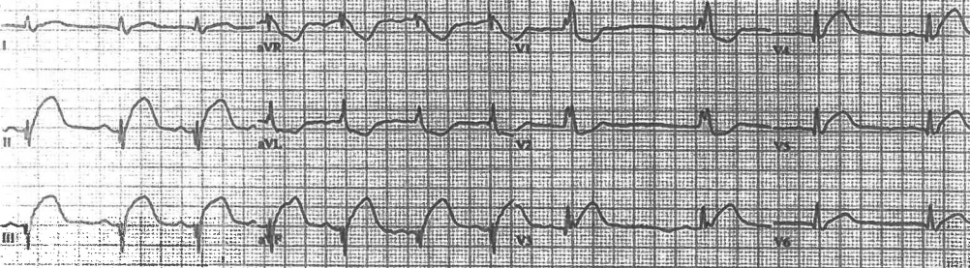
………………………………………………………………………………………………………………………….
………………………………………………………………………………………………………………………….
………………………………………………………………………………………………………………………….
………………………………………………………………………………………………………………………….
………………………………………………………………………………………………………………………….
………………………………………………………………………………………………………………………….
………………………………………………………………………………………………………………………….
………………………………………………………………………………………………………………………….
………………………………………………………………………………………………………………………….
………………………………………………………………………………………………………………………….
Question 4:
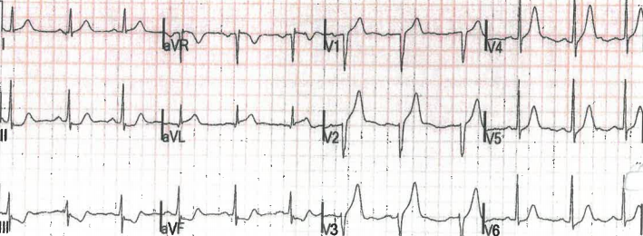
………………………………………………………………………………………………………………………….
………………………………………………………………………………………………………………………….
………………………………………………………………………………………………………………………….
………………………………………………………………………………………………………………………….
………………………………………………………………………………………………………………………….
………………………………………………………………………………………………………………………….
………………………………………………………………………………………………………………………….
………………………………………………………………………………………………………………………….
………………………………………………………………………………………………………………………….
………………………………………………………………………………………………………………………….
Question 5:
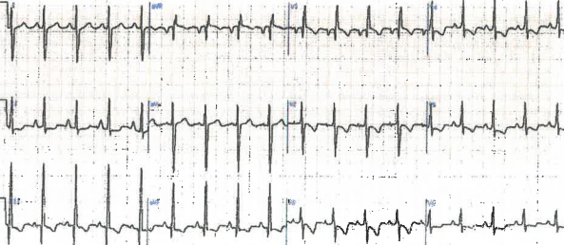
………………………………………………………………………………………………………………………….
………………………………………………………………………………………………………………………….
………………………………………………………………………………………………………………………….
………………………………………………………………………………………………………………………….
………………………………………………………………………………………………………………………….
………………………………………………………………………………………………………………………….
………………………………………………………………………………………………………………………….
………………………………………………………………………………………………………………………….
………………………………………………………………………………………………………………………….
………………………………………………………………………………………………………………………….
Question 6:
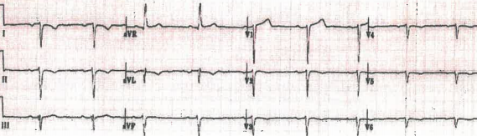
………………………………………………………………………………………………………………………….
………………………………………………………………………………………………………………………….
………………………………………………………………………………………………………………………….
………………………………………………………………………………………………………………………….
………………………………………………………………………………………………………………………….
………………………………………………………………………………………………………………………….
………………………………………………………………………………………………………………………….
………………………………………………………………………………………………………………………….
………………………………………………………………………………………………………………………….
………………………………………………………………………………………………………………………….
Question 7:
………………………………………………………………………………………………………………………….
………………………………………………………………………………………………………………………….
………………………………………………………………………………………………………………………….
………………………………………………………………………………………………………………………….
………………………………………………………………………………………………………………………….
………………………………………………………………………………………………………………………….
………………………………………………………………………………………………………………………….
………………………………………………………………………………………………………………………….
………………………………………………………………………………………………………………………….
………………………………………………………………………………………………………………………….
Question 8:












