Headache and Management Workbook

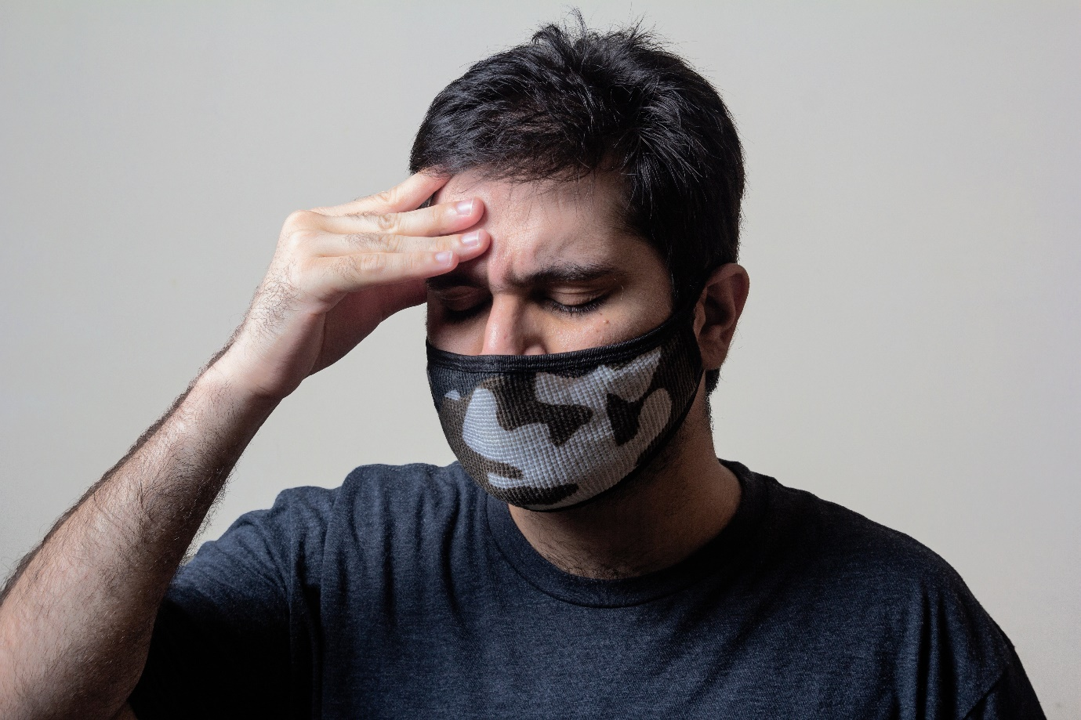

Name:

Grade:

Employer:

Introduction
Welcome to the Ambulance CPD Workbook. When filling out this workbook, to get the most out of your CPD, try and use multiple reputable/peer reviewed sources to fill in your answers. Try to provide references for your answers or links to where you gathered your information. If you need to add more space for your work, you can print out more copies or add information to the notes section.

Question 1: Discuss what are the differences between primary and secondary type headaches:
………………………………………………………………………………………………………………………….
………………………………………………………………………………………………………………………….
………………………………………………………………………………………………………………………….
………………………………………………………………………………………………………………………….
………………………………………………………………………………………………………………………….
………………………………………………………………………………………………………………………….
………………………………………………………………………………………………………………………….
………………………………………………………………………………………………………………………….
………………………………………………………………………………………………………………………….
………………………………………………………………………………………………………………………….

Question 2: How would your management differ between a medical related headache and trauma caused headache:
………………………………………………………………………………………………………………………….
………………………………………………………………………………………………………………………….
………………………………………………………………………………………………………………………….
………………………………………………………………………………………………………………………….
………………………………………………………………………………………………………………………….
………………………………………………………………………………………………………………………….
………………………………………………………………………………………………………………………….
………………………………………………………………………………………………………………………….
………………………………………………………………………………………………………………………….
………………………………………………………………………………………………………………………….

Question 3: List some of the red flag signs and symptoms associated with headaches:
………………………………………………………………………………………………………………………….
………………………………………………………………………………………………………………………….
………………………………………………………………………………………………………………………….
………………………………………………………………………………………………………………………….
………………………………………………………………………………………………………………………….
………………………………………………………………………………………………………………………….
………………………………………………………………………………………………………………………….
………………………………………………………………………………………………………………………….
………………………………………………………………………………………………………………………….
………………………………………………………………………………………………………………………….

Question 4: Describe what is a migraine and its several types:
………………………………………………………………………………………………………………………….
………………………………………………………………………………………………………………………….
………………………………………………………………………………………………………………………….
………………………………………………………………………………………………………………………….
………………………………………………………………………………………………………………………….
………………………………………………………………………………………………………………………….
………………………………………………………………………………………………………………………….
………………………………………………………………………………………………………………………….
………………………………………………………………………………………………………………………….
………………………………………………………………………………………………………………………….

Question 5: Discuss what are tension type headaches:
………………………………………………………………………………………………………………………….
………………………………………………………………………………………………………………………….
………………………………………………………………………………………………………………………….
………………………………………………………………………………………………………………………….
………………………………………………………………………………………………………………………….
………………………………………………………………………………………………………………………….
………………………………………………………………………………………………………………………….
………………………………………………………………………………………………………………………….
………………………………………………………………………………………………………………………….
………………………………………………………………………………………………………………………….

Question 6: Discuss what are cluster type headaches:
………………………………………………………………………………………………………………………….
………………………………………………………………………………………………………………………….
………………………………………………………………………………………………………………………….
………………………………………………………………………………………………………………………….
………………………………………………………………………………………………………………………….
………………………………………………………………………………………………………………………….
………………………………………………………………………………………………………………………….
………………………………………………………………………………………………………………………….
………………………………………………………………………………………………………………………….
………………………………………………………………………………………………………………………….

Question 7: Discuss what is a Subarachnoid haemorrhage:
………………………………………………………………………………………………………………………….
………………………………………………………………………………………………………………………….
………………………………………………………………………………………………………………………….
………………………………………………………………………………………………………………………….
………………………………………………………………………………………………………………………….
………………………………………………………………………………………………………………………….
………………………………………………………………………………………………………………………….
………………………………………………………………………………………………………………………….
………………………………………………………………………………………………………………………….
………………………………………………………………………………………………………………………….

Question 8: Discuss what environmental/external factors could cause headaches:
………………………………………………………………………………………………………………………….
………………………………………………………………………………………………………………………….
………………………………………………………………………………………………………………………….
………………………………………………………………………………………………………………………….
………………………………………………………………………………………………………………………….
………………………………………………………………………………………………………………………….
………………………………………………………………………………………………………………………….
………………………………………………………………………………………………………………………….
………………………………………………………………………………………………………………………….
………………………………………………………………………………………………………………………….

Question 9: Discuss what Internal/physiological factors could cause headaches: ………………………………………………………………………………………………………………………….
………………………………………………………………………………………………………………………….
………………………………………………………………………………………………………………………….
………………………………………………………………………………………………………………………….
………………………………………………………………………………………………………………………….
………………………………………………………………………………………………………………………….
………………………………………………………………………………………………………………………….
………………………………………………………………………………………………………………………….
………………………………………………………………………………………………………………………….
………………………………………………………………………………………………………………………….

Question 10: Discuss the prevalence of headaches associated with CVA’s and TIA’s:
………………………………………………………………………………………………………………………….
………………………………………………………………………………………………………………………….
………………………………………………………………………………………………………………………….
………………………………………………………………………………………………………………………….
………………………………………………………………………………………………………………………….
………………………………………………………………………………………………………………………….
………………………………………………………………………………………………………………………….
………………………………………………………………………………………………………………………….
………………………………………………………………………………………………………………………….
………………………………………………………………………………………………………………………….

Question 11: What specific examinations could you consider to assist you in assessing a headache patient:
………………………………………………………………………………………………………………………….
………………………………………………………………………………………………………………………….
………………………………………………………………………………………………………………………….
………………………………………………………………………………………………………………………….
………………………………………………………………………………………………………………………….
………………………………………………………………………………………………………………………….
………………………………………………………………………………………………………………………….
………………………………………………………………………………………………………………………….
………………………………………………………………………………………………………………………….
………………………………………………………………………………………………………………………….

Question 12: What management/assessment considerations would you have when attending a 999 call for a patient complaining of a significant headache: ………………………………………………………………………………………………………………………….
………………………………………………………………………………………………………………………….
………………………………………………………………………………………………………………………….
………………………………………………………………………………………………………………………….
………………………………………………………………………………………………………………………….
………………………………………………………………………………………………………………………….
………………………………………………………………………………………………………………………….
………………………………………………………………………………………………………………………….
………………………………………………………………………………………………………………………….
………………………………………………………………………………………………………………………….

Question 13: Are there any medications you would avoid administering for a headache patient:
………………………………………………………………………………………………………………………….
………………………………………………………………………………………………………………………….
………………………………………………………………………………………………………………………….
………………………………………………………………………………………………………………………….
………………………………………………………………………………………………………………………….
………………………………………………………………………………………………………………………….
………………………………………………………………………………………………………………………….
………………………………………………………………………………………………………………………….
………………………………………………………………………………………………………………………….
………………………………………………………………………………………………………………………….

Question 14: If leaving a headache patient at home, what safety net precautions would you want to have in place:
………………………………………………………………………………………………………………………….
………………………………………………………………………………………………………………………….
………………………………………………………………………………………………………………………….
………………………………………………………………………………………………………………………….
………………………………………………………………………………………………………………………….
………………………………………………………………………………………………………………………….
………………………………………………………………………………………………………………………….
………………………………………………………………………………………………………………………….
………………………………………………………………………………………………………………………….
………………………………………………………………………………………………………………………….

Notes:
………………………………………………………………………………………………………………………….
………………………………………………………………………………………………………………………….
………………………………………………………………………………………………………………………….
………………………………………………………………………………………………………………………….
………………………………………………………………………………………………………………………….
………………………………………………………………………………………………………………………….
………………………………………………………………………………………………………………………….
………………………………………………………………………………………………………………………….
………………………………………………………………………………………………………………………….
………………………………………………………………………………………………………………………….
………………………………………………………………………………………………………………………….
………………………………………………………………………………………………………………………….
………………………………………………………………………………………………………………………….
………………………………………………………………………………………………………………………….
………………………………………………………………………………………………………………………….
………………………………………………………………………………………………………………………….
………………………………………………………………………………………………………………………….
………………………………………………………………………………………………………………………….
………………………………………………………………………………………………………………………….
………………………………………………………………………………………………………………………….
………………………………………………………………………………………………………………………….
………………………………………………………………………………………………………………………….
………………………………………………………………………………………………………………………….
………………………………………………………………………………………………………………………….

