Major Incident
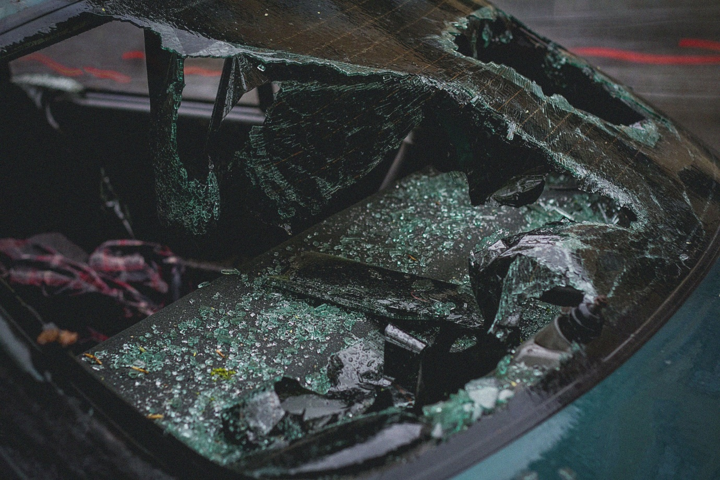

Name:

Grade:

Employer:

Introduction
Welcome to the Ambulance CPD Workbook. When filling out this workbook, to get the most out of your CPD, try and use multiple reputable/peer reviewed sources to fill in your answers. Try to provide references for your answers or links to where you gathered your information. If you need to add more space for your work, you can print out more copies or add information to the notes section.

Question 1: Discuss what is a major incident:
………………………………………………………………………………………………………………………….
………………………………………………………………………………………………………………………….
………………………………………………………………………………………………………………………….
………………………………………………………………………………………………………………………….
………………………………………………………………………………………………………………………….
………………………………………………………………………………………………………………………….
………………………………………………………………………………………………………………………….
………………………………………………………………………………………………………………………….
………………………………………………………………………………………………………………………….
………………………………………………………………………………………………………………………….

Question 2: Discuss how major incidents may differ in context between the different Emergency Services:
………………………………………………………………………………………………………………………….
………………………………………………………………………………………………………………………….
………………………………………………………………………………………………………………………….
………………………………………………………………………………………………………………………….
………………………………………………………………………………………………………………………….
………………………………………………………………………………………………………………………….
………………………………………………………………………………………………………………………….
………………………………………………………………………………………………………………………….
………………………………………………………………………………………………………………………….
………………………………………………………………………………………………………………………….

Question 3: Label and explain what are the different parts of the METHANE mnemonic:
………………………………………………………………………………………………………………………….
………………………………………………………………………………………………………………………….
………………………………………………………………………………………………………………………….
………………………………………………………………………………………………………………………….
………………………………………………………………………………………………………………………….
………………………………………………………………………………………………………………………….
………………………………………………………………………………………………………………………….
………………………………………………………………………………………………………………………….
………………………………………………………………………………………………………………………….
………………………………………………………………………………………………………………………….

Question 4: Write out a METHANE report for the following; Train derailment of 3 carriages during rush hour with potentially 50 persons for each carriage. Approximately 4 miles westbound from 123 Station on the bending section of railway, grid reference SS756879. Carriages are badly damaged due to speed of derailment. You have been able to access a car park near by the site just off the A128 westbound, junction for ‘Country Village’, next to the ‘Country Village’ pub:
………………………………………………………………………………………………………………………….
………………………………………………………………………………………………………………………….
………………………………………………………………………………………………………………………….
………………………………………………………………………………………………………………………….
………………………………………………………………………………………………………………………….
………………………………………………………………………………………………………………………….
………………………………………………………………………………………………………………………….
………………………………………………………………………………………………………………………….
………………………………………………………………………………………………………………………….
………………………………………………………………………………………………………………………….

Question 5: Write out a METHANE report for the following; Hotel Fire at the ‘Grand Hotel’ in ‘Grand’ City. 7 floors trapped due to fire, hotel manager believes there to be around 120 guests. The hotel has a very large car park where you are situated, and is off the major A128 carriageway, Grand hotel junction:
………………………………………………………………………………………………………………………….
………………………………………………………………………………………………………………………….
………………………………………………………………………………………………………………………….
………………………………………………………………………………………………………………………….
………………………………………………………………………………………………………………………….
………………………………………………………………………………………………………………………….
………………………………………………………………………………………………………………………….
………………………………………………………………………………………………………………………….
………………………………………………………………………………………………………………………….
………………………………………………………………………………………………………………………….

Question 6: Write out a METHANE report for the following; Rising flood water at ‘Country’ Village, 300 houses currently being flooded. Country Village is just off the B552 main road, junction for Country Village. Unknown number of residents with any medical issues:
………………………………………………………………………………………………………………………….
………………………………………………………………………………………………………………………….
………………………………………………………………………………………………………………………….
………………………………………………………………………………………………………………………….
………………………………………………………………………………………………………………………….
………………………………………………………………………………………………………………………….
………………………………………………………………………………………………………………………….
………………………………………………………………………………………………………………………….
………………………………………………………………………………………………………………………….
………………………………………………………………………………………………………………………….

Question 7: Label and explain the different parts of the IIMARCH mnemonic and when would you look to use it during a major incident:
………………………………………………………………………………………………………………………….
………………………………………………………………………………………………………………………….
………………………………………………………………………………………………………………………….
………………………………………………………………………………………………………………………….
………………………………………………………………………………………………………………………….
………………………………………………………………………………………………………………………….
………………………………………………………………………………………………………………………….
………………………………………………………………………………………………………………………….
………………………………………………………………………………………………………………………….
………………………………………………………………………………………………………………………….

Question 8: What would your general considerations be turning up to a Major Incident scene:
………………………………………………………………………………………………………………………….
………………………………………………………………………………………………………………………….
………………………………………………………………………………………………………………………….
………………………………………………………………………………………………………………………….
………………………………………………………………………………………………………………………….
………………………………………………………………………………………………………………………….
………………………………………………………………………………………………………………………….
………………………………………………………………………………………………………………………….
………………………………………………………………………………………………………………………….
………………………………………………………………………………………………………………………….

Question 9: List who you would want to contact and what further resources would you want at a Major Incident scene:
………………………………………………………………………………………………………………………….
………………………………………………………………………………………………………………………….
………………………………………………………………………………………………………………………….
………………………………………………………………………………………………………………………….
………………………………………………………………………………………………………………………….
………………………………………………………………………………………………………………………….
………………………………………………………………………………………………………………………….
………………………………………………………………………………………………………………………….
………………………………………………………………………………………………………………………….
………………………………………………………………………………………………………………………….

Question 10: What is the role of a NILO (National Inter-agency Liaison Officer) during a major incident:
………………………………………………………………………………………………………………………….
………………………………………………………………………………………………………………………….
………………………………………………………………………………………………………………………….
………………………………………………………………………………………………………………………….
………………………………………………………………………………………………………………………….
………………………………………………………………………………………………………………………….
………………………………………………………………………………………………………………………….
………………………………………………………………………………………………………………………….
………………………………………………………………………………………………………………………….
………………………………………………………………………………………………………………………….
Question 11: What is the role of HART (Hazardous Area Response Team) during a major incident:
………………………………………………………………………………………………………………………….
………………………………………………………………………………………………………………………….
………………………………………………………………………………………………………………………….
………………………………………………………………………………………………………………………….
………………………………………………………………………………………………………………………….
………………………………………………………………………………………………………………………….
………………………………………………………………………………………………………………………….
………………………………………………………………………………………………………………………….
………………………………………………………………………………………………………………………….
………………………………………………………………………………………………………………………….

Question 12: What is the role of SORT (Special Operations Response Team) during a major incident:
………………………………………………………………………………………………………………………….
………………………………………………………………………………………………………………………….
………………………………………………………………………………………………………………………….
………………………………………………………………………………………………………………………….
………………………………………………………………………………………………………………………….
………………………………………………………………………………………………………………………….
………………………………………………………………………………………………………………………….
………………………………………………………………………………………………………………………….
………………………………………………………………………………………………………………………….
………………………………………………………………………………………………………………………….

Question 13: What is the role of MERIT (Medical Emergency Response Incident Team) during a major incident:
………………………………………………………………………………………………………………………….
………………………………………………………………………………………………………………………….
………………………………………………………………………………………………………………………….
………………………………………………………………………………………………………………………….
………………………………………………………………………………………………………………………….
………………………………………………………………………………………………………………………….
………………………………………………………………………………………………………………………….
………………………………………………………………………………………………………………………….
………………………………………………………………………………………………………………………….
………………………………………………………………………………………………………………………….

Question 14: Discuss what are Steps123+ and how would they help you at an incident:
………………………………………………………………………………………………………………………….
………………………………………………………………………………………………………………………….
………………………………………………………………………………………………………………………….
………………………………………………………………………………………………………………………….
………………………………………………………………………………………………………………………….
………………………………………………………………………………………………………………………….
………………………………………………………………………………………………………………………….
………………………………………………………………………………………………………………………….
………………………………………………………………………………………………………………………….
………………………………………………………………………………………………………………………….

Question 15: Discuss what is JESIP and how do their principles aid in management of a Major Incident:
………………………………………………………………………………………………………………………….
………………………………………………………………………………………………………………………….
………………………………………………………………………………………………………………………….
………………………………………………………………………………………………………………………….
………………………………………………………………………………………………………………………….
………………………………………………………………………………………………………………………….
………………………………………………………………………………………………………………………….
………………………………………………………………………………………………………………………….
………………………………………………………………………………………………………………………….
………………………………………………………………………………………………………………………….

Notes:
………………………………………………………………………………………………………………………….
………………………………………………………………………………………………………………………….
………………………………………………………………………………………………………………………….
………………………………………………………………………………………………………………………….
………………………………………………………………………………………………………………………….
………………………………………………………………………………………………………………………….
………………………………………………………………………………………………………………………….
………………………………………………………………………………………………………………………….
………………………………………………………………………………………………………………………….
………………………………………………………………………………………………………………………….
………………………………………………………………………………………………………………………….
………………………………………………………………………………………………………………………….
………………………………………………………………………………………………………………………….
………………………………………………………………………………………………………………………….
………………………………………………………………………………………………………………………….
………………………………………………………………………………………………………………………….
………………………………………………………………………………………………………………………….
………………………………………………………………………………………………………………………….
………………………………………………………………………………………………………………………….
………………………………………………………………………………………………………………………….
………………………………………………………………………………………………………………………….
………………………………………………………………………………………………………………………….
………………………………………………………………………………………………………………………….
………………………………………………………………………………………………………………………….

