Blood Results Workbook

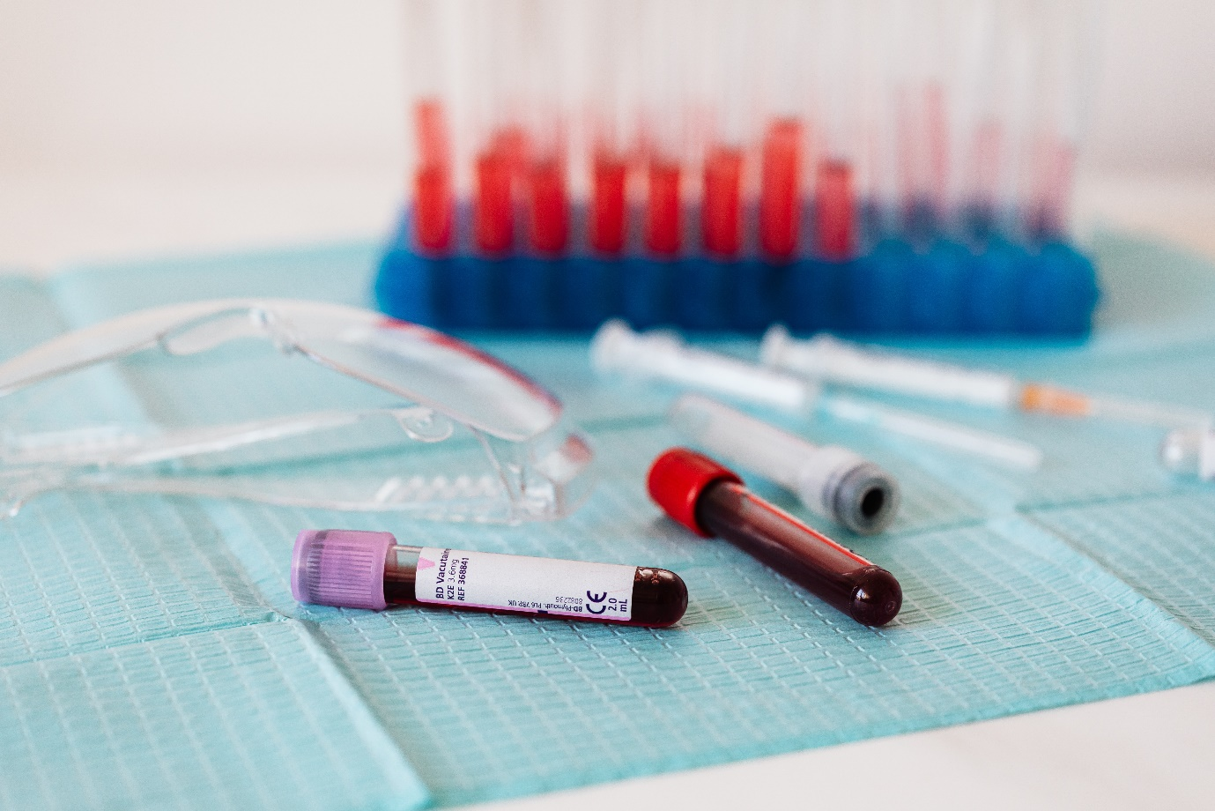

Name:

Grade:

Employer:

Introduction
Welcome to the Ambulance CPD Workbook. When filling out this workbook, to get the most out of your CPD, try and use multiple reputable/peer reviewed sources to fill in your answers. Try to provide references for your answers or links to where you gathered your information. If you need to add more space for your work, you can print out more copies or add information to the notes section.

Question 1: Discuss what results would normally be included in a FBC (Full Blood Count):
………………………………………………………………………………………………………………………….
………………………………………………………………………………………………………………………….
………………………………………………………………………………………………………………………….
………………………………………………………………………………………………………………………….
………………………………………………………………………………………………………………………….
………………………………………………………………………………………………………………………….
………………………………………………………………………………………………………………………….
………………………………………………………………………………………………………………………….
………………………………………………………………………………………………………………………….
………………………………………………………………………………………………………………………….

Question 2: What would the normal range of Heamoglobin (Hb) be, and what can be indicated if it is too high or low:
………………………………………………………………………………………………………………………….
………………………………………………………………………………………………………………………….
………………………………………………………………………………………………………………………….
………………………………………………………………………………………………………………………….
………………………………………………………………………………………………………………………….
………………………………………………………………………………………………………………………….
………………………………………………………………………………………………………………………….
………………………………………………………………………………………………………………………….
………………………………………………………………………………………………………………………….
………………………………………………………………………………………………………………………….

Question 3: What would the normal range of White Blood Count (WBC) be, and what can be indicated if it is too high or low:
………………………………………………………………………………………………………………………….
………………………………………………………………………………………………………………………….
………………………………………………………………………………………………………………………….
………………………………………………………………………………………………………………………….
………………………………………………………………………………………………………………………….
………………………………………………………………………………………………………………………….
………………………………………………………………………………………………………………………….
………………………………………………………………………………………………………………………….
………………………………………………………………………………………………………………………….
………………………………………………………………………………………………………………………….

Question 4: What would the normal range of Platelet (Plt) be, and what can be indicated if it is too high or low:
………………………………………………………………………………………………………………………….
………………………………………………………………………………………………………………………….
………………………………………………………………………………………………………………………….
………………………………………………………………………………………………………………………….
………………………………………………………………………………………………………………………….
………………………………………………………………………………………………………………………….
………………………………………………………………………………………………………………………….
………………………………………………………………………………………………………………………….
………………………………………………………………………………………………………………………….
………………………………………………………………………………………………………………………….

Question 5: What would the normal range of Red Cell Count (RBC) be, and what can be indicated if it is too high or low:
………………………………………………………………………………………………………………………….
………………………………………………………………………………………………………………………….
………………………………………………………………………………………………………………………….
………………………………………………………………………………………………………………………….
………………………………………………………………………………………………………………………….
………………………………………………………………………………………………………………………….
………………………………………………………………………………………………………………………….
………………………………………………………………………………………………………………………….
………………………………………………………………………………………………………………………….
………………………………………………………………………………………………………………………….

Question 6: What would the normal range of Haematocrit (HCT) be, and what can be indicated if it is too high or low:
………………………………………………………………………………………………………………………….
………………………………………………………………………………………………………………………….
………………………………………………………………………………………………………………………….
………………………………………………………………………………………………………………………….
………………………………………………………………………………………………………………………….
………………………………………………………………………………………………………………………….
………………………………………………………………………………………………………………………….
………………………………………………………………………………………………………………………….
………………………………………………………………………………………………………………………….
………………………………………………………………………………………………………………………….

Question 7: What would the normal range of Mean Cell Volume – Red Cell (MCV) be, and what can be indicated if it is too high or low:
………………………………………………………………………………………………………………………….
………………………………………………………………………………………………………………………….
………………………………………………………………………………………………………………………….
………………………………………………………………………………………………………………………….
………………………………………………………………………………………………………………………….
………………………………………………………………………………………………………………………….
………………………………………………………………………………………………………………………….
………………………………………………………………………………………………………………………….
………………………………………………………………………………………………………………………….
………………………………………………………………………………………………………………………….

Question 8: What would the normal range of Mean Cell Haemoglobin (MCH) be, and what can be indicated if it is too high or low:
………………………………………………………………………………………………………………………….
………………………………………………………………………………………………………………………….
………………………………………………………………………………………………………………………….
………………………………………………………………………………………………………………………….
………………………………………………………………………………………………………………………….
………………………………………………………………………………………………………………………….
………………………………………………………………………………………………………………………….
………………………………………………………………………………………………………………………….
………………………………………………………………………………………………………………………….
………………………………………………………………………………………………………………………….

Question 9: What would the normal range of Lactate (Lac) be, and what can be indicated if it is too high or low: ………………………………………………………………………………………………………………………….
………………………………………………………………………………………………………………………….
………………………………………………………………………………………………………………………….
………………………………………………………………………………………………………………………….
………………………………………………………………………………………………………………………….
………………………………………………………………………………………………………………………….
………………………………………………………………………………………………………………………….
………………………………………………………………………………………………………………………….
………………………………………………………………………………………………………………………….
………………………………………………………………………………………………………………………….

Question 10: What would the normal range of Sodium (Na+) be, and what can be indicated if it is too high or low:
………………………………………………………………………………………………………………………….
………………………………………………………………………………………………………………………….
………………………………………………………………………………………………………………………….
………………………………………………………………………………………………………………………….
………………………………………………………………………………………………………………………….
………………………………………………………………………………………………………………………….
………………………………………………………………………………………………………………………….
………………………………………………………………………………………………………………………….
………………………………………………………………………………………………………………………….
………………………………………………………………………………………………………………………….

Question 11: What would the normal range of Potassium (K+) be, and what can be indicated if it is too high or low:
………………………………………………………………………………………………………………………….
………………………………………………………………………………………………………………………….
………………………………………………………………………………………………………………………….
………………………………………………………………………………………………………………………….
………………………………………………………………………………………………………………………….
………………………………………………………………………………………………………………………….
………………………………………………………………………………………………………………………….
………………………………………………………………………………………………………………………….
………………………………………………………………………………………………………………………….
………………………………………………………………………………………………………………………….

Question 12: What would the normal range of Calcium (Ca++) be, and what can be indicated if it is too high or low: ………………………………………………………………………………………………………………………….
………………………………………………………………………………………………………………………….
………………………………………………………………………………………………………………………….
………………………………………………………………………………………………………………………….
………………………………………………………………………………………………………………………….
………………………………………………………………………………………………………………………….
………………………………………………………………………………………………………………………….
………………………………………………………………………………………………………………………….
………………………………………………………………………………………………………………………….
………………………………………………………………………………………………………………………….

Question 13: What would the normal range of Chloride (Cl-) be, and what can be indicated if it is too high or low:
………………………………………………………………………………………………………………………….
………………………………………………………………………………………………………………………….
………………………………………………………………………………………………………………………….
………………………………………………………………………………………………………………………….
………………………………………………………………………………………………………………………….
………………………………………………………………………………………………………………………….
………………………………………………………………………………………………………………………….
………………………………………………………………………………………………………………………….
………………………………………………………………………………………………………………………….
………………………………………………………………………………………………………………………….

Question 14: What would the normal range of Blood pH be, and what can be indicated if it is too high or low:
………………………………………………………………………………………………………………………….
………………………………………………………………………………………………………………………….
………………………………………………………………………………………………………………………….
………………………………………………………………………………………………………………………….
………………………………………………………………………………………………………………………….
………………………………………………………………………………………………………………………….
………………………………………………………………………………………………………………………….
………………………………………………………………………………………………………………………….
………………………………………………………………………………………………………………………….
………………………………………………………………………………………………………………………….
Notes:
………………………………………………………………………………………………………………………….
………………………………………………………………………………………………………………………….
………………………………………………………………………………………………………………………….
………………………………………………………………………………………………………………………….
………………………………………………………………………………………………………………………….
………………………………………………………………………………………………………………………….
………………………………………………………………………………………………………………………….
………………………………………………………………………………………………………………………….
………………………………………………………………………………………………………………………….
………………………………………………………………………………………………………………………….
………………………………………………………………………………………………………………………….
………………………………………………………………………………………………………………………….
………………………………………………………………………………………………………………………….
………………………………………………………………………………………………………………………….
………………………………………………………………………………………………………………………….
………………………………………………………………………………………………………………………….
………………………………………………………………………………………………………………………….
………………………………………………………………………………………………………………………….
………………………………………………………………………………………………………………………….
………………………………………………………………………………………………………………………….
………………………………………………………………………………………………………………………….
………………………………………………………………………………………………………………………….
………………………………………………………………………………………………………………………….
………………………………………………………………………………………………………………………….

