Bacteria Workbook

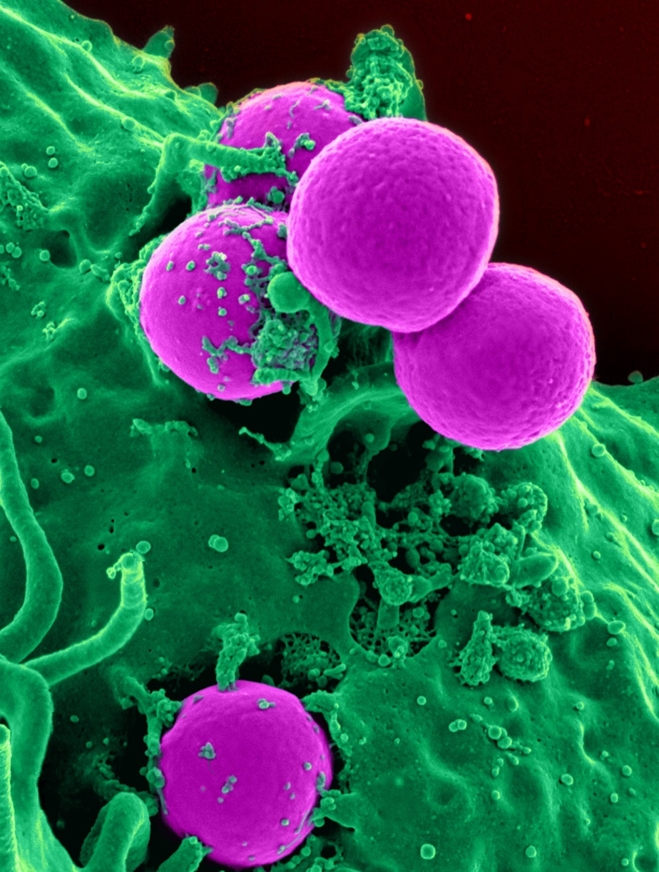

Name:

Grade:

Employer:
Introduction
Welcome to the Ambulance CPD Workbook. When filling out this workbook, to get the most out of your CPD, try and use multiple reputable/peer reviewed sources to fill in your answers. Try to provide references for your answers or links to where you gathered your information. If you need to add more space for your work, you can print out more copies or add information to the notes section.

Question 1: Discuss what is bacteria:
………………………………………………………………………………………………………………………….
………………………………………………………………………………………………………………………….
………………………………………………………………………………………………………………………….
………………………………………………………………………………………………………………………….
………………………………………………………………………………………………………………………….
………………………………………………………………………………………………………………………….
………………………………………………………………………………………………………………………….
………………………………………………………………………………………………………………………….
………………………………………………………………………………………………………………………….
………………………………………………………………………………………………………………………….

Question 2: What are the differences between bacteria and a virus:
………………………………………………………………………………………………………………………….
………………………………………………………………………………………………………………………….
………………………………………………………………………………………………………………………….
………………………………………………………………………………………………………………………….
………………………………………………………………………………………………………………………….
………………………………………………………………………………………………………………………….
………………………………………………………………………………………………………………………….
………………………………………………………………………………………………………………………….
………………………………………………………………………………………………………………………….
………………………………………………………………………………………………………………………….

Question 3: How does a bacteria spread within the body:
………………………………………………………………………………………………………………………….
………………………………………………………………………………………………………………………….
………………………………………………………………………………………………………………………….
………………………………………………………………………………………………………………………….
………………………………………………………………………………………………………………………….
………………………………………………………………………………………………………………………….
………………………………………………………………………………………………………………………….
………………………………………………………………………………………………………………………….
………………………………………………………………………………………………………………………….
………………………………………………………………………………………………………………………….

Question 4: What treatments are available for bacteria?
………………………………………………………………………………………………………………………….
………………………………………………………………………………………………………………………….
………………………………………………………………………………………………………………………….
………………………………………………………………………………………………………………………….
………………………………………………………………………………………………………………………….
………………………………………………………………………………………………………………………….
………………………………………………………………………………………………………………………….
………………………………………………………………………………………………………………………….
………………………………………………………………………………………………………………………….
………………………………………………………………………………………………………………………….

Discuss the following bacteria looking at how they affect the body, how they spread, what are their illness/death, and what treatments are available for them

Question 5: Campylobacter:
………………………………………………………………………………………………………………………….
………………………………………………………………………………………………………………………….
………………………………………………………………………………………………………………………….
………………………………………………………………………………………………………………………….
………………………………………………………………………………………………………………………….
………………………………………………………………………………………………………………………….
………………………………………………………………………………………………………………………….
………………………………………………………………………………………………………………………….
………………………………………………………………………………………………………………………….
………………………………………………………………………………………………………………………….

Question 6: Clostridium Difficile (C Diff):
………………………………………………………………………………………………………………………….
………………………………………………………………………………………………………………………….
………………………………………………………………………………………………………………………….
………………………………………………………………………………………………………………………….
………………………………………………………………………………………………………………………….
………………………………………………………………………………………………………………………….
………………………………………………………………………………………………………………………….
………………………………………………………………………………………………………………………….
………………………………………………………………………………………………………………………….
………………………………………………………………………………………………………………………….

Question 7: Klebsiella Pneumoniae:
………………………………………………………………………………………………………………………….
………………………………………………………………………………………………………………………….
………………………………………………………………………………………………………………………….
………………………………………………………………………………………………………………………….
………………………………………………………………………………………………………………………….
………………………………………………………………………………………………………………………….
………………………………………………………………………………………………………………………….
………………………………………………………………………………………………………………………….
………………………………………………………………………………………………………………………….
………………………………………………………………………………………………………………………….

Question 8: Escherichia Coli (E Coli):
………………………………………………………………………………………………………………………….
………………………………………………………………………………………………………………………….
………………………………………………………………………………………………………………………….
………………………………………………………………………………………………………………………….
………………………………………………………………………………………………………………………….
………………………………………………………………………………………………………………………….
………………………………………………………………………………………………………………………….
………………………………………………………………………………………………………………………….
………………………………………………………………………………………………………………………….
………………………………………………………………………………………………………………………….
Question 9: Legionella:
………………………………………………………………………………………………………………………….
………………………………………………………………………………………………………………………….
………………………………………………………………………………………………………………………….
………………………………………………………………………………………………………………………….
………………………………………………………………………………………………………………………….
………………………………………………………………………………………………………………………….
………………………………………………………………………………………………………………………….
………………………………………………………………………………………………………………………….
………………………………………………………………………………………………………………………….
………………………………………………………………………………………………………………………….

Question 10: Listeria:
………………………………………………………………………………………………………………………….
………………………………………………………………………………………………………………………….
………………………………………………………………………………………………………………………….
………………………………………………………………………………………………………………………….
………………………………………………………………………………………………………………………….
………………………………………………………………………………………………………………………….
………………………………………………………………………………………………………………………….
………………………………………………………………………………………………………………………….
………………………………………………………………………………………………………………………….
………………………………………………………………………………………………………………………….

Question 11: Methicillin-resistant Staphylococcus Aureus (MRSA):
………………………………………………………………………………………………………………………….
………………………………………………………………………………………………………………………….
………………………………………………………………………………………………………………………….
………………………………………………………………………………………………………………………….
………………………………………………………………………………………………………………………….
………………………………………………………………………………………………………………………….
………………………………………………………………………………………………………………………….
………………………………………………………………………………………………………………………….
………………………………………………………………………………………………………………………….
………………………………………………………………………………………………………………………….

Question 12: Salmonella:
………………………………………………………………………………………………………………………….
………………………………………………………………………………………………………………………….
………………………………………………………………………………………………………………………….
………………………………………………………………………………………………………………………….
………………………………………………………………………………………………………………………….
………………………………………………………………………………………………………………………….
………………………………………………………………………………………………………………………….
………………………………………………………………………………………………………………………….
………………………………………………………………………………………………………………………….
………………………………………………………………………………………………………………………….

Question 13: Tuberculosis:
………………………………………………………………………………………………………………………….
………………………………………………………………………………………………………………………….
………………………………………………………………………………………………………………………….
………………………………………………………………………………………………………………………….
………………………………………………………………………………………………………………………….
………………………………………………………………………………………………………………………….
………………………………………………………………………………………………………………………….
………………………………………………………………………………………………………………………….
………………………………………………………………………………………………………………………….
………………………………………………………………………………………………………………………….

Question 14: Helicobacter Pylori:
………………………………………………………………………………………………………………………….
………………………………………………………………………………………………………………………….
………………………………………………………………………………………………………………………….
………………………………………………………………………………………………………………………….
………………………………………………………………………………………………………………………….
………………………………………………………………………………………………………………………….
………………………………………………………………………………………………………………………….
………………………………………………………………………………………………………………………….
………………………………………………………………………………………………………………………….
………………………………………………………………………………………………………………………….

Question 15: Neisseria Gonorrhoeae:
………………………………………………………………………………………………………………………….
………………………………………………………………………………………………………………………….
………………………………………………………………………………………………………………………….
………………………………………………………………………………………………………………………….
………………………………………………………………………………………………………………………….
………………………………………………………………………………………………………………………….
………………………………………………………………………………………………………………………….
………………………………………………………………………………………………………………………….
………………………………………………………………………………………………………………………….
………………………………………………………………………………………………………………………….

Question 16: Pseudomonas Aeruginosa:
………………………………………………………………………………………………………………………….
………………………………………………………………………………………………………………………….
………………………………………………………………………………………………………………………….
………………………………………………………………………………………………………………………….
………………………………………………………………………………………………………………………….
………………………………………………………………………………………………………………………….
………………………………………………………………………………………………………………………….
………………………………………………………………………………………………………………………….
………………………………………………………………………………………………………………………….
………………………………………………………………………………………………………………………….

Question 17: Yersinia Pestis:
………………………………………………………………………………………………………………………….
………………………………………………………………………………………………………………………….
………………………………………………………………………………………………………………………….
………………………………………………………………………………………………………………………….
………………………………………………………………………………………………………………………….
………………………………………………………………………………………………………………………….
………………………………………………………………………………………………………………………….
………………………………………………………………………………………………………………………….
………………………………………………………………………………………………………………………….
………………………………………………………………………………………………………………………….

Question 18: Vibrio Cholerae:
………………………………………………………………………………………………………………………….
………………………………………………………………………………………………………………………….
………………………………………………………………………………………………………………………….
………………………………………………………………………………………………………………………….
………………………………………………………………………………………………………………………….
………………………………………………………………………………………………………………………….
………………………………………………………………………………………………………………………….
………………………………………………………………………………………………………………………….
………………………………………………………………………………………………………………………….
………………………………………………………………………………………………………………………….

Notes:
………………………………………………………………………………………………………………………….
………………………………………………………………………………………………………………………….
………………………………………………………………………………………………………………………….
………………………………………………………………………………………………………………………….
………………………………………………………………………………………………………………………….
………………………………………………………………………………………………………………………….
………………………………………………………………………………………………………………………….
………………………………………………………………………………………………………………………….
………………………………………………………………………………………………………………………….
………………………………………………………………………………………………………………………….
………………………………………………………………………………………………………………………….
………………………………………………………………………………………………………………………….
………………………………………………………………………………………………………………………….
………………………………………………………………………………………………………………………….
………………………………………………………………………………………………………………………….
………………………………………………………………………………………………………………………….
………………………………………………………………………………………………………………………….
………………………………………………………………………………………………………………………….
………………………………………………………………………………………………………………………….
………………………………………………………………………………………………………………………….
………………………………………………………………………………………………………………………….
………………………………………………………………………………………………………………………….
………………………………………………………………………………………………………………………….
………………………………………………………………………………………………………………………….

