Deadly Viruses Workbook

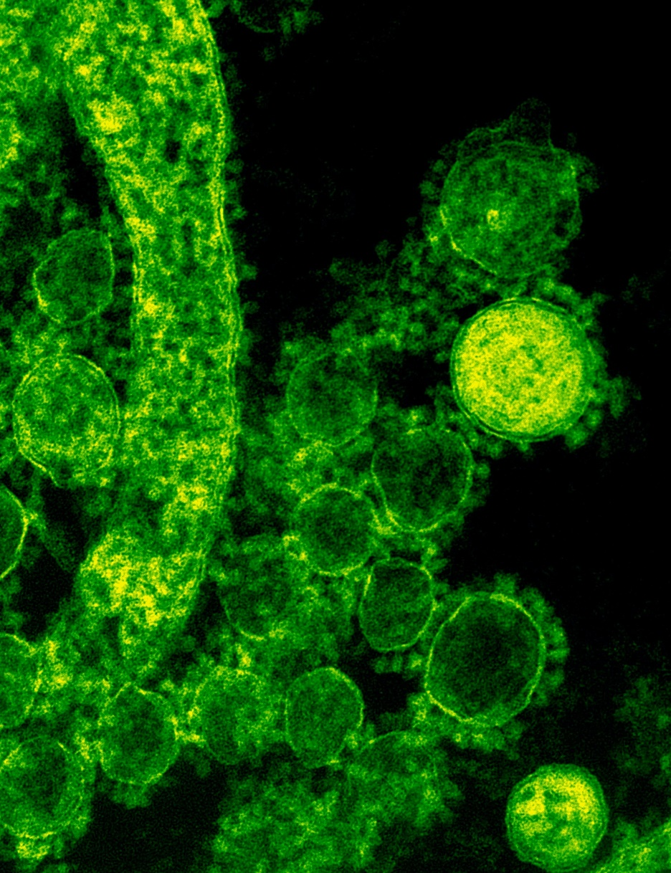

Name:

Grade:

Employer:
Introduction
Welcome to the Ambulance CPD Workbook. When filling out this workbook, to get the most out of your CPD, try and use multiple reputable/peer reviewed sources to fill in your answers. Try to provide references for your answers or links to where you gathered your information. If you need to add more space for your work, you can print out more copies or add information to the notes section.

Question 1: Discuss what is a virus:
………………………………………………………………………………………………………………………….
………………………………………………………………………………………………………………………….
………………………………………………………………………………………………………………………….
………………………………………………………………………………………………………………………….
………………………………………………………………………………………………………………………….
………………………………………………………………………………………………………………………….
………………………………………………………………………………………………………………………….
………………………………………………………………………………………………………………………….
………………………………………………………………………………………………………………………….
………………………………………………………………………………………………………………………….

Question 2: What are the differences between a virus and bacteria:
………………………………………………………………………………………………………………………….
………………………………………………………………………………………………………………………….
………………………………………………………………………………………………………………………….
………………………………………………………………………………………………………………………….
………………………………………………………………………………………………………………………….
………………………………………………………………………………………………………………………….
………………………………………………………………………………………………………………………….
………………………………………………………………………………………………………………………….
………………………………………………………………………………………………………………………….
………………………………………………………………………………………………………………………….

Question 3: How does a virus spread within the body:
………………………………………………………………………………………………………………………….
………………………………………………………………………………………………………………………….
………………………………………………………………………………………………………………………….
………………………………………………………………………………………………………………………….
………………………………………………………………………………………………………………………….
………………………………………………………………………………………………………………………….
………………………………………………………………………………………………………………………….
………………………………………………………………………………………………………………………….
………………………………………………………………………………………………………………………….
………………………………………………………………………………………………………………………….

Question 4: What treatments are available for viruses?
………………………………………………………………………………………………………………………….
………………………………………………………………………………………………………………………….
………………………………………………………………………………………………………………………….
………………………………………………………………………………………………………………………….
………………………………………………………………………………………………………………………….
………………………………………………………………………………………………………………………….
………………………………………………………………………………………………………………………….
………………………………………………………………………………………………………………………….
………………………………………………………………………………………………………………………….
………………………………………………………………………………………………………………………….

Discuss the following viruses looking at how they affect the body, how they spread, what are their death rates/illness percentages, and what treatments are available for them

Question 5: Marburg Virus:
………………………………………………………………………………………………………………………….
………………………………………………………………………………………………………………………….
………………………………………………………………………………………………………………………….
………………………………………………………………………………………………………………………….
………………………………………………………………………………………………………………………….
………………………………………………………………………………………………………………………….
………………………………………………………………………………………………………………………….
………………………………………………………………………………………………………………………….
………………………………………………………………………………………………………………………….
………………………………………………………………………………………………………………………….

Question 6: Ebola Virus:
………………………………………………………………………………………………………………………….
………………………………………………………………………………………………………………………….
………………………………………………………………………………………………………………………….
………………………………………………………………………………………………………………………….
………………………………………………………………………………………………………………………….
………………………………………………………………………………………………………………………….
………………………………………………………………………………………………………………………….
………………………………………………………………………………………………………………………….
………………………………………………………………………………………………………………………….
………………………………………………………………………………………………………………………….

Question 7: Rabies Virus:
………………………………………………………………………………………………………………………….
………………………………………………………………………………………………………………………….
………………………………………………………………………………………………………………………….
………………………………………………………………………………………………………………………….
………………………………………………………………………………………………………………………….
………………………………………………………………………………………………………………………….
………………………………………………………………………………………………………………………….
………………………………………………………………………………………………………………………….
………………………………………………………………………………………………………………………….
………………………………………………………………………………………………………………………….

Question 8: Human Immunodeficiency Virus (HIV):
………………………………………………………………………………………………………………………….
………………………………………………………………………………………………………………………….
………………………………………………………………………………………………………………………….
………………………………………………………………………………………………………………………….
………………………………………………………………………………………………………………………….
………………………………………………………………………………………………………………………….
………………………………………………………………………………………………………………………….
………………………………………………………………………………………………………………………….
………………………………………………………………………………………………………………………….
………………………………………………………………………………………………………………………….
Question 9: Smallpox Virus:
………………………………………………………………………………………………………………………….
………………………………………………………………………………………………………………………….
………………………………………………………………………………………………………………………….
………………………………………………………………………………………………………………………….
………………………………………………………………………………………………………………………….
………………………………………………………………………………………………………………………….
………………………………………………………………………………………………………………………….
………………………………………………………………………………………………………………………….
………………………………………………………………………………………………………………………….
………………………………………………………………………………………………………………………….

Question 10: Hantavirus:
………………………………………………………………………………………………………………………….
………………………………………………………………………………………………………………………….
………………………………………………………………………………………………………………………….
………………………………………………………………………………………………………………………….
………………………………………………………………………………………………………………………….
………………………………………………………………………………………………………………………….
………………………………………………………………………………………………………………………….
………………………………………………………………………………………………………………………….
………………………………………………………………………………………………………………………….
………………………………………………………………………………………………………………………….

Question 11: Influenza Virus
………………………………………………………………………………………………………………………….
………………………………………………………………………………………………………………………….
………………………………………………………………………………………………………………………….
………………………………………………………………………………………………………………………….
………………………………………………………………………………………………………………………….
………………………………………………………………………………………………………………………….
………………………………………………………………………………………………………………………….
………………………………………………………………………………………………………………………….
………………………………………………………………………………………………………………………….
………………………………………………………………………………………………………………………….

Question 12: Dengue Virus:
………………………………………………………………………………………………………………………….
………………………………………………………………………………………………………………………….
………………………………………………………………………………………………………………………….
………………………………………………………………………………………………………………………….
………………………………………………………………………………………………………………………….
………………………………………………………………………………………………………………………….
………………………………………………………………………………………………………………………….
………………………………………………………………………………………………………………………….
………………………………………………………………………………………………………………………….
………………………………………………………………………………………………………………………….

Question 13: Rotavirus:
………………………………………………………………………………………………………………………….
………………………………………………………………………………………………………………………….
………………………………………………………………………………………………………………………….
………………………………………………………………………………………………………………………….
………………………………………………………………………………………………………………………….
………………………………………………………………………………………………………………………….
………………………………………………………………………………………………………………………….
………………………………………………………………………………………………………………………….
………………………………………………………………………………………………………………………….
………………………………………………………………………………………………………………………….

Question 14: SARS-CoV:
………………………………………………………………………………………………………………………….
………………………………………………………………………………………………………………………….
………………………………………………………………………………………………………………………….
………………………………………………………………………………………………………………………….
………………………………………………………………………………………………………………………….
………………………………………………………………………………………………………………………….
………………………………………………………………………………………………………………………….
………………………………………………………………………………………………………………………….
………………………………………………………………………………………………………………………….
………………………………………………………………………………………………………………………….

Question 15: SARS-CoV-2:
………………………………………………………………………………………………………………………….
………………………………………………………………………………………………………………………….
………………………………………………………………………………………………………………………….
………………………………………………………………………………………………………………………….
………………………………………………………………………………………………………………………….
………………………………………………………………………………………………………………………….
………………………………………………………………………………………………………………………….
………………………………………………………………………………………………………………………….
………………………………………………………………………………………………………………………….
………………………………………………………………………………………………………………………….

Question 16: MERS-CoV:
………………………………………………………………………………………………………………………….
………………………………………………………………………………………………………………………….
………………………………………………………………………………………………………………………….
………………………………………………………………………………………………………………………….
………………………………………………………………………………………………………………………….
………………………………………………………………………………………………………………………….
………………………………………………………………………………………………………………………….
………………………………………………………………………………………………………………………….
………………………………………………………………………………………………………………………….
………………………………………………………………………………………………………………………….

Notes:
………………………………………………………………………………………………………………………….
………………………………………………………………………………………………………………………….
………………………………………………………………………………………………………………………….
………………………………………………………………………………………………………………………….
………………………………………………………………………………………………………………………….
………………………………………………………………………………………………………………………….
………………………………………………………………………………………………………………………….
………………………………………………………………………………………………………………………….
………………………………………………………………………………………………………………………….
………………………………………………………………………………………………………………………….
………………………………………………………………………………………………………………………….
………………………………………………………………………………………………………………………….
………………………………………………………………………………………………………………………….
………………………………………………………………………………………………………………………….
………………………………………………………………………………………………………………………….
………………………………………………………………………………………………………………………….
………………………………………………………………………………………………………………………….
………………………………………………………………………………………………………………………….
………………………………………………………………………………………………………………………….
………………………………………………………………………………………………………………………….
………………………………………………………………………………………………………………………….
………………………………………………………………………………………………………………………….
………………………………………………………………………………………………………………………….
………………………………………………………………………………………………………………………….

