CBRN Workbook

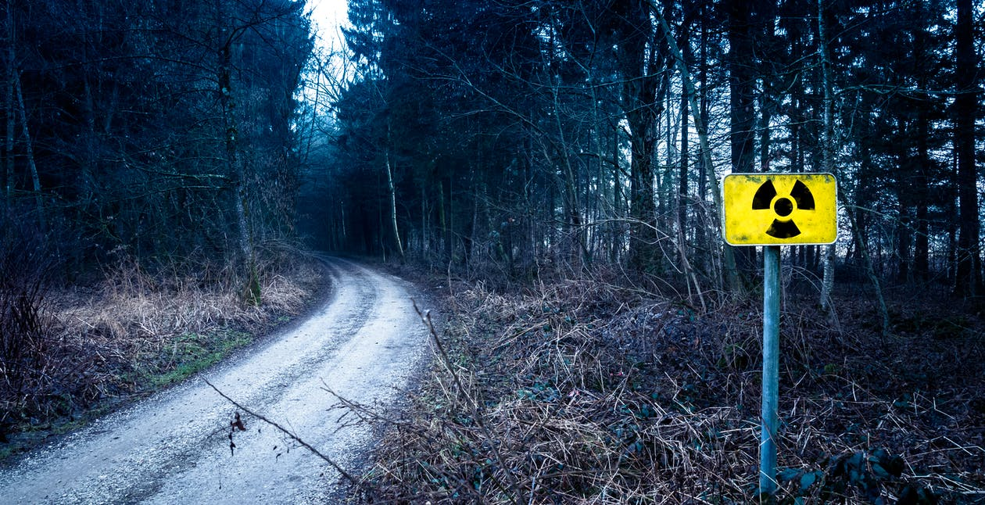

Name:

Grade:

Employer:

Introduction
Welcome to the Ambulance CPD Workbook. When filling out this workbook, to get the most out of your CPD, try and use multiple reputable/peer reviewed sources to fill in your answers. Try to provide references for your answers or links to where you gathered your information. If you need to add more space for your work, you can print out more copies or add information to the notes section.

Question 1: Briefly discuss what are the 4 different elements of CBRN:
………………………………………………………………………………………………………………………….
………………………………………………………………………………………………………………………….
………………………………………………………………………………………………………………………….
………………………………………………………………………………………………………………………….
………………………………………………………………………………………………………………………….
………………………………………………………………………………………………………………………….
………………………………………………………………………………………………………………………….
………………………………………………………………………………………………………………………….
………………………………………………………………………………………………………………………….
………………………………………………………………………………………………………………………….

Question 2: What are the differences between CBRN and HAZMAT incidents:
………………………………………………………………………………………………………………………….
………………………………………………………………………………………………………………………….
………………………………………………………………………………………………………………………….
………………………………………………………………………………………………………………………….
………………………………………………………………………………………………………………………….
………………………………………………………………………………………………………………………….
………………………………………………………………………………………………………………………….
………………………………………………………………………………………………………………………….
………………………………………………………………………………………………………………………….
………………………………………………………………………………………………………………………….

Question 3: Discuss what is a Nerve agent and how does it affect the body:
………………………………………………………………………………………………………………………….
………………………………………………………………………………………………………………………….
………………………………………………………………………………………………………………………….
………………………………………………………………………………………………………………………….
………………………………………………………………………………………………………………………….
………………………………………………………………………………………………………………………….
………………………………………………………………………………………………………………………….
………………………………………………………………………………………………………………………….
………………………………………………………………………………………………………………………….
………………………………………………………………………………………………………………………….

Question 4: Discuss what is a Blood agent and how does it affect the body:
………………………………………………………………………………………………………………………….
………………………………………………………………………………………………………………………….
………………………………………………………………………………………………………………………….
………………………………………………………………………………………………………………………….
………………………………………………………………………………………………………………………….
………………………………………………………………………………………………………………………….
………………………………………………………………………………………………………………………….
………………………………………………………………………………………………………………………….
………………………………………………………………………………………………………………………….
………………………………………………………………………………………………………………………….

Question 5: Discuss what is a Blister agent and how does it affect the body:
………………………………………………………………………………………………………………………….
………………………………………………………………………………………………………………………….
………………………………………………………………………………………………………………………….
………………………………………………………………………………………………………………………….
………………………………………………………………………………………………………………………….
………………………………………………………………………………………………………………………….
………………………………………………………………………………………………………………………….
………………………………………………………………………………………………………………………….
………………………………………………………………………………………………………………………….
………………………………………………………………………………………………………………………….

Question 6: What treatments are available for Nerve agent poisoning:
………………………………………………………………………………………………………………………….
………………………………………………………………………………………………………………………….
………………………………………………………………………………………………………………………….
………………………………………………………………………………………………………………………….
………………………………………………………………………………………………………………………….
………………………………………………………………………………………………………………………….
………………………………………………………………………………………………………………………….
………………………………………………………………………………………………………………………….
………………………………………………………………………………………………………………………….
………………………………………………………………………………………………………………………….

Question 7: What treatments are available for Blood agent poisoning:
………………………………………………………………………………………………………………………….
………………………………………………………………………………………………………………………….
………………………………………………………………………………………………………………………….
………………………………………………………………………………………………………………………….
………………………………………………………………………………………………………………………….
………………………………………………………………………………………………………………………….
………………………………………………………………………………………………………………………….
………………………………………………………………………………………………………………………….
………………………………………………………………………………………………………………………….
………………………………………………………………………………………………………………………….

Question 8: What treatments are available for Blister agent poisoning:
………………………………………………………………………………………………………………………….
………………………………………………………………………………………………………………………….
………………………………………………………………………………………………………………………….
………………………………………………………………………………………………………………………….
………………………………………………………………………………………………………………………….
………………………………………………………………………………………………………………………….
………………………………………………………………………………………………………………………….
………………………………………………………………………………………………………………………….
………………………………………………………………………………………………………………………….
………………………………………………………………………………………………………………………….
Question 9: Discuss examples of Biological agents:
………………………………………………………………………………………………………………………….
………………………………………………………………………………………………………………………….
………………………………………………………………………………………………………………………….
………………………………………………………………………………………………………………………….
………………………………………………………………………………………………………………………….
………………………………………………………………………………………………………………………….
………………………………………………………………………………………………………………………….
………………………………………………………………………………………………………………………….
………………………………………………………………………………………………………………………….
………………………………………………………………………………………………………………………….

Question 10: Discuss different methods of how agents could poison people:
………………………………………………………………………………………………………………………….
………………………………………………………………………………………………………………………….
………………………………………………………………………………………………………………………….
………………………………………………………………………………………………………………………….
………………………………………………………………………………………………………………………….
………………………………………………………………………………………………………………………….
………………………………………………………………………………………………………………………….
………………………………………………………………………………………………………………………….
………………………………………………………………………………………………………………………….
………………………………………………………………………………………………………………………….

Question 11: Discuss signs and symptoms of radiation poisoning:
………………………………………………………………………………………………………………………….
………………………………………………………………………………………………………………………….
………………………………………………………………………………………………………………………….
………………………………………………………………………………………………………………………….
………………………………………………………………………………………………………………………….
………………………………………………………………………………………………………………………….
………………………………………………………………………………………………………………………….
………………………………………………………………………………………………………………………….
………………………………………………………………………………………………………………………….
………………………………………………………………………………………………………………………….

Question 12: Discuss what treatments are available for Radiation poisoning:
………………………………………………………………………………………………………………………….
………………………………………………………………………………………………………………………….
………………………………………………………………………………………………………………………….
………………………………………………………………………………………………………………………….
………………………………………………………………………………………………………………………….
………………………………………………………………………………………………………………………….
………………………………………………………………………………………………………………………….
………………………………………………………………………………………………………………………….
………………………………………………………………………………………………………………………….
………………………………………………………………………………………………………………………….

Question 13: What are the risks of injury or death from a nuclear detonation:
………………………………………………………………………………………………………………………….
………………………………………………………………………………………………………………………….
………………………………………………………………………………………………………………………….
………………………………………………………………………………………………………………………….
………………………………………………………………………………………………………………………….
………………………………………………………………………………………………………………………….
………………………………………………………………………………………………………………………….
………………………………………………………………………………………………………………………….
………………………………………………………………………………………………………………………….
………………………………………………………………………………………………………………………….

Question 14: What is Steps123+ and how does it relate to CBRN:
………………………………………………………………………………………………………………………….
………………………………………………………………………………………………………………………….
………………………………………………………………………………………………………………………….
………………………………………………………………………………………………………………………….
………………………………………………………………………………………………………………………….
………………………………………………………………………………………………………………………….
………………………………………………………………………………………………………………………….
………………………………………………………………………………………………………………………….
………………………………………………………………………………………………………………………….
………………………………………………………………………………………………………………………….

Question 15: What procedures are in place for responding to a CBRN incident in your local Trust/Service:
………………………………………………………………………………………………………………………….
………………………………………………………………………………………………………………………….
………………………………………………………………………………………………………………………….
………………………………………………………………………………………………………………………….
………………………………………………………………………………………………………………………….
………………………………………………………………………………………………………………………….
………………………………………………………………………………………………………………………….
………………………………………………………………………………………………………………………….
………………………………………………………………………………………………………………………….
………………………………………………………………………………………………………………………….

Question 16: What are the capabilities of HART and how can they operate within a CBRN environment:
………………………………………………………………………………………………………………………….
………………………………………………………………………………………………………………………….
………………………………………………………………………………………………………………………….
………………………………………………………………………………………………………………………….
………………………………………………………………………………………………………………………….
………………………………………………………………………………………………………………………….
………………………………………………………………………………………………………………………….
………………………………………………………………………………………………………………………….
………………………………………………………………………………………………………………………….
………………………………………………………………………………………………………………………….

Notes:
………………………………………………………………………………………………………………………….
………………………………………………………………………………………………………………………….
………………………………………………………………………………………………………………………….
………………………………………………………………………………………………………………………….
………………………………………………………………………………………………………………………….
………………………………………………………………………………………………………………………….
………………………………………………………………………………………………………………………….
………………………………………………………………………………………………………………………….
………………………………………………………………………………………………………………………….
………………………………………………………………………………………………………………………….
………………………………………………………………………………………………………………………….
………………………………………………………………………………………………………………………….
………………………………………………………………………………………………………………………….
………………………………………………………………………………………………………………………….
………………………………………………………………………………………………………………………….
………………………………………………………………………………………………………………………….
………………………………………………………………………………………………………………………….
………………………………………………………………………………………………………………………….
………………………………………………………………………………………………………………………….
………………………………………………………………………………………………………………………….
………………………………………………………………………………………………………………………….
………………………………………………………………………………………………………………………….
………………………………………………………………………………………………………………………….
………………………………………………………………………………………………………………………….

