Rare Conditions Workbook No1

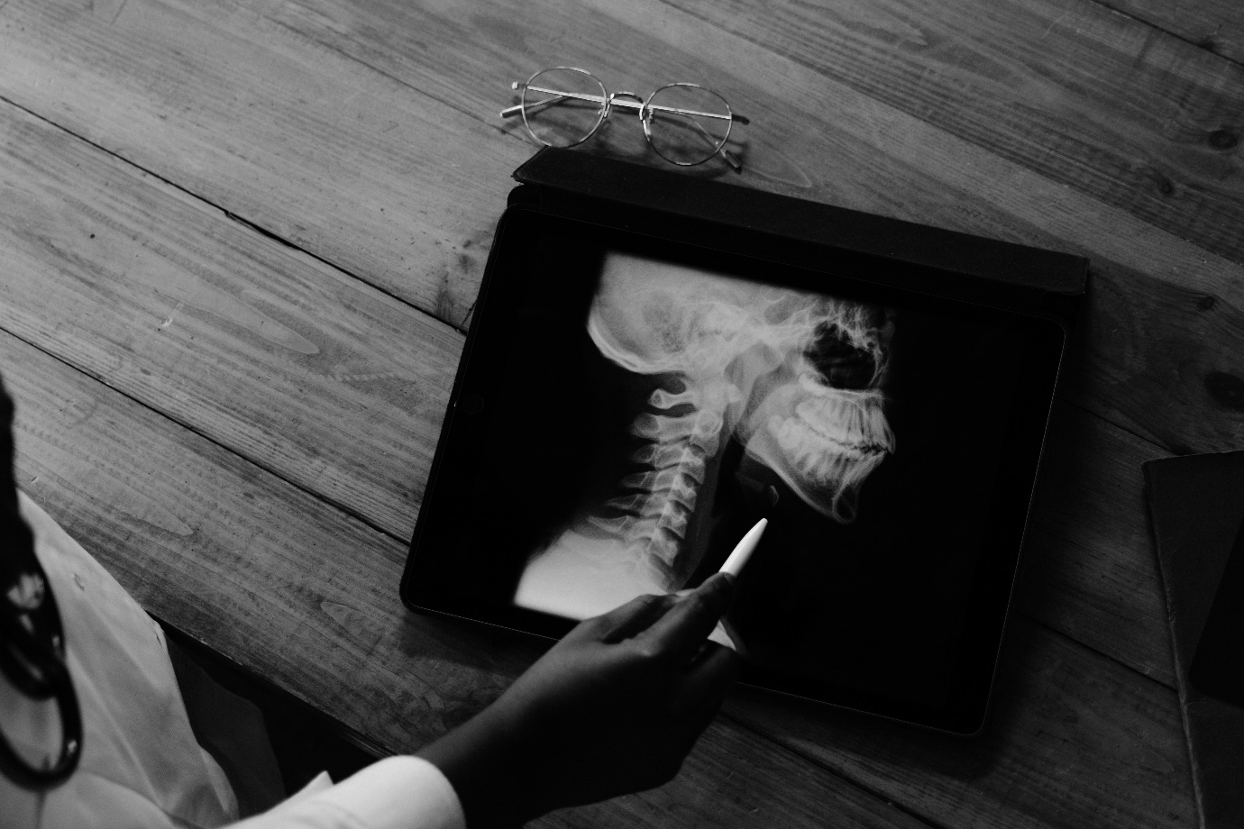

Name:

Grade:

Employer:
Introduction
Welcome to the Ambulance CPD Workbook. When filling out this workbook, to get the most out of your CPD, try and use multiple reputable/peer reviewed sources to fill in your answers. Try to provide references for your answers or links to where you gathered your information. If you need to add more space for your work, you can print out more copies or add information to the notes section.
With the following, discuss their Pathophysiology, Signs and Symptoms, and what Treatment (if any) is available: Addison’s Disease:
………………………………………………………………………………………………………………………….
………………………………………………………………………………………………………………………….
………………………………………………………………………………………………………………………….
………………………………………………………………………………………………………………………….
………………………………………………………………………………………………………………………….
………………………………………………………………………………………………………………………….
………………………………………………………………………………………………………………………….
………………………………………………………………………………………………………………………….
………………………………………………………………………………………………………………………….
………………………………………………………………………………………………………………………….………………………………………………………………………………………………………………………….
………………………………………………………………………………………………………………………….
………………………………………………………………………………………………………………………….………………………………………………………………………………………………………………………….
………………………………………………………………………………………………………………………….
………………………………………………………………………………………………………………………….………………………………………………………………………………………………………………………….
………………………………………………………………………………………………………………………….
………………………………………………………………………………………………………………………….
………………………………………………………………………………………………………………………….
Brugada Syndrome:
………………………………………………………………………………………………………………………….
………………………………………………………………………………………………………………………….
………………………………………………………………………………………………………………………….
………………………………………………………………………………………………………………………….
………………………………………………………………………………………………………………………….
………………………………………………………………………………………………………………………….
………………………………………………………………………………………………………………………….
………………………………………………………………………………………………………………………….
………………………………………………………………………………………………………………………….………………………………………………………………………………………………………………………….
………………………………………………………………………………………………………………………….
………………………………………………………………………………………………………………………….………………………………………………………………………………………………………………………….
………………………………………………………………………………………………………………………….
………………………………………………………………………………………………………………………….………………………………………………………………………………………………………………………….
………………………………………………………………………………………………………………………….
………………………………………………………………………………………………………………………….………………………………………………………………………………………………………………………….
………………………………………………………………………………………………………………………….
………………………………………………………………………………………………………………………….………………………………………………………………………………………………………………………….
………………………………………………………………………………………………………………………….
………………………………………………………………………………………………………………………….………………………………………………………………………………………………………………………….
………………………………………………………………………………………………………………………….………………………………………………………………………………………………………………………….
Cerebral Palsy:
………………………………………………………………………………………………………………………….
………………………………………………………………………………………………………………………….
………………………………………………………………………………………………………………………….
………………………………………………………………………………………………………………………….
………………………………………………………………………………………………………………………….
………………………………………………………………………………………………………………………….
………………………………………………………………………………………………………………………….
………………………………………………………………………………………………………………………….
………………………………………………………………………………………………………………………….
………………………………………………………………………………………………………………………….………………………………………………………………………………………………………………………….
………………………………………………………………………………………………………………………….
………………………………………………………………………………………………………………………….………………………………………………………………………………………………………………………….
………………………………………………………………………………………………………………………….
………………………………………………………………………………………………………………………….………………………………………………………………………………………………………………………….
………………………………………………………………………………………………………………………….
………………………………………………………………………………………………………………………….………………………………………………………………………………………………………………………….
………………………………………………………………………………………………………………………….
………………………………………………………………………………………………………………………….………………………………………………………………………………………………………………………….
………………………………………………………………………………………………………………………….
………………………………………………………………………………………………………………………….………………………………………………………………………………………………………………………….
………………………………………………………………………………………………………………………….
Delirium Tremens:
………………………………………………………………………………………………………………………….
………………………………………………………………………………………………………………………….
………………………………………………………………………………………………………………………….
………………………………………………………………………………………………………………………….
………………………………………………………………………………………………………………………….
………………………………………………………………………………………………………………………….
………………………………………………………………………………………………………………………….
………………………………………………………………………………………………………………………….
………………………………………………………………………………………………………………………….
………………………………………………………………………………………………………………………….………………………………………………………………………………………………………………………….
………………………………………………………………………………………………………………………….
………………………………………………………………………………………………………………………….………………………………………………………………………………………………………………………….
………………………………………………………………………………………………………………………….
………………………………………………………………………………………………………………………….………………………………………………………………………………………………………………………….
………………………………………………………………………………………………………………………….
………………………………………………………………………………………………………………………….………………………………………………………………………………………………………………………….
………………………………………………………………………………………………………………………….
………………………………………………………………………………………………………………………….………………………………………………………………………………………………………………………….
………………………………………………………………………………………………………………………….
………………………………………………………………………………………………………………………….………………………………………………………………………………………………………………………….
………………………………………………………………………………………………………………………….
Ehlers-Danlos Syndrome: ………………………………………………………………………………………………………………………….
………………………………………………………………………………………………………………………….
………………………………………………………………………………………………………………………….
………………………………………………………………………………………………………………………….
………………………………………………………………………………………………………………………….
………………………………………………………………………………………………………………………….
………………………………………………………………………………………………………………………….
………………………………………………………………………………………………………………………….
………………………………………………………………………………………………………………………….
………………………………………………………………………………………………………………………….………………………………………………………………………………………………………………………….
………………………………………………………………………………………………………………………….
………………………………………………………………………………………………………………………….………………………………………………………………………………………………………………………….
………………………………………………………………………………………………………………………….
………………………………………………………………………………………………………………………….………………………………………………………………………………………………………………………….
………………………………………………………………………………………………………………………….
………………………………………………………………………………………………………………………….………………………………………………………………………………………………………………………….
………………………………………………………………………………………………………………………….
………………………………………………………………………………………………………………………….………………………………………………………………………………………………………………………….
………………………………………………………………………………………………………………………….
………………………………………………………………………………………………………………………….………………………………………………………………………………………………………………………….
………………………………………………………………………………………………………………………….
Guillian-Barre Syndrome:
………………………………………………………………………………………………………………………….
………………………………………………………………………………………………………………………….
………………………………………………………………………………………………………………………….
………………………………………………………………………………………………………………………….
………………………………………………………………………………………………………………………….
………………………………………………………………………………………………………………………….
………………………………………………………………………………………………………………………….
………………………………………………………………………………………………………………………….
………………………………………………………………………………………………………………………….
………………………………………………………………………………………………………………………….………………………………………………………………………………………………………………………….
………………………………………………………………………………………………………………………….
………………………………………………………………………………………………………………………….………………………………………………………………………………………………………………………….
………………………………………………………………………………………………………………………….
………………………………………………………………………………………………………………………….………………………………………………………………………………………………………………………….
………………………………………………………………………………………………………………………….
………………………………………………………………………………………………………………………….………………………………………………………………………………………………………………………….
………………………………………………………………………………………………………………………….
………………………………………………………………………………………………………………………….………………………………………………………………………………………………………………………….
………………………………………………………………………………………………………………………….
………………………………………………………………………………………………………………………….………………………………………………………………………………………………………………………….
………………………………………………………………………………………………………………………….
Long QT Syndrome:
………………………………………………………………………………………………………………………….
………………………………………………………………………………………………………………………….
………………………………………………………………………………………………………………………….
………………………………………………………………………………………………………………………….
………………………………………………………………………………………………………………………….
………………………………………………………………………………………………………………………….
………………………………………………………………………………………………………………………….
………………………………………………………………………………………………………………………….
………………………………………………………………………………………………………………………….
………………………………………………………………………………………………………………………….………………………………………………………………………………………………………………………….
………………………………………………………………………………………………………………………….
………………………………………………………………………………………………………………………….………………………………………………………………………………………………………………………….
………………………………………………………………………………………………………………………….
………………………………………………………………………………………………………………………….………………………………………………………………………………………………………………………….
………………………………………………………………………………………………………………………….
………………………………………………………………………………………………………………………….………………………………………………………………………………………………………………………….
………………………………………………………………………………………………………………………….
………………………………………………………………………………………………………………………….………………………………………………………………………………………………………………………….
………………………………………………………………………………………………………………………….
………………………………………………………………………………………………………………………….………………………………………………………………………………………………………………………….
………………………………………………………………………………………………………………………….
Marfan Syndrome:
………………………………………………………………………………………………………………………….
………………………………………………………………………………………………………………………….
………………………………………………………………………………………………………………………….
………………………………………………………………………………………………………………………….
………………………………………………………………………………………………………………………….
………………………………………………………………………………………………………………………….
………………………………………………………………………………………………………………………….
………………………………………………………………………………………………………………………….
………………………………………………………………………………………………………………………….
………………………………………………………………………………………………………………………….………………………………………………………………………………………………………………………….
………………………………………………………………………………………………………………………….
………………………………………………………………………………………………………………………….………………………………………………………………………………………………………………………….
………………………………………………………………………………………………………………………….
………………………………………………………………………………………………………………………….………………………………………………………………………………………………………………………….
………………………………………………………………………………………………………………………….
………………………………………………………………………………………………………………………….………………………………………………………………………………………………………………………….
………………………………………………………………………………………………………………………….
………………………………………………………………………………………………………………………….………………………………………………………………………………………………………………………….
………………………………………………………………………………………………………………………….
………………………………………………………………………………………………………………………….………………………………………………………………………………………………………………………….
………………………………………………………………………………………………………………………….
Neutropenic Sepsis:
………………………………………………………………………………………………………………………….
………………………………………………………………………………………………………………………….
………………………………………………………………………………………………………………………….
………………………………………………………………………………………………………………………….
………………………………………………………………………………………………………………………….
………………………………………………………………………………………………………………………….
………………………………………………………………………………………………………………………….
………………………………………………………………………………………………………………………….
………………………………………………………………………………………………………………………….
………………………………………………………………………………………………………………………….………………………………………………………………………………………………………………………….
………………………………………………………………………………………………………………………….
………………………………………………………………………………………………………………………….………………………………………………………………………………………………………………………….
………………………………………………………………………………………………………………………….
………………………………………………………………………………………………………………………….………………………………………………………………………………………………………………………….
………………………………………………………………………………………………………………………….
………………………………………………………………………………………………………………………….………………………………………………………………………………………………………………………….
………………………………………………………………………………………………………………………….
………………………………………………………………………………………………………………………….………………………………………………………………………………………………………………………….
………………………………………………………………………………………………………………………….
………………………………………………………………………………………………………………………….………………………………………………………………………………………………………………………….
………………………………………………………………………………………………………………………….
Spontaneous Coronary Artery Dissection
………………………………………………………………………………………………………………………….
………………………………………………………………………………………………………………………….
………………………………………………………………………………………………………………………….
………………………………………………………………………………………………………………………….
………………………………………………………………………………………………………………………….
………………………………………………………………………………………………………………………….
………………………………………………………………………………………………………………………….
………………………………………………………………………………………………………………………….
………………………………………………………………………………………………………………………….
………………………………………………………………………………………………………………………….………………………………………………………………………………………………………………………….
………………………………………………………………………………………………………………………….
………………………………………………………………………………………………………………………….………………………………………………………………………………………………………………………….
………………………………………………………………………………………………………………………….
………………………………………………………………………………………………………………………….………………………………………………………………………………………………………………………….
………………………………………………………………………………………………………………………….
………………………………………………………………………………………………………………………….………………………………………………………………………………………………………………………….
………………………………………………………………………………………………………………………….
………………………………………………………………………………………………………………………….………………………………………………………………………………………………………………………….
………………………………………………………………………………………………………………………….
………………………………………………………………………………………………………………………….………………………………………………………………………………………………………………………….
………………………………………………………………………………………………………………………….
Wernicke Encethalopathy:
………………………………………………………………………………………………………………………….
………………………………………………………………………………………………………………………….
………………………………………………………………………………………………………………………….
………………………………………………………………………………………………………………………….
………………………………………………………………………………………………………………………….
………………………………………………………………………………………………………………………….
………………………………………………………………………………………………………………………….
………………………………………………………………………………………………………………………….
………………………………………………………………………………………………………………………….
………………………………………………………………………………………………………………………….………………………………………………………………………………………………………………………….
………………………………………………………………………………………………………………………….
………………………………………………………………………………………………………………………….………………………………………………………………………………………………………………………….
………………………………………………………………………………………………………………………….
………………………………………………………………………………………………………………………….………………………………………………………………………………………………………………………….
………………………………………………………………………………………………………………………….
………………………………………………………………………………………………………………………….………………………………………………………………………………………………………………………….
………………………………………………………………………………………………………………………….
………………………………………………………………………………………………………………………….………………………………………………………………………………………………………………………….
………………………………………………………………………………………………………………………….
………………………………………………………………………………………………………………………….………………………………………………………………………………………………………………………….
………………………………………………………………………………………………………………………….
Notes:
………………………………………………………………………………………………………………………….
………………………………………………………………………………………………………………………….
………………………………………………………………………………………………………………………….
………………………………………………………………………………………………………………………….
………………………………………………………………………………………………………………………….
………………………………………………………………………………………………………………………….
………………………………………………………………………………………………………………………….
………………………………………………………………………………………………………………………….
………………………………………………………………………………………………………………………….
………………………………………………………………………………………………………………………….
………………………………………………………………………………………………………………………….
………………………………………………………………………………………………………………………….
………………………………………………………………………………………………………………………….
………………………………………………………………………………………………………………………….
………………………………………………………………………………………………………………………….
………………………………………………………………………………………………………………………….
………………………………………………………………………………………………………………………….
………………………………………………………………………………………………………………………….
………………………………………………………………………………………………………………………….
………………………………………………………………………………………………………………………….
………………………………………………………………………………………………………………………….
………………………………………………………………………………………………………………………….
………………………………………………………………………………………………………………………….
………………………………………………………………………………………………………………………….

