Circulatory System Workbook

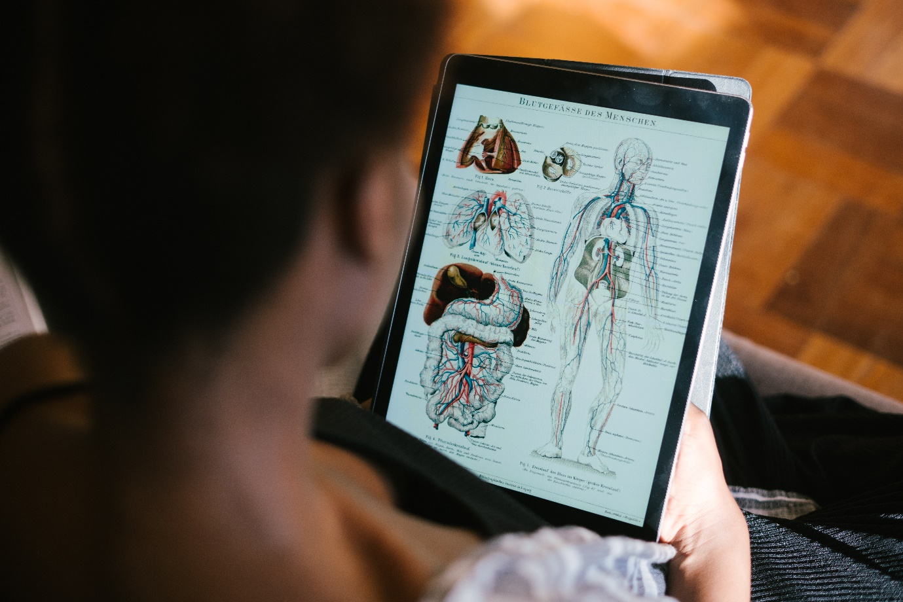

Name:

Grade:

Employer:

Introduction
Welcome to the Ambulance CPD Workbook. When filling out this workbook, to get the most out of your CPD, try and use multiple reputable/peer reviewed sources to fill in your answers. Try to provide references for your answers or links to where you gathered your information. If you need to add more space for your work, you can print out more copies or add information to the notes section.

Question 1: Discuss what are the functions of blood in the body:
………………………………………………………………………………………………………………………….
………………………………………………………………………………………………………………………….
………………………………………………………………………………………………………………………….
………………………………………………………………………………………………………………………….
………………………………………………………………………………………………………………………….
………………………………………………………………………………………………………………………….
………………………………………………………………………………………………………………………….
………………………………………………………………………………………………………………………….
………………………………………………………………………………………………………………………….
………………………………………………………………………………………………………………………….

Question 2: Discuss what is the composition of blood and what role does each element play:
………………………………………………………………………………………………………………………….
………………………………………………………………………………………………………………………….
………………………………………………………………………………………………………………………….
………………………………………………………………………………………………………………………….
………………………………………………………………………………………………………………………….
………………………………………………………………………………………………………………………….
………………………………………………………………………………………………………………………….
………………………………………………………………………………………………………………………….
………………………………………………………………………………………………………………………….
………………………………………………………………………………………………………………………….

Question 3: Discuss what blood groups are there and why it is important in the context of transfusion:
………………………………………………………………………………………………………………………….
………………………………………………………………………………………………………………………….
………………………………………………………………………………………………………………………….
………………………………………………………………………………………………………………………….
………………………………………………………………………………………………………………………….
………………………………………………………………………………………………………………………….
………………………………………………………………………………………………………………………….
………………………………………………………………………………………………………………………….
………………………………………………………………………………………………………………………….
………………………………………………………………………………………………………………………….

Question 4: Discuss what is blood pressure and what are the Systolic and Diastolic stages:
………………………………………………………………………………………………………………………….
………………………………………………………………………………………………………………………….
………………………………………………………………………………………………………………………….
………………………………………………………………………………………………………………………….
………………………………………………………………………………………………………………………….
………………………………………………………………………………………………………………………….
………………………………………………………………………………………………………………………….
………………………………………………………………………………………………………………………….
………………………………………………………………………………………………………………………….
………………………………………………………………………………………………………………………….

Question 5: Discuss the flow of blood through the body starting with the Left Ventricle:
………………………………………………………………………………………………………………………….
………………………………………………………………………………………………………………………….
………………………………………………………………………………………………………………………….
………………………………………………………………………………………………………………………….
………………………………………………………………………………………………………………………….
………………………………………………………………………………………………………………………….
………………………………………………………………………………………………………………………….
………………………………………………………………………………………………………………………….
………………………………………………………………………………………………………………………….
………………………………………………………………………………………………………………………….

Question 6: Discuss why the left side of the heart is larger than the right:
………………………………………………………………………………………………………………………….
………………………………………………………………………………………………………………………….
………………………………………………………………………………………………………………………….
………………………………………………………………………………………………………………………….
………………………………………………………………………………………………………………………….
………………………………………………………………………………………………………………………….
………………………………………………………………………………………………………………………….
………………………………………………………………………………………………………………………….
………………………………………………………………………………………………………………………….
………………………………………………………………………………………………………………………….

Question 7: Discuss the layers of the heart:
………………………………………………………………………………………………………………………….
………………………………………………………………………………………………………………………….
………………………………………………………………………………………………………………………….
………………………………………………………………………………………………………………………….
………………………………………………………………………………………………………………………….
………………………………………………………………………………………………………………………….
………………………………………………………………………………………………………………………….
………………………………………………………………………………………………………………………….
………………………………………………………………………………………………………………………….
………………………………………………………………………………………………………………………….

Question 8: Discuss the Coronary artery system:
………………………………………………………………………………………………………………………….
………………………………………………………………………………………………………………………….
………………………………………………………………………………………………………………………….
………………………………………………………………………………………………………………………….
………………………………………………………………………………………………………………………….
………………………………………………………………………………………………………………………….
………………………………………………………………………………………………………………………….
………………………………………………………………………………………………………………………….
………………………………………………………………………………………………………………………….
………………………………………………………………………………………………………………………….

Question 9: Discuss the flow of electrical activity through the heart:
………………………………………………………………………………………………………………………….
………………………………………………………………………………………………………………………….
………………………………………………………………………………………………………………………….
………………………………………………………………………………………………………………………….
………………………………………………………………………………………………………………………….
………………………………………………………………………………………………………………………….
………………………………………………………………………………………………………………………….
………………………………………………………………………………………………………………………….
………………………………………………………………………………………………………………………….
………………………………………………………………………………………………………………………….

Question 10: Discuss the differences between arteries and veins:
………………………………………………………………………………………………………………………….
………………………………………………………………………………………………………………………….
………………………………………………………………………………………………………………………….
………………………………………………………………………………………………………………………….
………………………………………………………………………………………………………………………….
………………………………………………………………………………………………………………………….
………………………………………………………………………………………………………………………….
………………………………………………………………………………………………………………………….
………………………………………………………………………………………………………………………….
………………………………………………………………………………………………………………………….

Question 11: Discuss the aorta and its’ off-branching arteries:
………………………………………………………………………………………………………………………….
………………………………………………………………………………………………………………………….
………………………………………………………………………………………………………………………….
………………………………………………………………………………………………………………………….
………………………………………………………………………………………………………………………….
………………………………………………………………………………………………………………………….
………………………………………………………………………………………………………………………….
………………………………………………………………………………………………………………………….
………………………………………………………………………………………………………………………….
………………………………………………………………………………………………………………………….

Question 12: Discuss the gaseous exchange that takes place between capillaries:
………………………………………………………………………………………………………………………….
………………………………………………………………………………………………………………………….
………………………………………………………………………………………………………………………….
………………………………………………………………………………………………………………………….
………………………………………………………………………………………………………………………….
………………………………………………………………………………………………………………………….
………………………………………………………………………………………………………………………….
………………………………………………………………………………………………………………………….
………………………………………………………………………………………………………………………….
………………………………………………………………………………………………………………………….

Notes:
………………………………………………………………………………………………………………………….
………………………………………………………………………………………………………………………….
………………………………………………………………………………………………………………………….
………………………………………………………………………………………………………………………….
………………………………………………………………………………………………………………………….
………………………………………………………………………………………………………………………….
………………………………………………………………………………………………………………………….
………………………………………………………………………………………………………………………….
………………………………………………………………………………………………………………………….
………………………………………………………………………………………………………………………….
………………………………………………………………………………………………………………………….
………………………………………………………………………………………………………………………….
………………………………………………………………………………………………………………………….
………………………………………………………………………………………………………………………….
………………………………………………………………………………………………………………………….
………………………………………………………………………………………………………………………….
………………………………………………………………………………………………………………………….
………………………………………………………………………………………………………………………….
………………………………………………………………………………………………………………………….
………………………………………………………………………………………………………………………….
………………………………………………………………………………………………………………………….
………………………………………………………………………………………………………………………….
………………………………………………………………………………………………………………………….
………………………………………………………………………………………………………………………….
………………………………………………………………………………………………………………………….

