Trauma Workbook

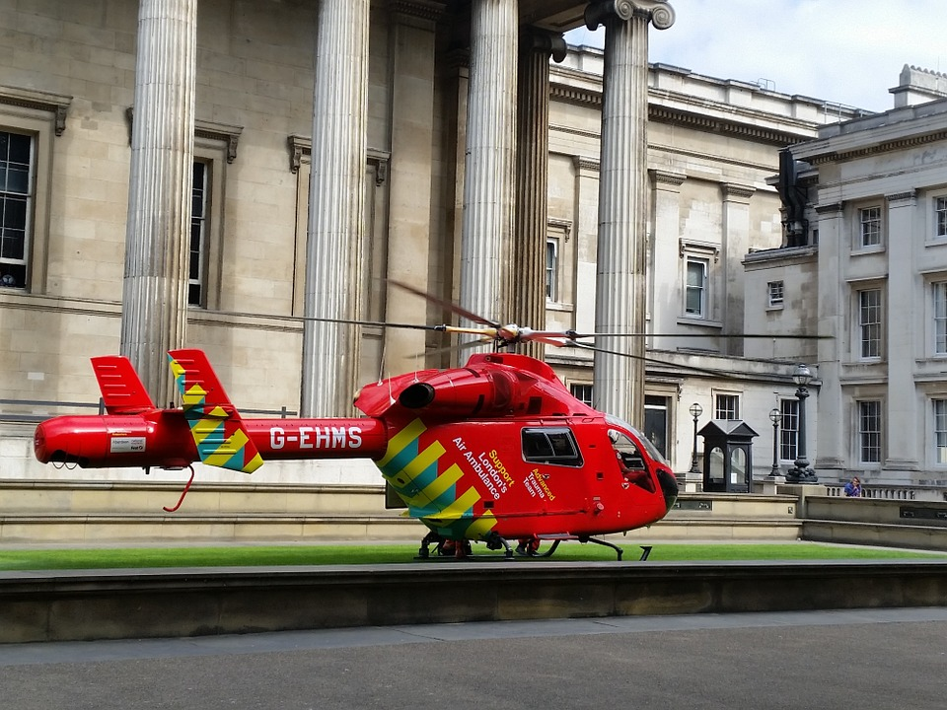

Name:

Grade:

Employer:

Introduction
Welcome to the Ambulance CPD Workbook. When filling out this workbook, to get the most out of your CPD, try and use multiple reputable/peer reviewed sources to fill in your answers. Try to provide references for your answers or links to where you gathered your information. If you need to add more space for your work, you can print out more copies or add information to the notes section.

Question 1: Discuss what is trauma:
………………………………………………………………………………………………………………………….
………………………………………………………………………………………………………………………….
………………………………………………………………………………………………………………………….
………………………………………………………………………………………………………………………….
………………………………………………………………………………………………………………………….
………………………………………………………………………………………………………………………….
………………………………………………………………………………………………………………………….
………………………………………………………………………………………………………………………….
………………………………………………………………………………………………………………………….
………………………………………………………………………………………………………………………….

Question 2: How can blunt trauma vary from penetrating trauma:
………………………………………………………………………………………………………………………….
………………………………………………………………………………………………………………………….
………………………………………………………………………………………………………………………….
………………………………………………………………………………………………………………………….
………………………………………………………………………………………………………………………….
………………………………………………………………………………………………………………………….
………………………………………………………………………………………………………………………….
………………………………………………………………………………………………………………………….
………………………………………………………………………………………………………………………….
………………………………………………………………………………………………………………………….

Question 3: What is the lethal triad in the context of trauma:
………………………………………………………………………………………………………………………….
………………………………………………………………………………………………………………………….
………………………………………………………………………………………………………………………….
………………………………………………………………………………………………………………………….
………………………………………………………………………………………………………………………….
………………………………………………………………………………………………………………………….
………………………………………………………………………………………………………………………….
………………………………………………………………………………………………………………………….
………………………………………………………………………………………………………………………….
………………………………………………………………………………………………………………………….

Question 4: Discuss the Hypothermia’s effect in the lethal triad and what can be done to prevent it:
………………………………………………………………………………………………………………………….
………………………………………………………………………………………………………………………….
………………………………………………………………………………………………………………………….
………………………………………………………………………………………………………………………….
………………………………………………………………………………………………………………………….
………………………………………………………………………………………………………………………….
………………………………………………………………………………………………………………………….
………………………………………………………………………………………………………………………….
………………………………………………………………………………………………………………………….
………………………………………………………………………………………………………………………….

Question 5: Discuss the Acidosis’s effect in the lethal triad and what can be done to prevent it:
………………………………………………………………………………………………………………………….
………………………………………………………………………………………………………………………….
………………………………………………………………………………………………………………………….
………………………………………………………………………………………………………………………….
………………………………………………………………………………………………………………………….
………………………………………………………………………………………………………………………….
………………………………………………………………………………………………………………………….
………………………………………………………………………………………………………………………….
………………………………………………………………………………………………………………………….
………………………………………………………………………………………………………………………….

Question 6: Discuss the Coagulopathy’s effect in the lethal triad and what can be done to prevent it:
………………………………………………………………………………………………………………………….
………………………………………………………………………………………………………………………….
………………………………………………………………………………………………………………………….
………………………………………………………………………………………………………………………….
………………………………………………………………………………………………………………………….
………………………………………………………………………………………………………………………….
………………………………………………………………………………………………………………………….
………………………………………………………………………………………………………………………….
………………………………………………………………………………………………………………………….
………………………………………………………………………………………………………………………….

Question 7: What key treatments should be considered in a critical trauma patient:
………………………………………………………………………………………………………………………….
………………………………………………………………………………………………………………………….
………………………………………………………………………………………………………………………….
………………………………………………………………………………………………………………………….
………………………………………………………………………………………………………………………….
………………………………………………………………………………………………………………………….
………………………………………………………………………………………………………………………….
………………………………………………………………………………………………………………………….
………………………………………………………………………………………………………………………….
………………………………………………………………………………………………………………………….

Question 8: What decision should be made to ‘stay and play’ vs ‘load and go’ in the trauma context:
………………………………………………………………………………………………………………………….
………………………………………………………………………………………………………………………….
………………………………………………………………………………………………………………………….
………………………………………………………………………………………………………………………….
………………………………………………………………………………………………………………………….
………………………………………………………………………………………………………………………….
………………………………………………………………………………………………………………………….
………………………………………………………………………………………………………………………….
………………………………………………………………………………………………………………………….
………………………………………………………………………………………………………………………….

Question 9: How can traumatic cardiac arrest be different from medical cardiac arrest:
………………………………………………………………………………………………………………………….
………………………………………………………………………………………………………………………….
………………………………………………………………………………………………………………………….
………………………………………………………………………………………………………………………….
………………………………………………………………………………………………………………………….
………………………………………………………………………………………………………………………….
………………………………………………………………………………………………………………………….
………………………………………………………………………………………………………………………….
………………………………………………………………………………………………………………………….
………………………………………………………………………………………………………………………….

Question 10: Discuss what main areas of internal haemorrhage there may be and what can be done to help treat:
………………………………………………………………………………………………………………………….
………………………………………………………………………………………………………………………….
………………………………………………………………………………………………………………………….
………………………………………………………………………………………………………………………….
………………………………………………………………………………………………………………………….
………………………………………………………………………………………………………………………….
………………………………………………………………………………………………………………………….
………………………………………………………………………………………………………………………….
………………………………………………………………………………………………………………………….
………………………………………………………………………………………………………………………….

Question 11: Discuss the actions of Tranexamic Acid and how it can be beneficial to a trauma patient:
………………………………………………………………………………………………………………………….
………………………………………………………………………………………………………………………….
………………………………………………………………………………………………………………………….
………………………………………………………………………………………………………………………….
………………………………………………………………………………………………………………………….
………………………………………………………………………………………………………………………….
………………………………………………………………………………………………………………………….
………………………………………………………………………………………………………………………….
………………………………………………………………………………………………………………………….
………………………………………………………………………………………………………………………….

Question 12: Discuss the administration of IV fluids in a trauma patient and what cautions should you be aware of: ………………………………………………………………………………………………………………………….
………………………………………………………………………………………………………………………….
………………………………………………………………………………………………………………………….
………………………………………………………………………………………………………………………….
………………………………………………………………………………………………………………………….
………………………………………………………………………………………………………………………….
………………………………………………………………………………………………………………………….
………………………………………………………………………………………………………………………….
………………………………………………………………………………………………………………………….
………………………………………………………………………………………………………………………….

Question 13: Discuss the benefits of Major Trauma Centres and when would you bypass a general A & E:
………………………………………………………………………………………………………………………….
………………………………………………………………………………………………………………………….
………………………………………………………………………………………………………………………….
………………………………………………………………………………………………………………………….
………………………………………………………………………………………………………………………….
………………………………………………………………………………………………………………………….
………………………………………………………………………………………………………………………….
………………………………………………………………………………………………………………………….
………………………………………………………………………………………………………………………….
………………………………………………………………………………………………………………………….

Question 14: Discuss what advanced skills and support could you request during difficult traumatic incidents:
………………………………………………………………………………………………………………………….
………………………………………………………………………………………………………………………….
………………………………………………………………………………………………………………………….
………………………………………………………………………………………………………………………….
………………………………………………………………………………………………………………………….
………………………………………………………………………………………………………………………….
………………………………………………………………………………………………………………………….
………………………………………………………………………………………………………………………….
………………………………………………………………………………………………………………………….
………………………………………………………………………………………………………………………….

Notes:
………………………………………………………………………………………………………………………….
………………………………………………………………………………………………………………………….
………………………………………………………………………………………………………………………….
………………………………………………………………………………………………………………………….
………………………………………………………………………………………………………………………….
………………………………………………………………………………………………………………………….
………………………………………………………………………………………………………………………….
………………………………………………………………………………………………………………………….
………………………………………………………………………………………………………………………….
………………………………………………………………………………………………………………………….
………………………………………………………………………………………………………………………….
………………………………………………………………………………………………………………………….
………………………………………………………………………………………………………………………….
………………………………………………………………………………………………………………………….
………………………………………………………………………………………………………………………….
………………………………………………………………………………………………………………………….
………………………………………………………………………………………………………………………….
………………………………………………………………………………………………………………………….
………………………………………………………………………………………………………………………….
………………………………………………………………………………………………………………………….
………………………………………………………………………………………………………………………….
………………………………………………………………………………………………………………………….
………………………………………………………………………………………………………………………….
………………………………………………………………………………………………………………………….

