Cardiac Drug Workbook

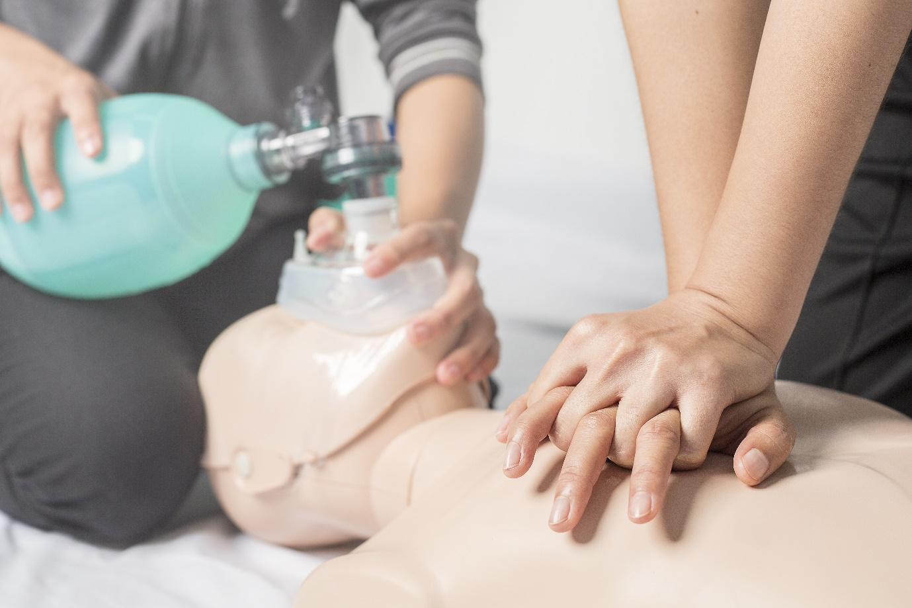

Name:

Grade:

Employer:

Introduction
Welcome to the Ambulance CPD Workbook. When filling out this workbook, to get the most out of your CPD, try and use multiple reputable/peer reviewed sources to fill in your answers. Try to provide references for your answers or links to where you gathered your information. If you need to add more space for your work, you can print out more copies or add information to the notes section.

Question 1: Discuss Aspirin works and how does it benefit a patient suffering from an Ischaemic Heart Disease/Myocardial Infarction event:
………………………………………………………………………………………………………………………….
………………………………………………………………………………………………………………………….
………………………………………………………………………………………………………………………….
………………………………………………………………………………………………………………………….
………………………………………………………………………………………………………………………….
………………………………………………………………………………………………………………………….
………………………………………………………………………………………………………………………….
………………………………………………………………………………………………………………………….
………………………………………………………………………………………………………………………….
………………………………………………………………………………………………………………………….

Question 2: Discuss the dosage of Aspirin in the above context, and what contra-indications are present:
………………………………………………………………………………………………………………………….
………………………………………………………………………………………………………………………….
………………………………………………………………………………………………………………………….
………………………………………………………………………………………………………………………….
………………………………………………………………………………………………………………………….
………………………………………………………………………………………………………………………….
………………………………………………………………………………………………………………………….
………………………………………………………………………………………………………………………….
………………………………………………………………………………………………………………………….
………………………………………………………………………………………………………………………….

Question 3: Discuss what effect GTN has and how does it benefit a patient suffering from an Ischaemic Heart Disease/Myocardial Infarction event:
………………………………………………………………………………………………………………………….
………………………………………………………………………………………………………………………….
………………………………………………………………………………………………………………………….
………………………………………………………………………………………………………………………….
………………………………………………………………………………………………………………………….
………………………………………………………………………………………………………………………….
………………………………………………………………………………………………………………………….
………………………………………………………………………………………………………………………….
………………………………………………………………………………………………………………………….
………………………………………………………………………………………………………………………….

Question 4: Discuss the dosage of GTN in the above context, and what contra-indications are present:
………………………………………………………………………………………………………………………….
………………………………………………………………………………………………………………………….
………………………………………………………………………………………………………………………….
………………………………………………………………………………………………………………………….
………………………………………………………………………………………………………………………….
………………………………………………………………………………………………………………………….
………………………………………………………………………………………………………………………….
………………………………………………………………………………………………………………………….
………………………………………………………………………………………………………………………….
………………………………………………………………………………………………………………………….

Question 5: Discuss what effect Atropine has and how does it benefit a patient suffering from bradycardia:
………………………………………………………………………………………………………………………….
………………………………………………………………………………………………………………………….
………………………………………………………………………………………………………………………….
………………………………………………………………………………………………………………………….
………………………………………………………………………………………………………………………….
………………………………………………………………………………………………………………………….
………………………………………………………………………………………………………………………….
………………………………………………………………………………………………………………………….
………………………………………………………………………………………………………………………….
………………………………………………………………………………………………………………………….

Question 6: Discuss the dosage of Atropine in the above context, and what contra-indications are present:
………………………………………………………………………………………………………………………….
………………………………………………………………………………………………………………………….
………………………………………………………………………………………………………………………….
………………………………………………………………………………………………………………………….
………………………………………………………………………………………………………………………….
………………………………………………………………………………………………………………………….
………………………………………………………………………………………………………………………….
………………………………………………………………………………………………………………………….
………………………………………………………………………………………………………………………….
………………………………………………………………………………………………………………………….

Question 7: Discuss what effect Morphine has and how does it benefit a patient suffering from an Ischaemic Heart Disease/Myocardial Infarction event:
………………………………………………………………………………………………………………………….
………………………………………………………………………………………………………………………….
………………………………………………………………………………………………………………………….
………………………………………………………………………………………………………………………….
………………………………………………………………………………………………………………………….
………………………………………………………………………………………………………………………….
………………………………………………………………………………………………………………………….
………………………………………………………………………………………………………………………….
………………………………………………………………………………………………………………………….
………………………………………………………………………………………………………………………….

Question 8: Discuss the dosage of Morphine in the above context, and what contra-indications are present:
………………………………………………………………………………………………………………………….
………………………………………………………………………………………………………………………….
………………………………………………………………………………………………………………………….
………………………………………………………………………………………………………………………….
………………………………………………………………………………………………………………………….
………………………………………………………………………………………………………………………….
………………………………………………………………………………………………………………………….
………………………………………………………………………………………………………………………….
………………………………………………………………………………………………………………………….
………………………………………………………………………………………………………………………….

Question 9: Discuss what effect Adrenaline 1:10000 has and how does it benefit a patient suffering from a cardiac arrest:
………………………………………………………………………………………………………………………….
………………………………………………………………………………………………………………………….
………………………………………………………………………………………………………………………….
………………………………………………………………………………………………………………………….
………………………………………………………………………………………………………………………….
………………………………………………………………………………………………………………………….
………………………………………………………………………………………………………………………….
………………………………………………………………………………………………………………………….
………………………………………………………………………………………………………………………….
………………………………………………………………………………………………………………………….

Question 10: Discuss what effect Amiodarone has and how does it benefit a patient suffering from a cardiac arrest:
………………………………………………………………………………………………………………………….
………………………………………………………………………………………………………………………….
………………………………………………………………………………………………………………………….
………………………………………………………………………………………………………………………….
………………………………………………………………………………………………………………………….
………………………………………………………………………………………………………………………….
………………………………………………………………………………………………………………………….
………………………………………………………………………………………………………………………….
Notes:
………………………………………………………………………………………………………………………….
………………………………………………………………………………………………………………………….
………………………………………………………………………………………………………………………….
………………………………………………………………………………………………………………………….
………………………………………………………………………………………………………………………….
………………………………………………………………………………………………………………………….
………………………………………………………………………………………………………………………….
………………………………………………………………………………………………………………………….
………………………………………………………………………………………………………………………….
………………………………………………………………………………………………………………………….
………………………………………………………………………………………………………………………….
………………………………………………………………………………………………………………………….
………………………………………………………………………………………………………………………….
………………………………………………………………………………………………………………………….
………………………………………………………………………………………………………………………….
………………………………………………………………………………………………………………………….
………………………………………………………………………………………………………………………….
………………………………………………………………………………………………………………………….
………………………………………………………………………………………………………………………….
………………………………………………………………………………………………………………………….
………………………………………………………………………………………………………………………….
………………………………………………………………………………………………………………………….
………………………………………………………………………………………………………………………….
………………………………………………………………………………………………………………………….

