Pelvic Trauma Workbook

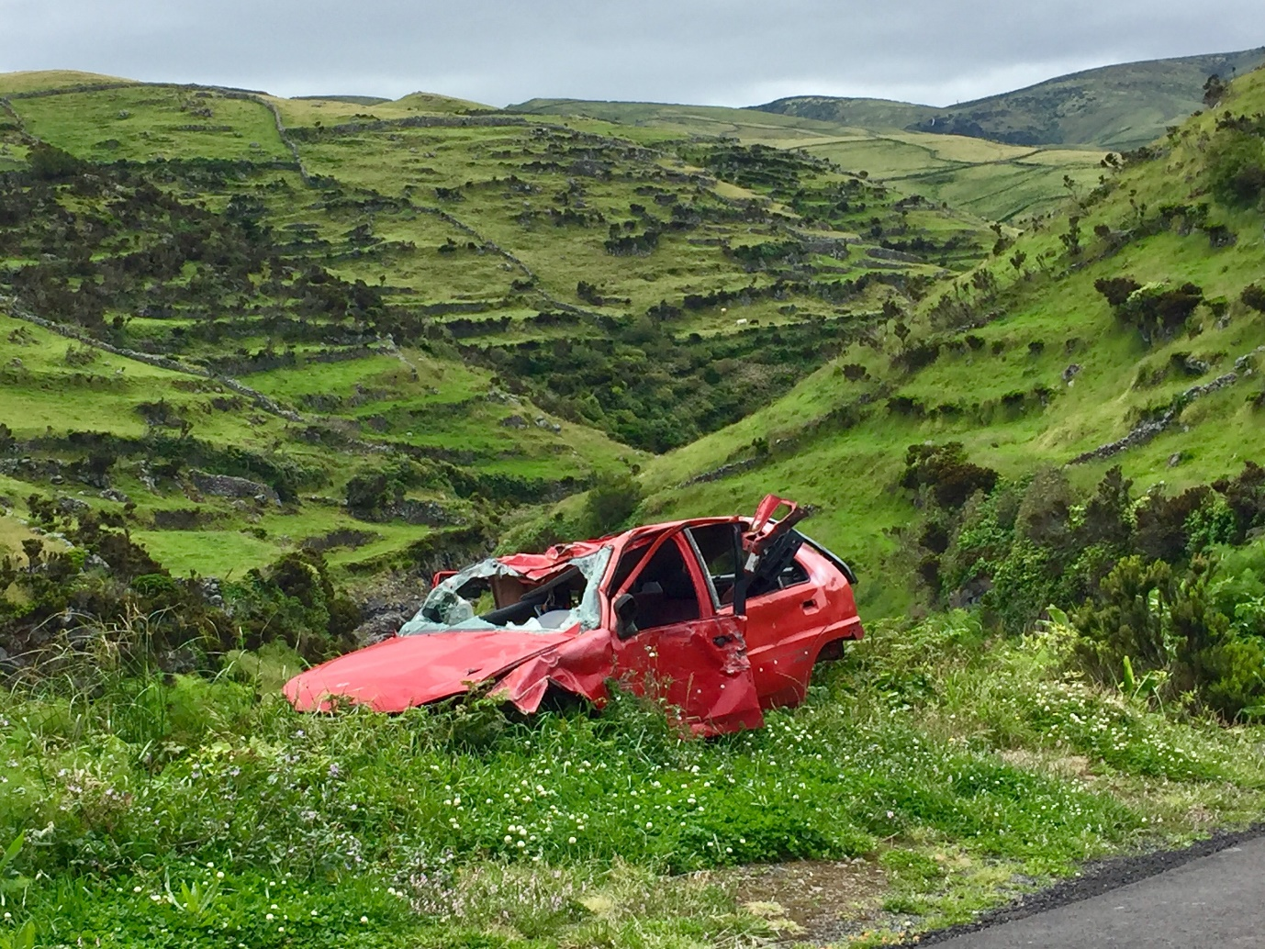

Name:

Grade:

Employer:

Introduction
Welcome to the Ambulance CPD Workbook. When filling out this workbook, to get the most out of your CPD, try and use multiple reputable/peer reviewed sources to fill in your answers. Try to provide references for your answers or links to where you gathered your information. If you need to add more space for your work, you can print out more copies or add information to the notes section.

Question 1: Discuss what organs and major blood vessels are contained within the pelvic area:
………………………………………………………………………………………………………………………….
………………………………………………………………………………………………………………………….
………………………………………………………………………………………………………………………….
………………………………………………………………………………………………………………………….
………………………………………………………………………………………………………………………….
………………………………………………………………………………………………………………………….
………………………………………………………………………………………………………………………….
………………………………………………………………………………………………………………………….
………………………………………………………………………………………………………………………….
………………………………………………………………………………………………………………………….

Question 2: Discuss what a Lateral Compression pelvic Fracture is:
………………………………………………………………………………………………………………………….
………………………………………………………………………………………………………………………….
………………………………………………………………………………………………………………………….
………………………………………………………………………………………………………………………….
………………………………………………………………………………………………………………………….
………………………………………………………………………………………………………………………….
………………………………………………………………………………………………………………………….
………………………………………………………………………………………………………………………….
………………………………………………………………………………………………………………………….
………………………………………………………………………………………………………………………….

Question 3: Discuss what an Anterior Posterior Compression Pelvic Fracture is:
………………………………………………………………………………………………………………………….
………………………………………………………………………………………………………………………….
………………………………………………………………………………………………………………………….
………………………………………………………………………………………………………………………….
………………………………………………………………………………………………………………………….
………………………………………………………………………………………………………………………….
………………………………………………………………………………………………………………………….
………………………………………………………………………………………………………………………….
………………………………………………………………………………………………………………………….
………………………………………………………………………………………………………………………….

Question 4: Discuss what a Lateral Shear Pelvic Fracture is:
………………………………………………………………………………………………………………………….
………………………………………………………………………………………………………………………….
………………………………………………………………………………………………………………………….
………………………………………………………………………………………………………………………….
………………………………………………………………………………………………………………………….
………………………………………………………………………………………………………………………….
………………………………………………………………………………………………………………………….
………………………………………………………………………………………………………………………….
………………………………………………………………………………………………………………………….
………………………………………………………………………………………………………………………….

Question 5: Discuss what a Combined Mechanical Pelvic Fracture is:
………………………………………………………………………………………………………………………….
………………………………………………………………………………………………………………………….
………………………………………………………………………………………………………………………….
………………………………………………………………………………………………………………………….
………………………………………………………………………………………………………………………….
………………………………………………………………………………………………………………………….
………………………………………………………………………………………………………………………….
………………………………………………………………………………………………………………………….
………………………………………………………………………………………………………………………….
………………………………………………………………………………………………………………………….

Question 6: Discuss what the complications and risks of a pelvic fracture are:
………………………………………………………………………………………………………………………….
………………………………………………………………………………………………………………………….
………………………………………………………………………………………………………………………….
………………………………………………………………………………………………………………………….
………………………………………………………………………………………………………………………….
………………………………………………………………………………………………………………………….
………………………………………………………………………………………………………………………….
………………………………………………………………………………………………………………………….
………………………………………………………………………………………………………………………….
………………………………………………………………………………………………………………………….

Question 7: Discuss what associated injuries may occur to a patient with a pelvic fracture:
………………………………………………………………………………………………………………………….
………………………………………………………………………………………………………………………….
………………………………………………………………………………………………………………………….
………………………………………………………………………………………………………………………….
………………………………………………………………………………………………………………………….
………………………………………………………………………………………………………………………….
………………………………………………………………………………………………………………………….
………………………………………………………………………………………………………………………….
………………………………………………………………………………………………………………………….
………………………………………………………………………………………………………………………….

Question 8: What are the signs and symptoms of a pelvic fracture:
………………………………………………………………………………………………………………………….
………………………………………………………………………………………………………………………….
………………………………………………………………………………………………………………………….
………………………………………………………………………………………………………………………….
………………………………………………………………………………………………………………………….
………………………………………………………………………………………………………………………….
………………………………………………………………………………………………………………………….
………………………………………………………………………………………………………………………….
………………………………………………………………………………………………………………………….
………………………………………………………………………………………………………………………….

Question 9: What would be your management of a patient with a pelvic fracture:
………………………………………………………………………………………………………………………….
………………………………………………………………………………………………………………………….
………………………………………………………………………………………………………………………….
………………………………………………………………………………………………………………………….
………………………………………………………………………………………………………………………….
………………………………………………………………………………………………………………………….
………………………………………………………………………………………………………………………….
………………………………………………………………………………………………………………………….
………………………………………………………………………………………………………………………….
………………………………………………………………………………………………………………………….

Question 10: Discuss how you would apply a pelvic binder and over what anatomical landmarks:
………………………………………………………………………………………………………………………….
………………………………………………………………………………………………………………………….
………………………………………………………………………………………………………………………….
………………………………………………………………………………………………………………………….
………………………………………………………………………………………………………………………….
………………………………………………………………………………………………………………………….
………………………………………………………………………………………………………………………….
………………………………………………………………………………………………………………………….
Notes:
………………………………………………………………………………………………………………………….
………………………………………………………………………………………………………………………….
………………………………………………………………………………………………………………………….
………………………………………………………………………………………………………………………….
………………………………………………………………………………………………………………………….
………………………………………………………………………………………………………………………….
………………………………………………………………………………………………………………………….
………………………………………………………………………………………………………………………….
………………………………………………………………………………………………………………………….
………………………………………………………………………………………………………………………….
………………………………………………………………………………………………………………………….
………………………………………………………………………………………………………………………….
………………………………………………………………………………………………………………………….
………………………………………………………………………………………………………………………….
………………………………………………………………………………………………………………………….
………………………………………………………………………………………………………………………….
………………………………………………………………………………………………………………………….
………………………………………………………………………………………………………………………….
………………………………………………………………………………………………………………………….
………………………………………………………………………………………………………………………….
………………………………………………………………………………………………………………………….
………………………………………………………………………………………………………………………….
………………………………………………………………………………………………………………………….
………………………………………………………………………………………………………………………….

