Facial Trauma Workbook

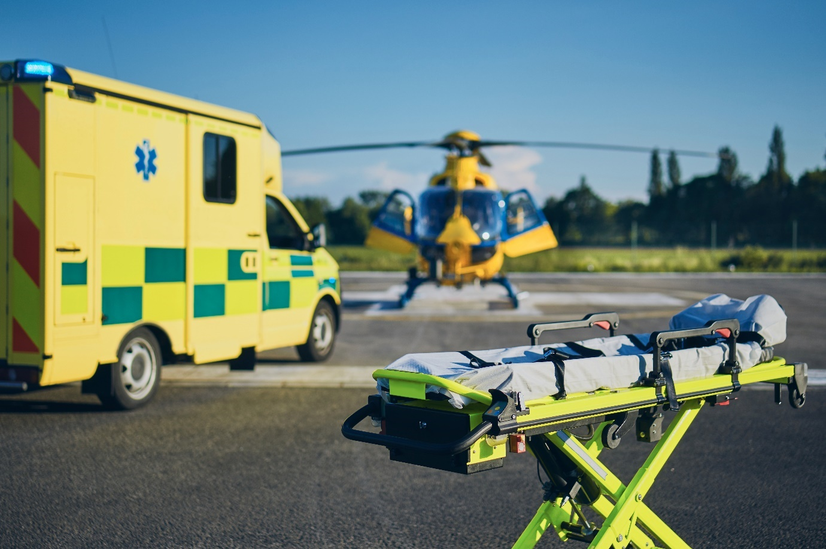

Name:

Grade:

Employer:

Introduction
Welcome to the Ambulance CPD Workbook. When filling out this workbook, to get the most out of your CPD, try and use multiple reputable/peer reviewed sources to fill in your answers. Try to provide references for your answers or links to where you gathered your information. If you need to add more space for your work, you can print out more copies or add information to the notes section.

Question 1: Discuss what are the signs and symptoms of a Nasal fracture and what complications can arise:
………………………………………………………………………………………………………………………….
………………………………………………………………………………………………………………………….
………………………………………………………………………………………………………………………….
………………………………………………………………………………………………………………………….
………………………………………………………………………………………………………………………….
………………………………………………………………………………………………………………………….
………………………………………………………………………………………………………………………….
………………………………………………………………………………………………………………………….
………………………………………………………………………………………………………………………….
………………………………………………………………………………………………………………………….

Question 2: The frontal bone is the main bone in the forehead. What signs and symptoms can arise from a frontal bone fracture and what complications may present:
………………………………………………………………………………………………………………………….
………………………………………………………………………………………………………………………….
………………………………………………………………………………………………………………………….
………………………………………………………………………………………………………………………….
………………………………………………………………………………………………………………………….
………………………………………………………………………………………………………………………….
………………………………………………………………………………………………………………………….
………………………………………………………………………………………………………………………….
………………………………………………………………………………………………………………………….
………………………………………………………………………………………………………………………….

Question 3: There are 3 types of orbital fractures; Orbital rim, Blowout, and Direct Orbital Floor fracture. Discuss each type:
………………………………………………………………………………………………………………………….
………………………………………………………………………………………………………………………….
………………………………………………………………………………………………………………………….
………………………………………………………………………………………………………………………….
………………………………………………………………………………………………………………………….
………………………………………………………………………………………………………………………….
………………………………………………………………………………………………………………………….
………………………………………………………………………………………………………………………….
………………………………………………………………………………………………………………………….
………………………………………………………………………………………………………………………….

Question 4: Discuss the signs and symptoms of a Zygomaticomaxillary fracture and what complications may present:
………………………………………………………………………………………………………………………….
………………………………………………………………………………………………………………………….
………………………………………………………………………………………………………………………….
………………………………………………………………………………………………………………………….
………………………………………………………………………………………………………………………….
………………………………………………………………………………………………………………………….
………………………………………………………………………………………………………………………….
………………………………………………………………………………………………………………………….
………………………………………………………………………………………………………………………….
………………………………………………………………………………………………………………………….

Question 5: There are 3 types of Le Fort fracture; Le Fort I, Le Fort II, and Le Fort III. Discuss each type:
………………………………………………………………………………………………………………………….
………………………………………………………………………………………………………………………….
………………………………………………………………………………………………………………………….
………………………………………………………………………………………………………………………….
………………………………………………………………………………………………………………………….
………………………………………………………………………………………………………………………….
………………………………………………………………………………………………………………………….
………………………………………………………………………………………………………………………….
………………………………………………………………………………………………………………………….
………………………………………………………………………………………………………………………….

Question 6: List what Airway difficulties may arise through facial trauma:
………………………………………………………………………………………………………………………….
………………………………………………………………………………………………………………………….
………………………………………………………………………………………………………………………….
………………………………………………………………………………………………………………………….
………………………………………………………………………………………………………………………….
………………………………………………………………………………………………………………………….
………………………………………………………………………………………………………………………….
………………………………………………………………………………………………………………………….
………………………………………………………………………………………………………………………….
………………………………………………………………………………………………………………………….

Question 7: What considerations need to be considered when dealing with facial fractures and Naso-Pharyngeal Airways
………………………………………………………………………………………………………………………….
………………………………………………………………………………………………………………………….
………………………………………………………………………………………………………………………….
………………………………………………………………………………………………………………………….
………………………………………………………………………………………………………………………….
………………………………………………………………………………………………………………………….
………………………………………………………………………………………………………………………….
………………………………………………………………………………………………………………………….
………………………………………………………………………………………………………………………….
………………………………………………………………………………………………………………………….

Question 8: What additional injuries may present where a patient has sustained significant facial trauma:
………………………………………………………………………………………………………………………….
………………………………………………………………………………………………………………………….
………………………………………………………………………………………………………………………….
………………………………………………………………………………………………………………………….
………………………………………………………………………………………………………………………….
………………………………………………………………………………………………………………………….
………………………………………………………………………………………………………………………….
………………………………………………………………………………………………………………………….
………………………………………………………………………………………………………………………….
………………………………………………………………………………………………………………………….

Question 9: For haemorrhage control of significant facial injuries, what treatments could you implement:
………………………………………………………………………………………………………………………….
………………………………………………………………………………………………………………………….
………………………………………………………………………………………………………………………….
………………………………………………………………………………………………………………………….
………………………………………………………………………………………………………………………….
………………………………………………………………………………………………………………………….
………………………………………………………………………………………………………………………….
………………………………………………………………………………………………………………………….
………………………………………………………………………………………………………………………….
………………………………………………………………………………………………………………………….

Question 10: Discuss what would be your treatment plan for a patient with an impalement injury through the face to the back of the head, GCS 15 and observations normal throughout:
………………………………………………………………………………………………………………………….
………………………………………………………………………………………………………………………….
………………………………………………………………………………………………………………………….
………………………………………………………………………………………………………………………….
………………………………………………………………………………………………………………………….
………………………………………………………………………………………………………………………….
………………………………………………………………………………………………………………………….
………………………………………………………………………………………………………………………….
Notes:
………………………………………………………………………………………………………………………….
………………………………………………………………………………………………………………………….
………………………………………………………………………………………………………………………….
………………………………………………………………………………………………………………………….
………………………………………………………………………………………………………………………….
………………………………………………………………………………………………………………………….
………………………………………………………………………………………………………………………….
………………………………………………………………………………………………………………………….
………………………………………………………………………………………………………………………….
………………………………………………………………………………………………………………………….
………………………………………………………………………………………………………………………….
………………………………………………………………………………………………………………………….
………………………………………………………………………………………………………………………….
………………………………………………………………………………………………………………………….
………………………………………………………………………………………………………………………….
………………………………………………………………………………………………………………………….
………………………………………………………………………………………………………………………….
………………………………………………………………………………………………………………………….
………………………………………………………………………………………………………………………….
………………………………………………………………………………………………………………………….
………………………………………………………………………………………………………………………….
………………………………………………………………………………………………………………………….
………………………………………………………………………………………………………………………….
………………………………………………………………………………………………………………………….

