Head Trauma Workbook

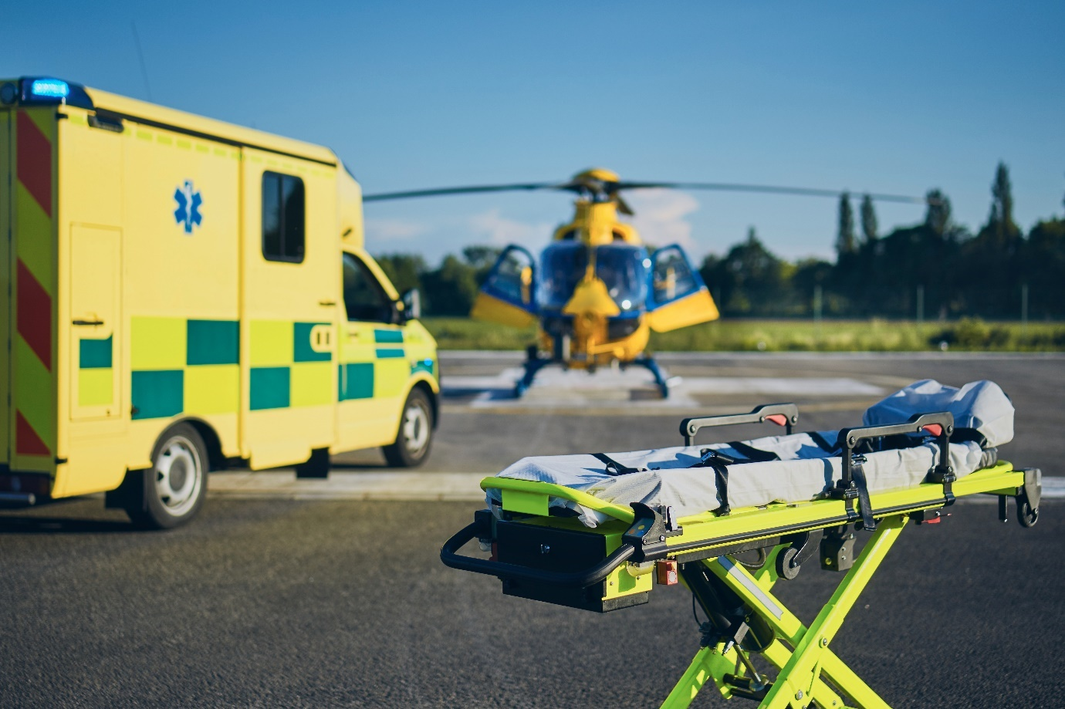

Name:

Grade:

Employer:

Introduction
Welcome to the Ambulance CPD Workbook. When filling out this workbook, to get the most out of your CPD, try and use multiple reputable/peer reviewed sources to fill in your answers. Try to provide references for your answers or links to where you gathered your information. If you need to add more space for your work, you can print out more copies or add information to the notes section.

Question 1: Discuss the differences between a minor and major head injury:
………………………………………………………………………………………………………………………….
………………………………………………………………………………………………………………………….
………………………………………………………………………………………………………………………….
………………………………………………………………………………………………………………………….
………………………………………………………………………………………………………………………….
………………………………………………………………………………………………………………………….
………………………………………………………………………………………………………………………….
………………………………………………………………………………………………………………………….
………………………………………………………………………………………………………………………….
………………………………………………………………………………………………………………………….

Question 2: List some red flags in relation to head injury:
………………………………………………………………………………………………………………………….
………………………………………………………………………………………………………………………….
………………………………………………………………………………………………………………………….
………………………………………………………………………………………………………………………….
………………………………………………………………………………………………………………………….
………………………………………………………………………………………………………………………….
………………………………………………………………………………………………………………………….
………………………………………………………………………………………………………………………….
………………………………………………………………………………………………………………………….
………………………………………………………………………………………………………………………….

Question 3: Discuss what is a Coup, Contra Coup injury pattern:
………………………………………………………………………………………………………………………….
………………………………………………………………………………………………………………………….
………………………………………………………………………………………………………………………….
………………………………………………………………………………………………………………………….
………………………………………………………………………………………………………………………….
………………………………………………………………………………………………………………………….
………………………………………………………………………………………………………………………….
………………………………………………………………………………………………………………………….
………………………………………………………………………………………………………………………….
………………………………………………………………………………………………………………………….

Question 4: List the signs and symptoms of a base of skull fracture:
………………………………………………………………………………………………………………………….
………………………………………………………………………………………………………………………….
………………………………………………………………………………………………………………………….
………………………………………………………………………………………………………………………….
………………………………………………………………………………………………………………………….
………………………………………………………………………………………………………………………….
………………………………………………………………………………………………………………………….
………………………………………………………………………………………………………………………….
………………………………………………………………………………………………………………………….
………………………………………………………………………………………………………………………….

Question 5: Discuss the differences between a subdural and subarachnoid haemorrhage, and how signs and symptoms may differ:
………………………………………………………………………………………………………………………….
………………………………………………………………………………………………………………………….
………………………………………………………………………………………………………………………….
………………………………………………………………………………………………………………………….
………………………………………………………………………………………………………………………….
………………………………………………………………………………………………………………………….
………………………………………………………………………………………………………………………….
………………………………………………………………………………………………………………………….
………………………………………………………………………………………………………………………….
………………………………………………………………………………………………………………………….

Question 6: Discuss the relationship between Cerebral Perfusion Pressure, Mean Arterial Pressure, and Intercranial Pressure:
………………………………………………………………………………………………………………………….
………………………………………………………………………………………………………………………….
………………………………………………………………………………………………………………………….
………………………………………………………………………………………………………………………….
………………………………………………………………………………………………………………………….
………………………………………………………………………………………………………………………….
………………………………………………………………………………………………………………………….
………………………………………………………………………………………………………………………….
………………………………………………………………………………………………………………………….
………………………………………………………………………………………………………………………….

Question 7: Discuss how Intercranial Pressure can increase in major head injury, and what pathophysiological processes can occur between Mean Arterial Pressure and Intercranial Pressure:
………………………………………………………………………………………………………………………….
………………………………………………………………………………………………………………………….
………………………………………………………………………………………………………………………….
………………………………………………………………………………………………………………………….
………………………………………………………………………………………………………………………….
………………………………………………………………………………………………………………………….
………………………………………………………………………………………………………………………….
………………………………………………………………………………………………………………………….
………………………………………………………………………………………………………………………….
………………………………………………………………………………………………………………………….

Question 8: What pathophysiological events can occur to the brain when Intercranial Pressure increases:
………………………………………………………………………………………………………………………….
………………………………………………………………………………………………………………………….
………………………………………………………………………………………………………………………….
………………………………………………………………………………………………………………………….
………………………………………………………………………………………………………………………….
………………………………………………………………………………………………………………………….
………………………………………………………………………………………………………………………….
………………………………………………………………………………………………………………………….
………………………………………………………………………………………………………………………….
………………………………………………………………………………………………………………………….

Question 9: Discuss the 3 factors within Cushing’s reflex/triad:
………………………………………………………………………………………………………………………….
………………………………………………………………………………………………………………………….
………………………………………………………………………………………………………………………….
………………………………………………………………………………………………………………………….
………………………………………………………………………………………………………………………….
………………………………………………………………………………………………………………………….
………………………………………………………………………………………………………………………….
………………………………………………………………………………………………………………………….
………………………………………………………………………………………………………………………….
………………………………………………………………………………………………………………………….

Question 10: Discuss the difference between primary and secondary brain damage:
………………………………………………………………………………………………………………………….
………………………………………………………………………………………………………………………….
………………………………………………………………………………………………………………………….
………………………………………………………………………………………………………………………….
………………………………………………………………………………………………………………………….
………………………………………………………………………………………………………………………….
………………………………………………………………………………………………………………………….
………………………………………………………………………………………………………………………….
………………………………………………………………………………………………………………………….
………………………………………………………………………………………………………………………….
………………………………………………………………………………………………………………………….
Notes:
………………………………………………………………………………………………………………………….
………………………………………………………………………………………………………………………….
………………………………………………………………………………………………………………………….
………………………………………………………………………………………………………………………….
………………………………………………………………………………………………………………………….
………………………………………………………………………………………………………………………….
………………………………………………………………………………………………………………………….
………………………………………………………………………………………………………………………….
………………………………………………………………………………………………………………………….
………………………………………………………………………………………………………………………….
………………………………………………………………………………………………………………………….
………………………………………………………………………………………………………………………….
………………………………………………………………………………………………………………………….
………………………………………………………………………………………………………………………….
………………………………………………………………………………………………………………………….
………………………………………………………………………………………………………………………….
………………………………………………………………………………………………………………………….
………………………………………………………………………………………………………………………….
………………………………………………………………………………………………………………………….
………………………………………………………………………………………………………………………….
………………………………………………………………………………………………………………………….
………………………………………………………………………………………………………………………….
………………………………………………………………………………………………………………………….
………………………………………………………………………………………………………………………….

